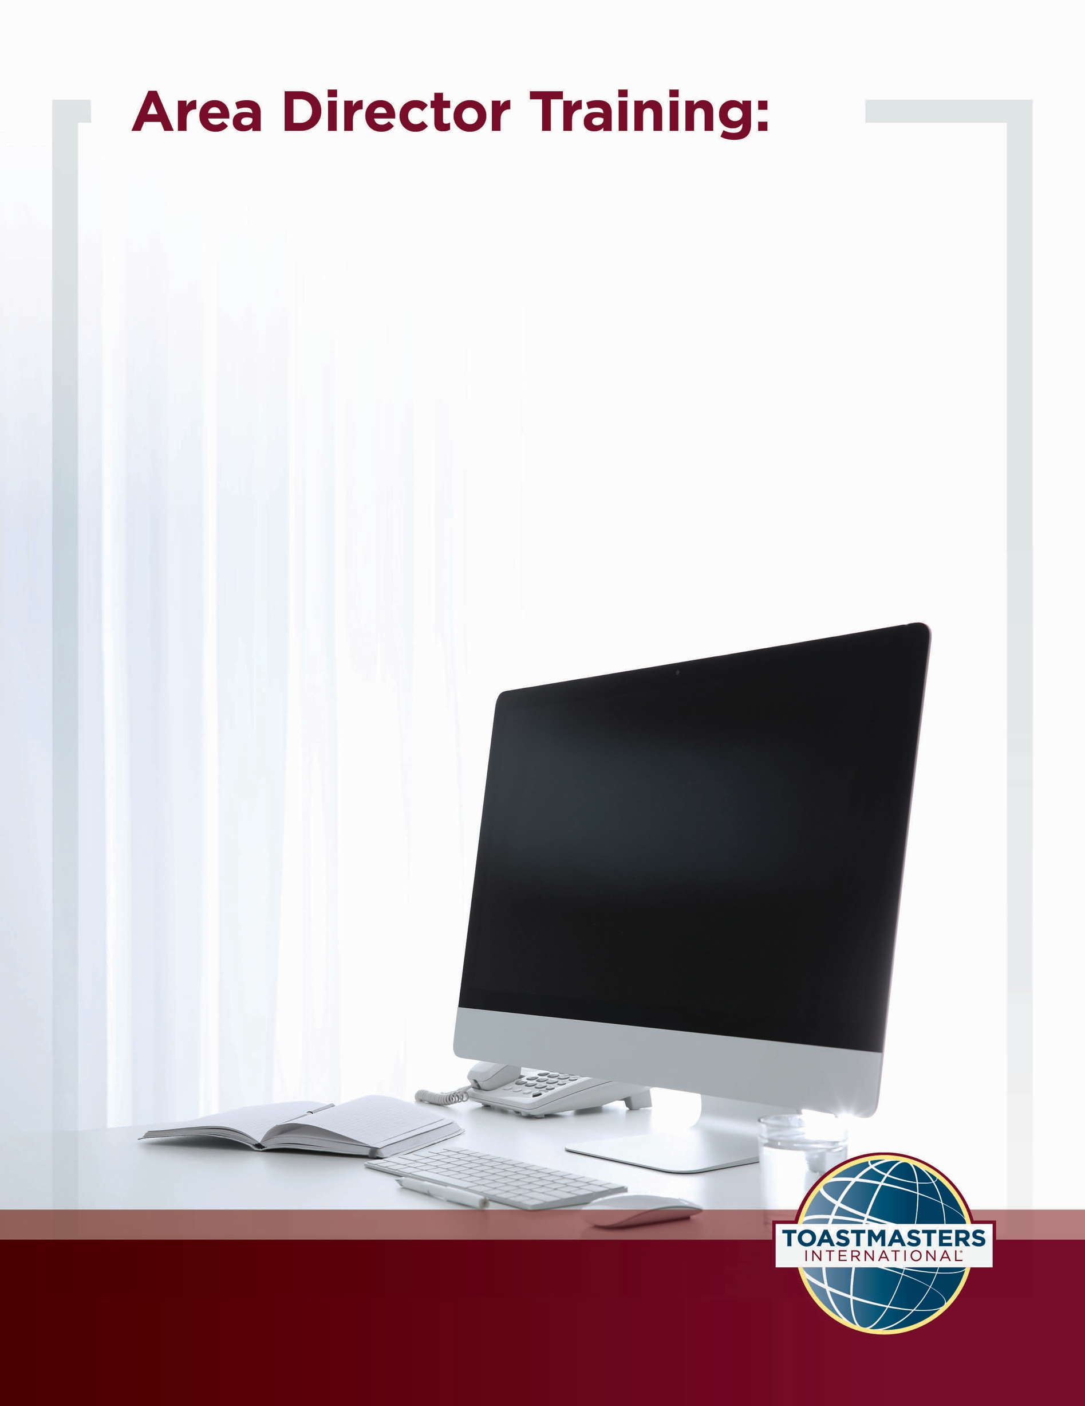
Area Director Expectations

Location of Material: https://www.toastmasters.org/leadership-central/district-leader-tools/training/division-and-area-directors-training-materials

5/05/2021

Area Director Expectations
Introduction
An Area Director is in the position with the greatest opportunity to positively impact clubs. The purpose of this session is to outline the Area Director’s relationship with other leaders in the District, the clubs in the Area, other stakeholders, and emphasize the impact an Area Director has on the organization through executing their role well.
Overview
First, Area Directors will work in groups to explore the impact they have on the clubs in their Area, other leaders, and the District. Then, they work in groups to connect roles and responsibilities in their District and examine their role in relation to others. Finally, they will share their vision for the impact they will have by executing their role well.
In this session, facilitators discuss the following topics:
- Making an Impact in Your Area
- The Roles Around You
Objectives
After completing this session, Area Directors will be able to do the following:
- Recognize the relationship the Area Director has with clubs in the Area, other stakeholders (such as the Board of Directors), and other leaders in the District
- Recognize the importance of supporting clubs by fulfilling their role
- Identify the expectations of the role
By meeting these objectives, Area Directors will have the basic knowledge necessary to develop plans and access resources to deliver on their responsibilities.
Materials
- PowerPoint
- Session Workbook PDF
Time
These session materials take approximately 1 hour and 32 minutes to cover. However, you may choose to present this topic over multiple days or in a shorter format, depending on your preference.
This guide includes suggestions about how to alter the content to suit your needs below:
- This session divides into two shorter sessions by splitting the topics into stand-alone sessions. The review slide in each session would become the conclusion slide, and the pre-work and Session Workbook is adjustable to match the material.
- Check the Area Director Expectations Session Outline for some options of how you might break this session up.

You should add at least one 5-minute break in any session that lasts longer than 60 minutes.
Session Preparation
- Familiarize yourself with the pre-work for this session, where club officers will:
- Read District Leader Handbook (page 31)
  - This is the description of the Area Director role and responsibilities, which are critical for participants to be familiar with prior to attending this session.

- Watch Dashboards for Area Directors (Video)
Members who do not have access to YouTube can watch the video by clicking this link.
  - This video will help Area Directors understand the function and features of their dashboard. This is a critical tool for Area Directors to deliver their role.

- Watch Dashboards for Club Officers (Video)
Members who do not have access to YouTube can watch the video by clicking this link.
  - This video will help Area Directors understand what clubs see in their dashboards and gives them more information to reference.

- Complete Trace your Role Activity
  - This activity connects responsibilities to roles throughout the District and emphasizes their responsibilities in the role as Area Director.

- Complete Questions to Consider
  - These questions promote reflection on the pre-work and their experiences. These add depth to the discussion in each Breakout Room Activity and the Whole Room Discussions.
- Review the entire Facilitator Guide
  - You will find Notes to Facilitator throughout the guide, which are informational and are not intended to be read aloud to participants. Use them to help formulate your talking points and identify your objectives.
  - This session may be delivered online through a video conference platform or in person. This guide contains tips and notes that you will need to apply to how the material will be delivered.
  - Throughout this guide, you will find highlighted yellow directions. These are callouts to what actions need to be taken when delivering this session online.
  - If you plan to conduct this session in person, some of the instructions or slides will no longer be applicable. Please review the materials carefully and update them to best suit the needs of your session format.
- Practice with your co-facilitator(s) to ensure smooth transitions throughout the session, if applicable.
- Consider assigning a technical assistant to help with the logistics of the session (breakout rooms, chat, technical issues, etc.) when delivering this training online.
- Review the instructions and materials for each Breakout Room Activity.
- There is a slide at the end of this session that gives 5 minutes for participants to fill out a survey. Consider creating a survey to gather feedback on your session or remove the slide.

Pre-Session
START the meeting 30 minutes ahead of time.
START sharing the slides.
note to facilitator
The following slide should be updated to reflect who will be handling technical support.
SHOW the Pre-Session slide.
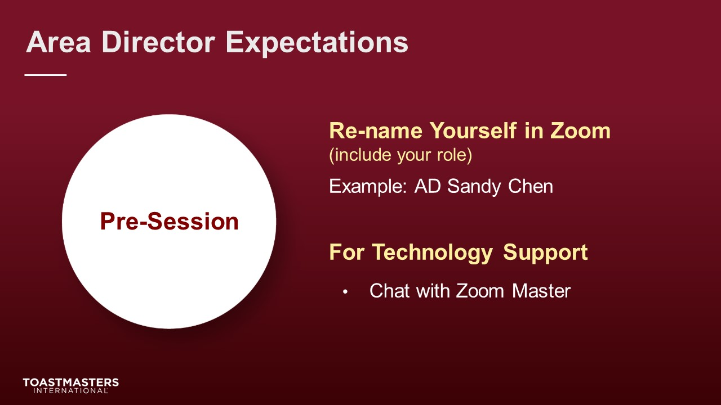
MONITOR chat messages.

Introduction
(5 minutes)
note to facilitator
Use this time to introduce yourself formally to the Area Directors. A good introduction sets the tone for the session and highlights your experience and credibility. This is an excellent time to share a story related to the topic from your background as a Toastmaster leader.
Throughout this session, it is essential to encourage them to use the pre-work insights and apply them to their current interactions.
This session intends to get Area Directors to critically examine their role, responsibilities, and the opportunity they have to impact their District.
START RECORDING.
SHOW the Session Title slide.
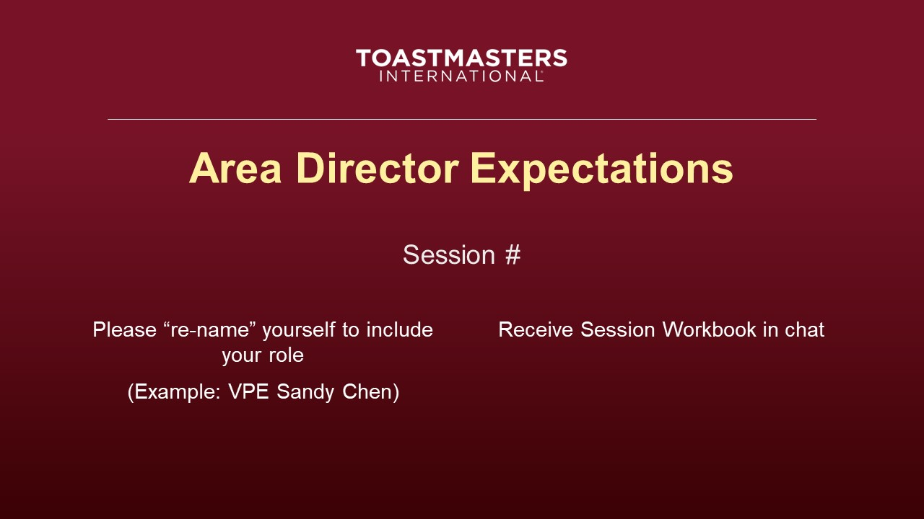
PRESENT
- [insert your talking points here]
SEND Session Workbook to club officers in chat.

SHOW the Agenda slide.
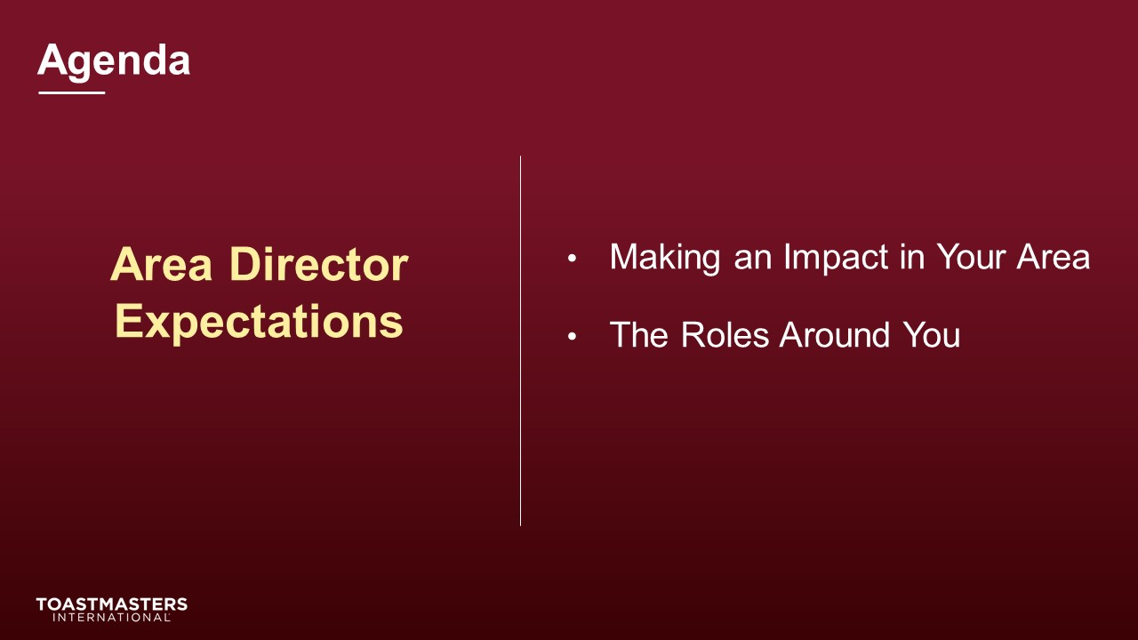
SHOW the Objectives slide.
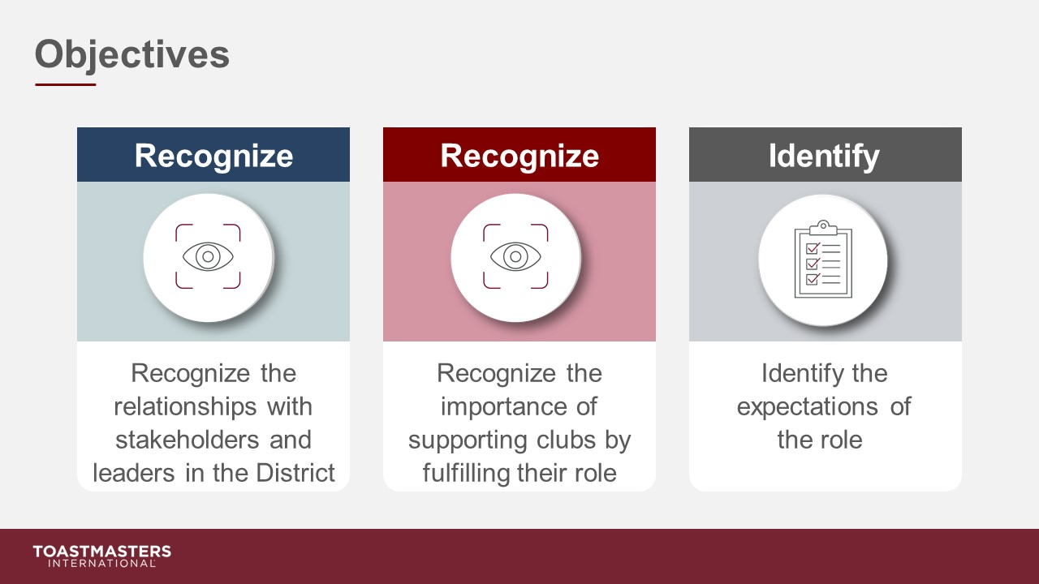

Making an Impact in Your Area
(43 minutes)
note to facilitator
This next section aims to get Area Directors to explore the profound influence on their District being the role that connects the most with clubs. Their work brings them in contact with nearly all the leadership roles in the District, making their position key to advancing any strategy in the District. Area Directors are also stepping into a role that can deliver tremendous personal growth.
PREPARE Breakout Rooms by randomly assigning a minimum of three and a maximum of four Area Directors to each room.
SHOW the Section Title slide.
PRESENT
- Your role is uniquely positioned to make a difference in your District. You work closely with all the other key leaders in your District, and you are the person who works directly with clubs.
- Let’s explore the impact that your role has on your District.
SHOW the Breakout Room Activity slide.
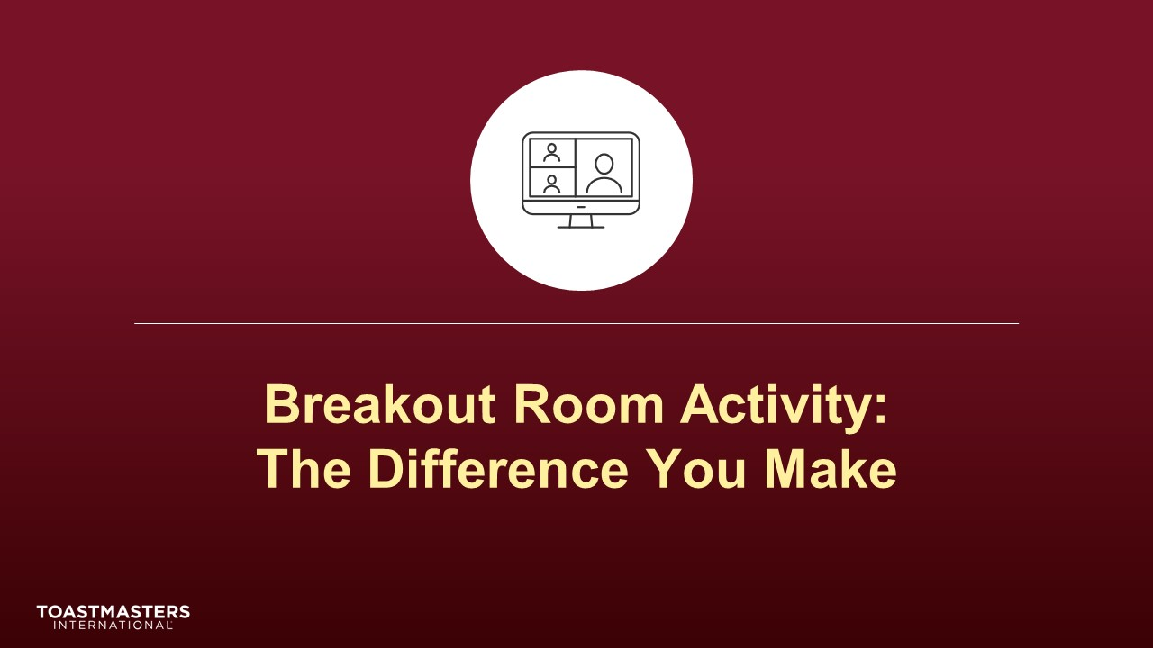
Note To Facilitator
The following slide's purpose is to remind club officers about a few of the tools available to them in virtual breakout rooms. You may need to adjust these according to the platform that you are using to deliver this material. Plan to spend less than one minute on the next slide.
Ideally, you would like to see a minimum of three and a maximum of four Area Directors per group for this activity.
SHOW the Breakout Room Tips slide.
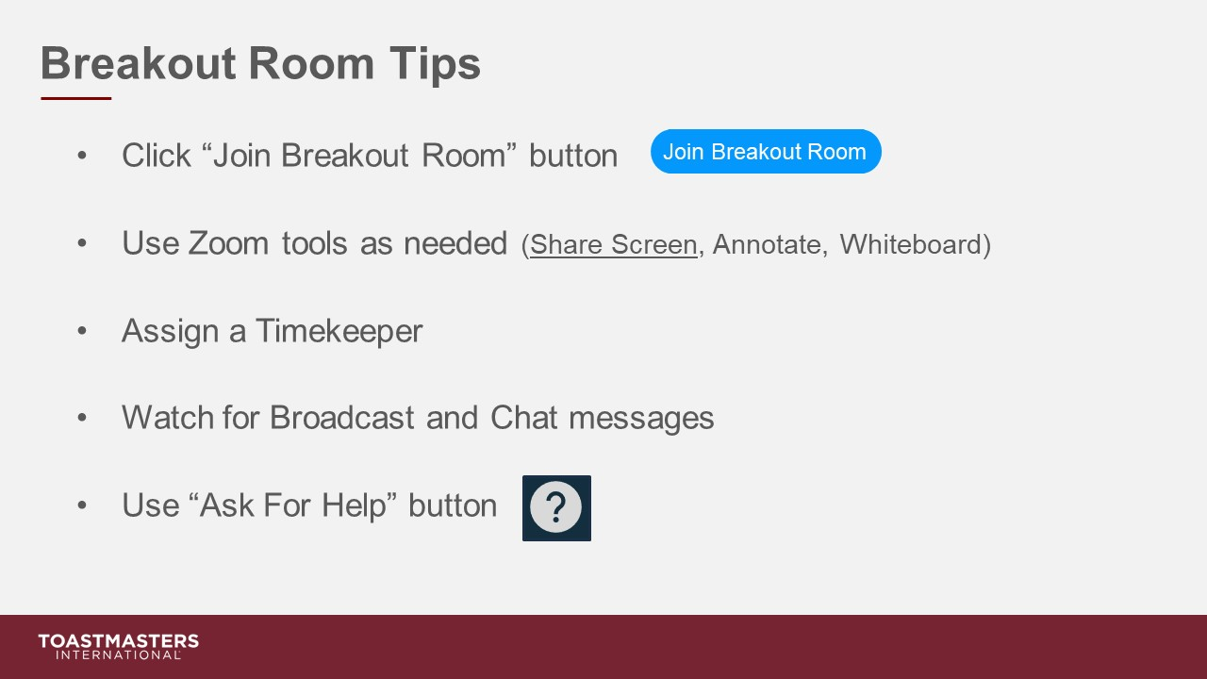
SHOW the Instructions slide.
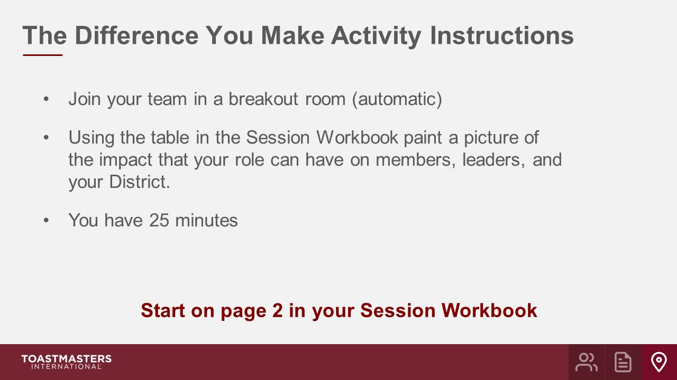
PRESENT
- We will send a two-minute warning before the end of each scenario.
- I will be available to answer questions or provide assistance.
OPEN breakout rooms for activity (ideally 3-4 Area Directors per room).
MONITOR requests for assistance from breakout rooms.
VISIT breakout rooms to offer assistance and guidance, as needed.
SEND broadcast after 10 minutes has elapsed: you have 15 more minutes.
SEND broadcast after 20 minutes has elapsed: you have 5 more minutes.
SEND broadcast after 23 minutes has elapsed: In approximately 2 minutes, you will be asked to return to the main session room.
CLOSE breakout rooms after 25 minutes.
SHOW the Whole Room Discussion slide.
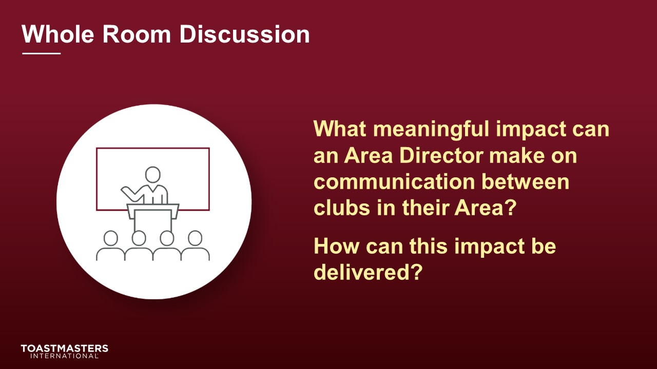
DISCUSS responses for up to 2 minutes.
SHOW the Whole Room Discussion slide.
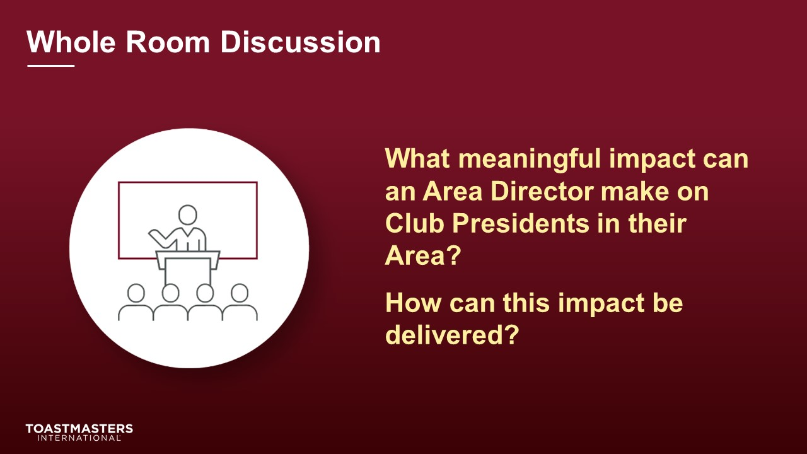
DISCUSS responses for up to 2 minutes.
SHOW the Whole Room Discussion slide.
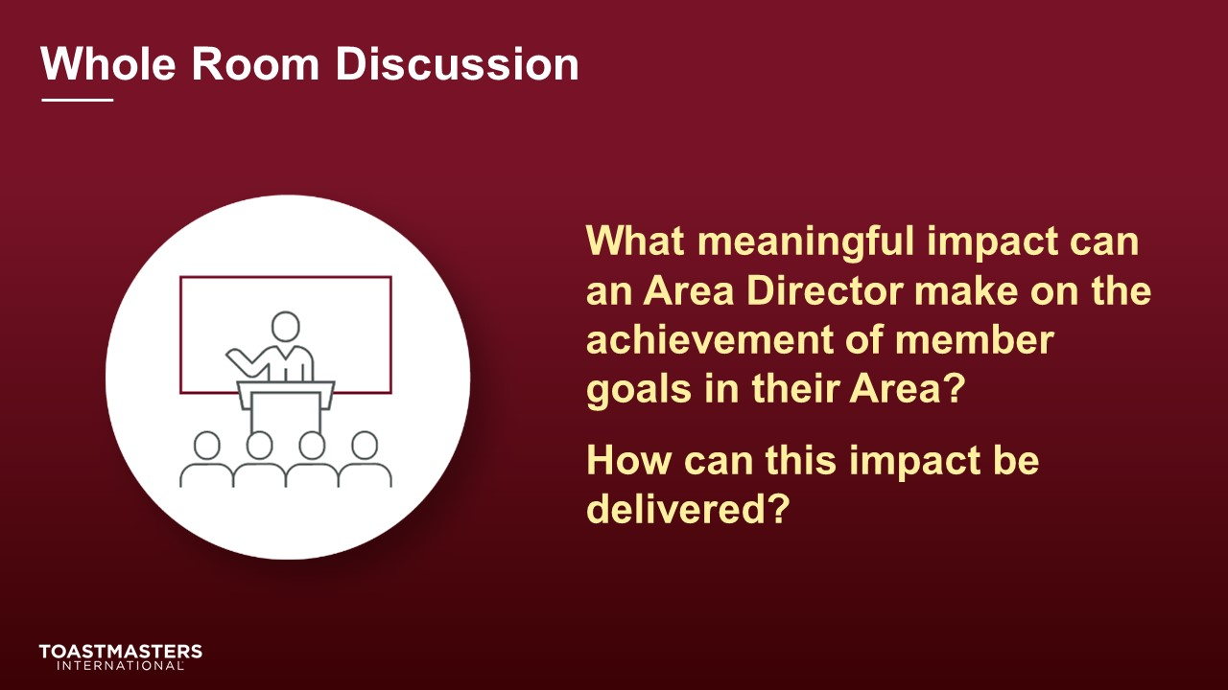
DISCUSS responses for up to 2 minutes.
SHOW the Whole Room Discussion slide.
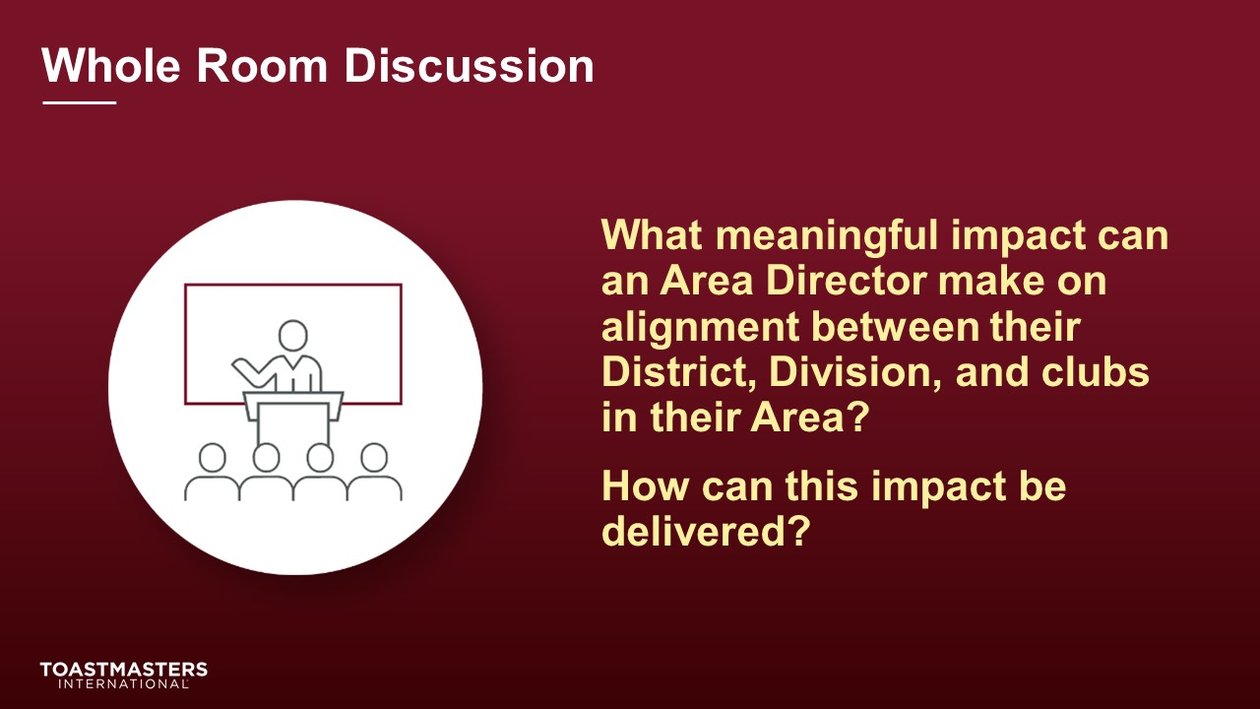
DISCUSS responses for up to 2 minutes.
SHOW the Review slide.
PRESENT
- [insert your talking points here]

The Roles Around You
(34 minutes)
note to facilitator
Remind participants to open their pre-work so they can refer to concepts and their responses to questions. This reminder will help guide their participation in the discussions they will have in the first section.
This section helps Area Directors identify their responsibilities and see where they may overlap with other roles. Overlaps are an opportunity to collaborate with other roles and also remain focused on what they need to do to achieve success.
PREPARE breakout rooms by randomly assigning a minimum of three and a maximum of four Area Directors to each room.
SHOW the Section Title slide.
PRESENT
- Your role is critical to the success of your District. As you perform your role, you will work with other people who provide opportunities to collaborate to support achievement in your Area. There are a lot of opportunities to make an impact on your Area, Division, District, and the organization. It is easy to get drawn in many directions.
- Let’s work together to identify the other roles that you will work with and connect those roles with the work to be done.
SHOW the Breakout Room Activity slide.
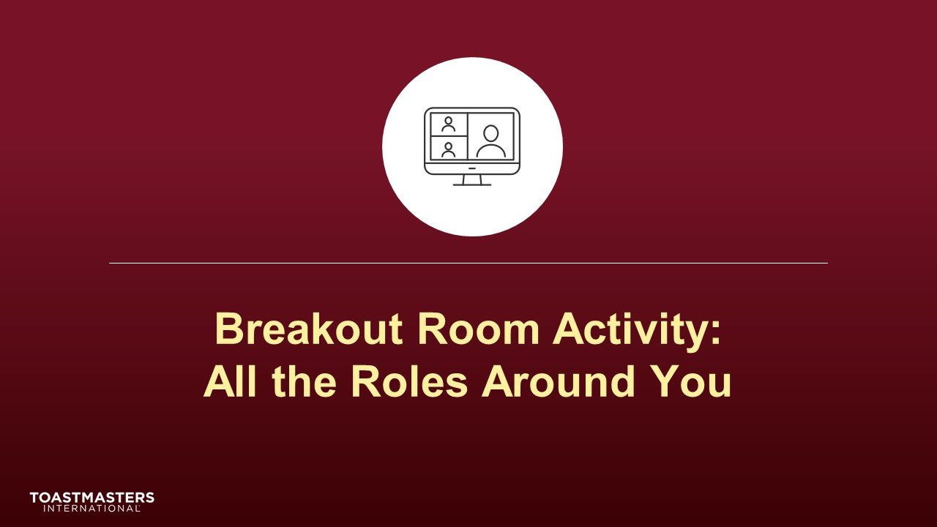
note to facilitator
The following slide's purpose is to remind Area Directors about a few of the tools available to them in virtual breakout rooms. You may need to adjust these according to the platform that you are using to deliver this material. Plan to spend less than one minute on the next slide.
Ideally, you would like to see a minimum of three and a maximum of four Area Directors per group for this activity.
SHOW the Breakout Room Tips slide.
SHOW the Instructions slide.
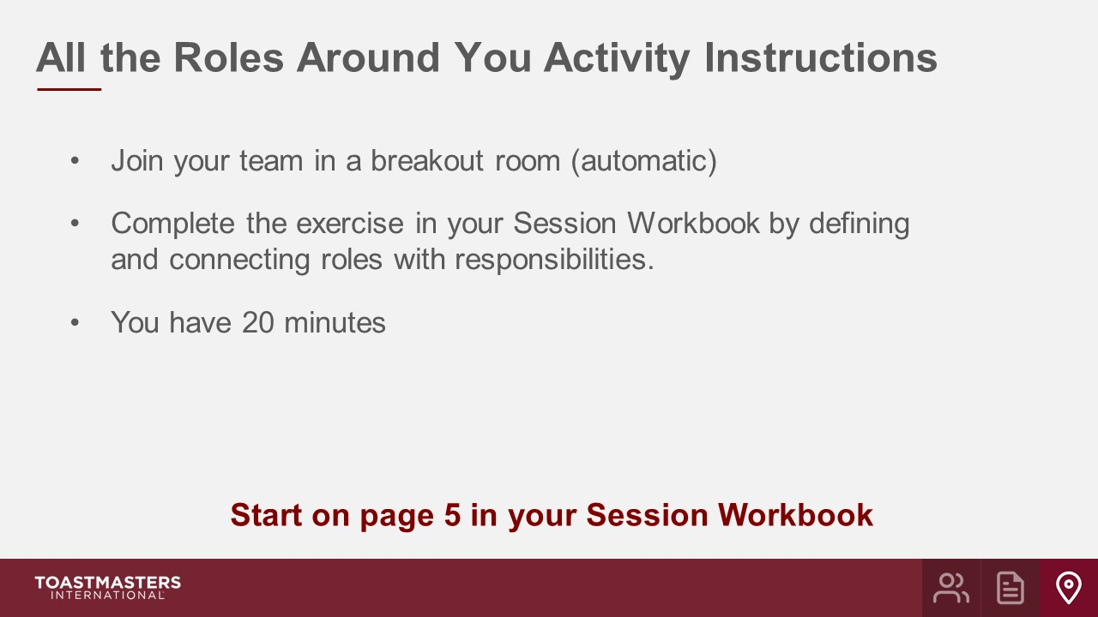
PRESENT
- We will send a 2 minute warning before the end of the activity.
- I will be available to answer questions or provide assistance.
OPEN Breakout Rooms for activity (ideally 3-4 Area Directors per room).
MONITOR requests for assistance from breakout rooms.
VISIT breakout rooms to offer assistance and guidance, as needed.
SEND broadcast after 10 minutes has elapsed: You have 10 more minutes.
SEND broadcast after 15 minutes has elapsed: You have 5 more minutes.
SEND broadcast after 18 minutes has elapsed: In approximately 2 minutes, you will be asked to return to the main session room.
CLOSE breakout rooms after 20 minutes.
SHOW the Whole Room Discussion slide.
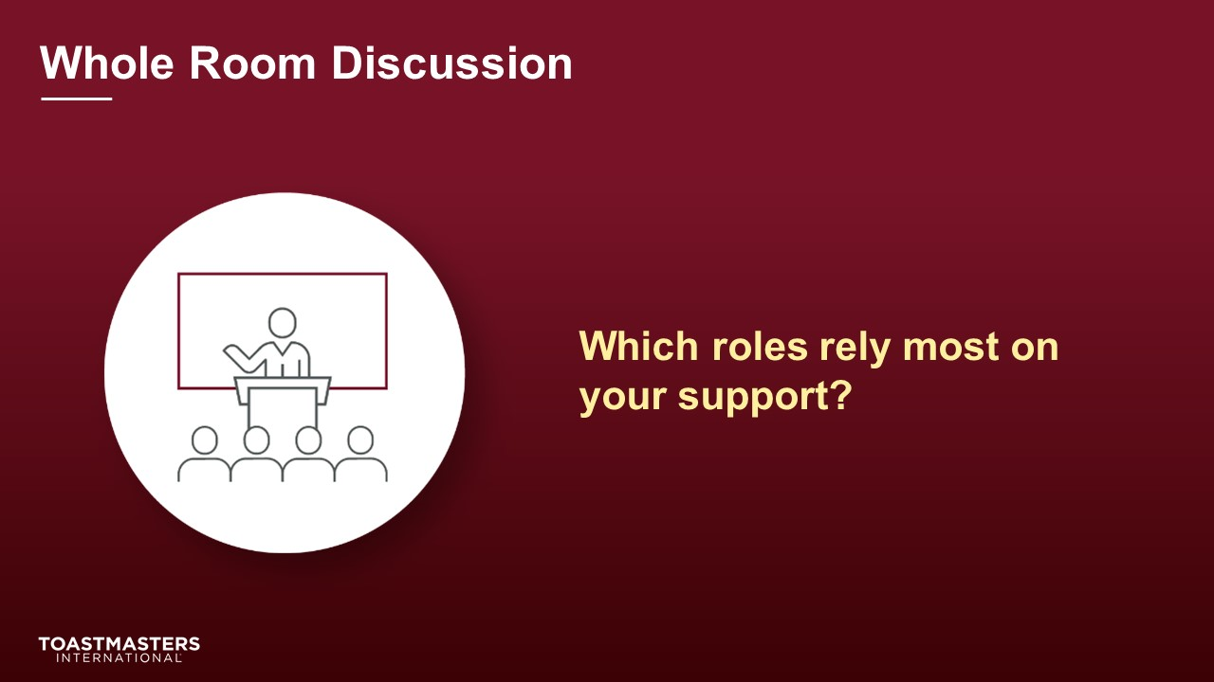
DISCUSS responses for up to 3 minutes.

SHOW the Whole Room Discussion slide.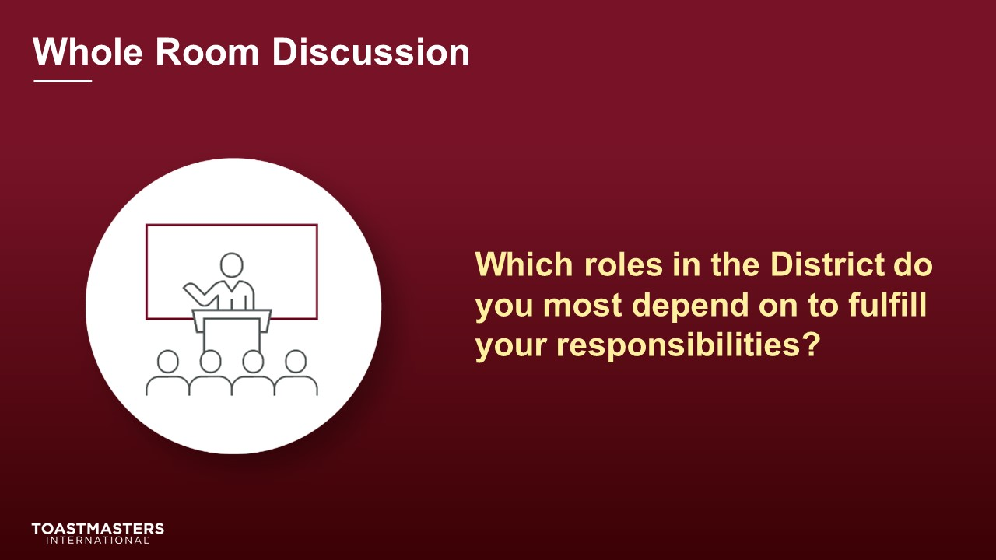
DISCUSS responses for up to 3 minutes.
SHOW the Review slide.
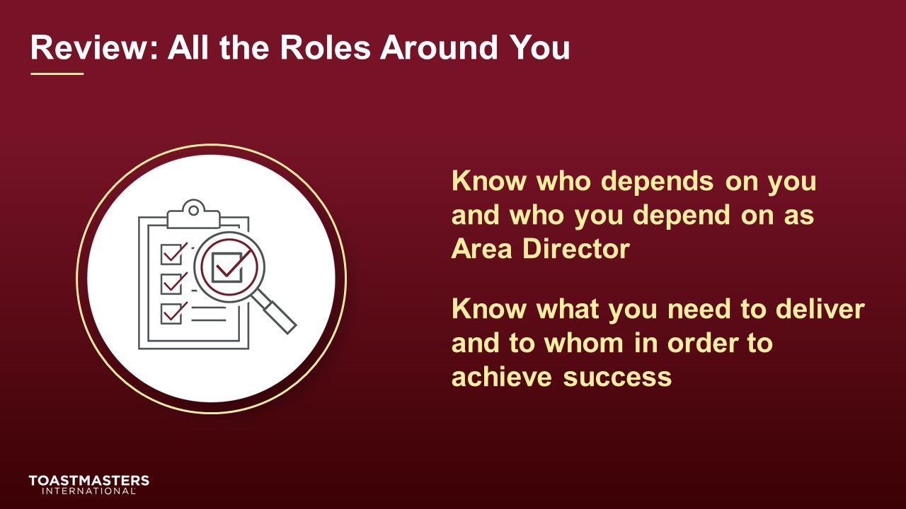
PRESENT
- Answers to the All the Roles Around You activity can be found on page 4 of your Session Workbook.

Conclusion
(10 minutes)
SHOW the Conclusion slide.
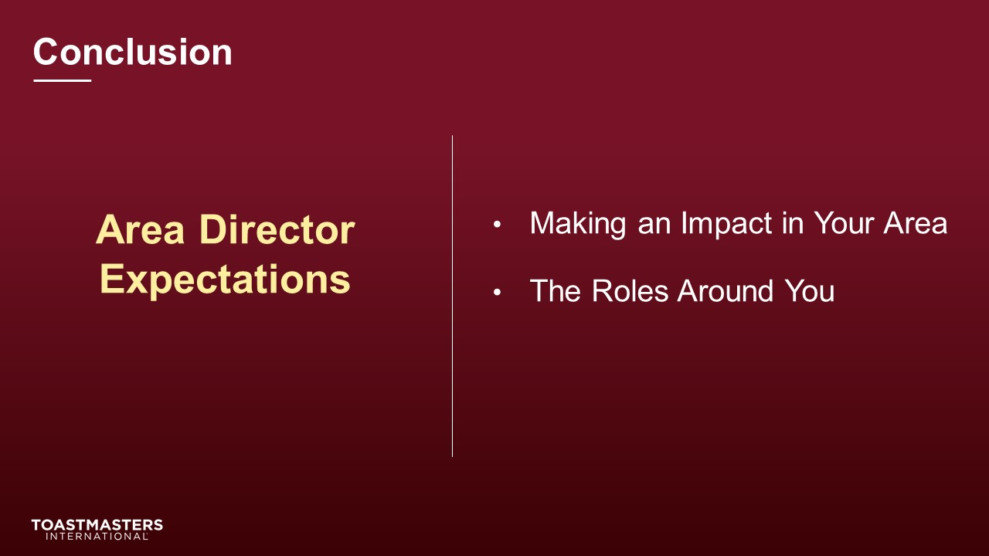
PRESENT
- There are resources in your Session Workbook on page 10 and a reflection activity on page 11 for you to complete on your own.
SHOW the Chat slide.
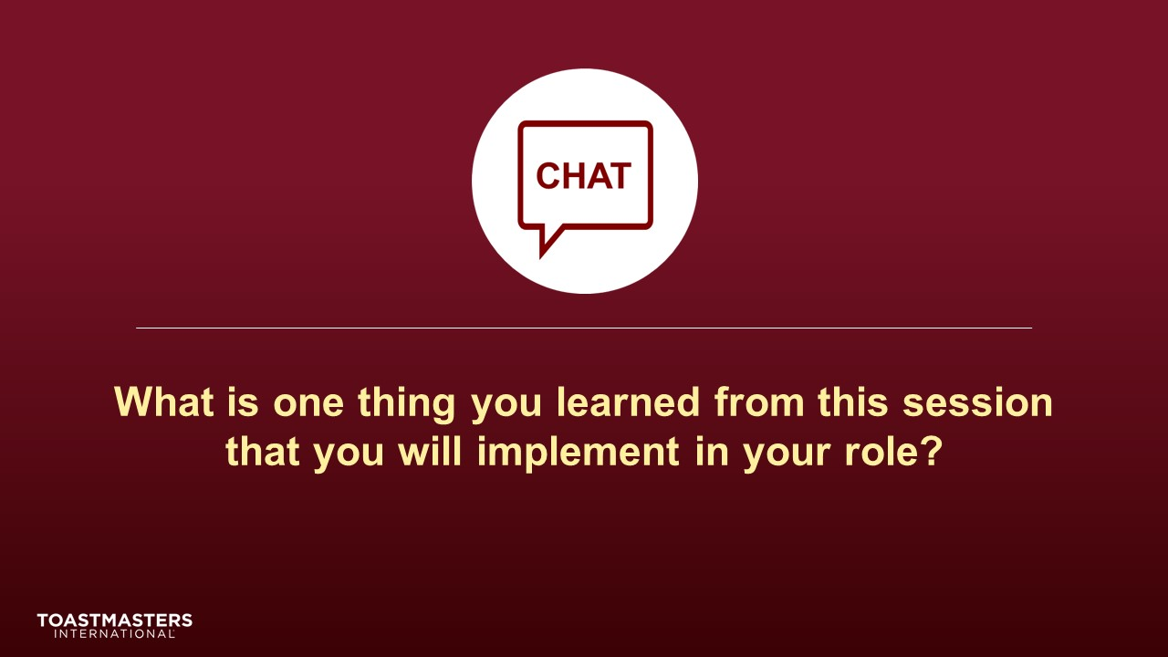
MONITOR chat responses.
DISCUSS responses for up to 2 minutes.
note to facilitator
The following two slides should be edited to fit your requirements.
SHOW the Session Assessment slide.
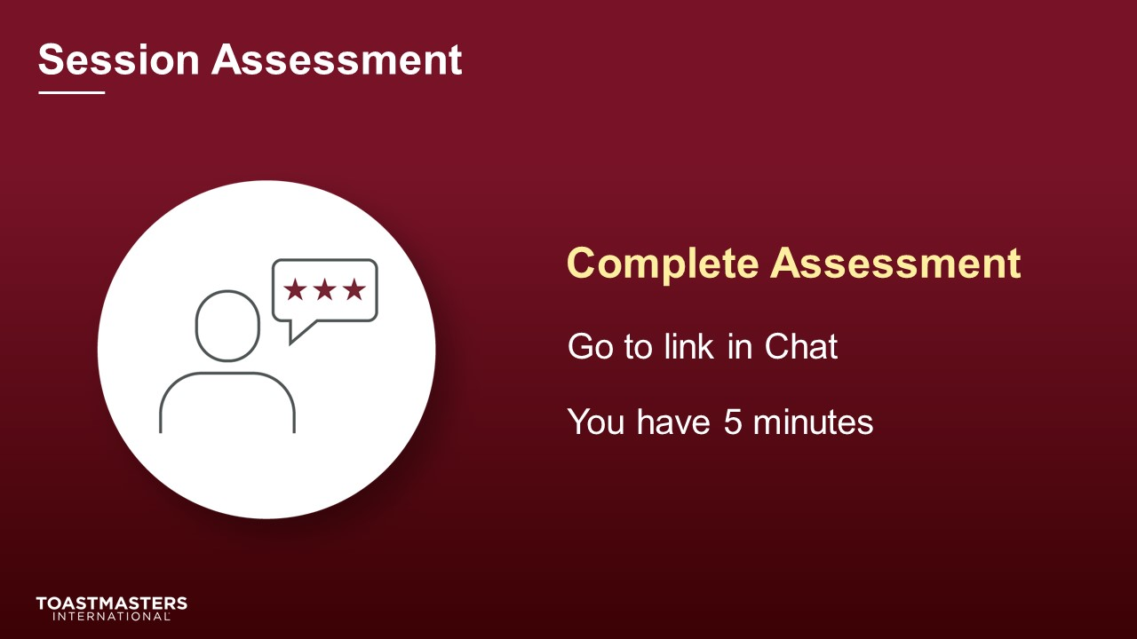
SEND chat message to everyone: [insert link to assessment]
SHOW the What is Next slide.
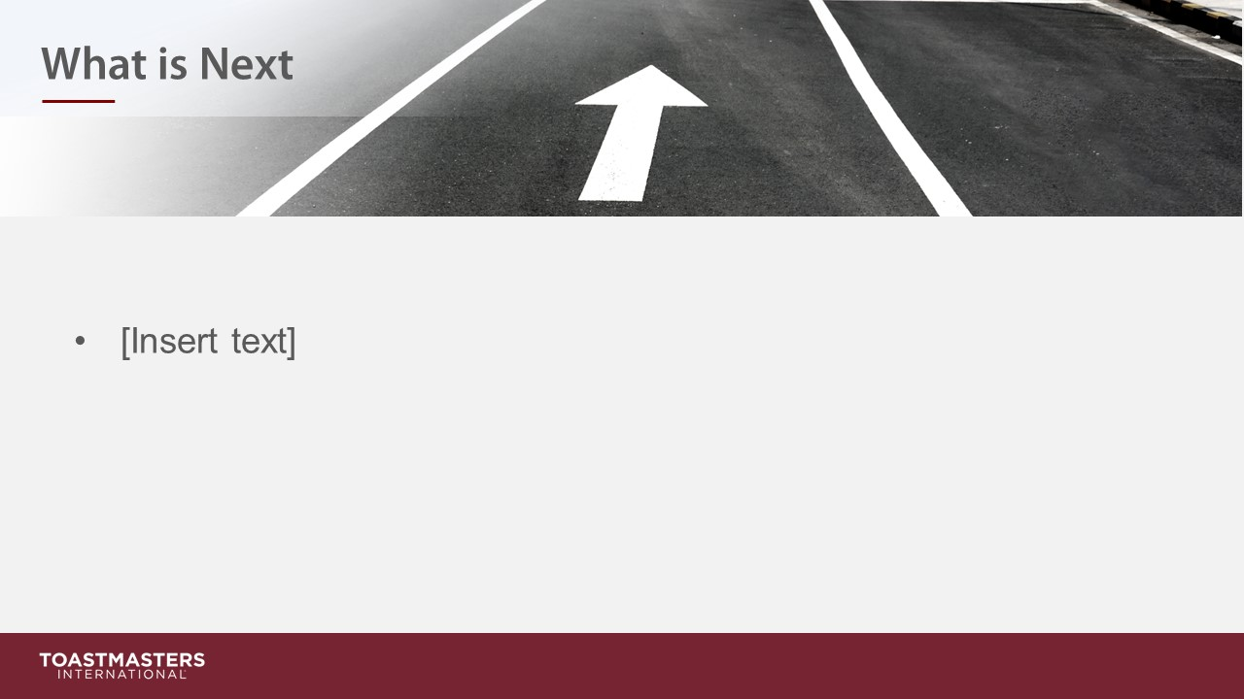
PRESENT
- [insert your talking points here]

