Club Success Plan

Location of the material: https://www.toastmasters.org/leadership-central/district-leader-tools/training/club-officer-training-materials

5/05/2021

Club Success Plan
Introduction
The Club Success Plan is the first step towards delivering club excellence. Properly developing and executing the plan enables and supports member achievement, which in turn promotes engagement, retention, and club growth. The purpose of this session is to assist club officers to identify and address common barriers surrounding planning, critically look at the Club Success Plans, and facilitate the use of planning best practices.
Overview
First, club officers will work in a group to analyze and edit excerpts of a completed Club Success Plan. Then, they will analyze a club scenario and write selected parts of the Club Success Plan. Finally, they will review sample answers and discuss as a group.
This session includes the following topics:
- Improving Plans
- Club Success Plan Simulation
Objectives
After completing this session, club officers will be able to do the following:
- Recognize the advantages to good planning
- Assess and revise planning documents to improve effectiveness
- Develop planning documents to effectively target goals
By meeting these objectives, club officers will be able to support their clubs in critically reviewing their Club Success Plan and implementing best planning practices.
Materials
- PowerPoint
- Session Workbook PDF
Time
These session materials are designed for a session that takes approximately one hour and twenty minutes. However, you may choose to present this topic over multiple days or in a shorter format, depending on your preference.
This guide includes suggestions about how to alter the content to suit your needs below:
- This session divides into two shorter sessions by dividing the topics into standalone sessions. The review slide in each session would become the conclusion slide, and the Pre-work and Session Workbook is adjustable to match the material.
- Check the Club Success Plan Session Outline for some options of how you might break this session up.

You should add at least one 5-minute break in any session that lasts longer than 60 minutes.
Session Preparation
- Familiarize yourself with club officer Pre-work for this session:
  - Read Recognizing the Advantages of Planning (Source: cliffnotes.com)
    - The article emphasizes why planning is valuable and is helpful to refer to throughout the session

  - Read Using Plans to Achieve Goals (Source: cliffnotes.com)
    - The article addresses common barriers to planning and is used in the first Breakout Room Activity

  - Read Identifying Barriers to Planning (Source: cliffnotes.com)
    - The article addresses common barriers to planning and will be used in the first Breakout Room Activity.

  - Read Distinguished Club Program and Club Success Plan from page 16
    - Participants will gain more value in the Breakout Room Activities by reviewing their current Club Success Plan or the manual if they have not created one yet.

  - Watch Dashboards for Club Officers (Video)
Members who do not have access to YouTube can watch the video by clicking this link.
    - This video will give participants information to reference when reflecting on the Club Success Plan's different sections. The dashboards are referenced in both the Breakout Room Activities.

  - Complete Questions to Consider
    - These questions promote reflection on the pre-work and their experiences. These add depth to the discussion in each Breakout Room Activity and the Whole Room Discussions.
- Review the entire Facilitator Guide
  - You will find Notes to Facilitator throughout the guide, which are informational and are not intended to be read aloud to participants. Use them to help formulate your talking points and identify your objectives.
  - This session may be delivered online through a video conference platform or in person. This guide contains tips and notes that you will need to apply to how the material will be delivered.
  - Throughout this guide, you will find highlighted yellow directions. These are callouts to what actions need to be taken when delivering this session online.
  - If you plan to conduct this session in person, some of the instructions or slides will no longer be applicable. Please review the materials carefully and update them to best suit the needs of your session format.
- Practice with your co-facilitator(s) to ensure smooth transitions throughout the session, if applicable.
- Consider assigning a technical assistant to help with the logistics of the session and (breakout rooms, chat, technical issues, etc.) when delivering this session online.
- Review the instructions and materials for each Breakout Room Activity
- There is a slide at the end of this session that gives five minutes for participants to fill out a survey. Consider creating a survey to gather feedback on your session or remove the slide.

Pre-Session
START the meeting 30 minutes ahead of time.
START sharing the slides.
note to facilitator
The following slide should be updated to reflect who will be handling technical support.
SHOW the Pre-Session slide.
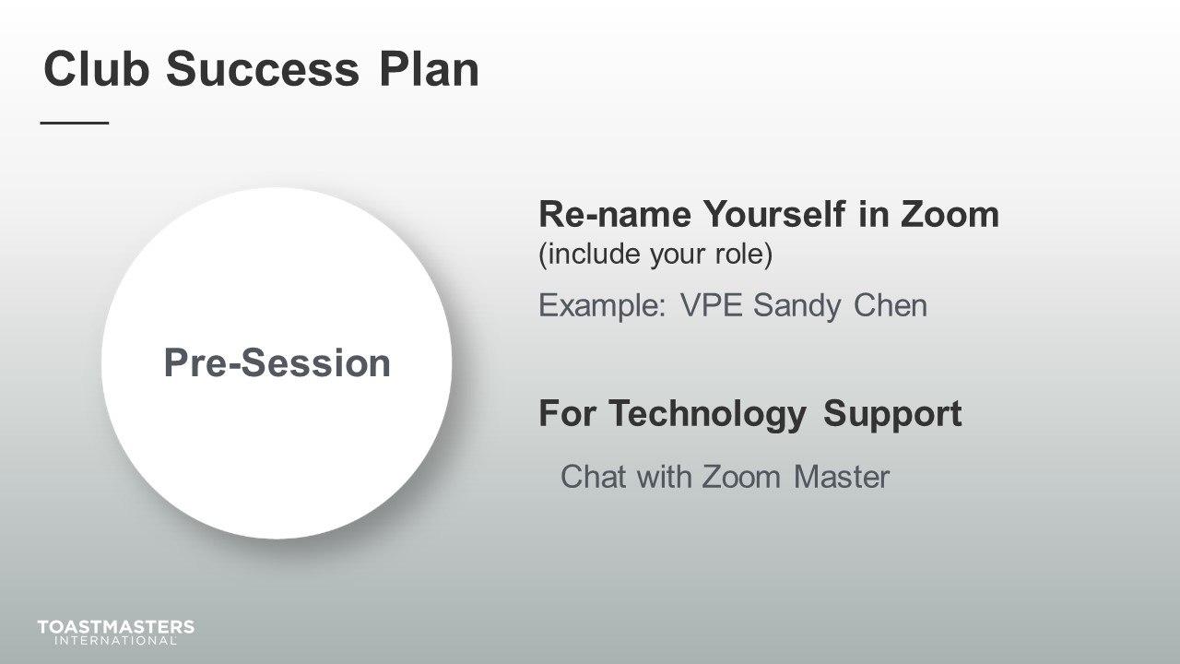
MONITOR chat messages.

Introduction
(5 minutes)
note to facilitator
Use this time to introduce yourself formally to the club officers. A good introduction sets the tone for the session and highlights your experience and credibility. This is an excellent time to share a story related to the topic from your background as a Toastmaster leader.
Throughout this session, it is essential to encourage club officers to use the pre-work insights and apply them to their current interactions.
This session intends to emphasize the Club Success Plan's importance and allow club officers to refine their planning and analytical skills.
The following slide should be updated to reflect where this session falls in your training program.
SHOW the Session Title slide.
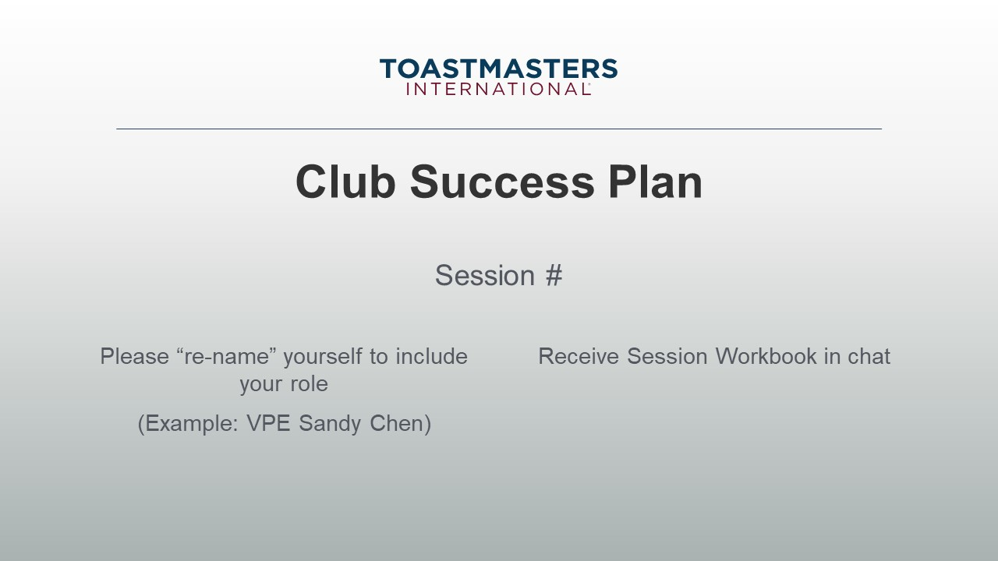
PRESENT
- [insert your talking points here]
SEND session workbook to club officers in chat.

SHOW the Agenda slide.
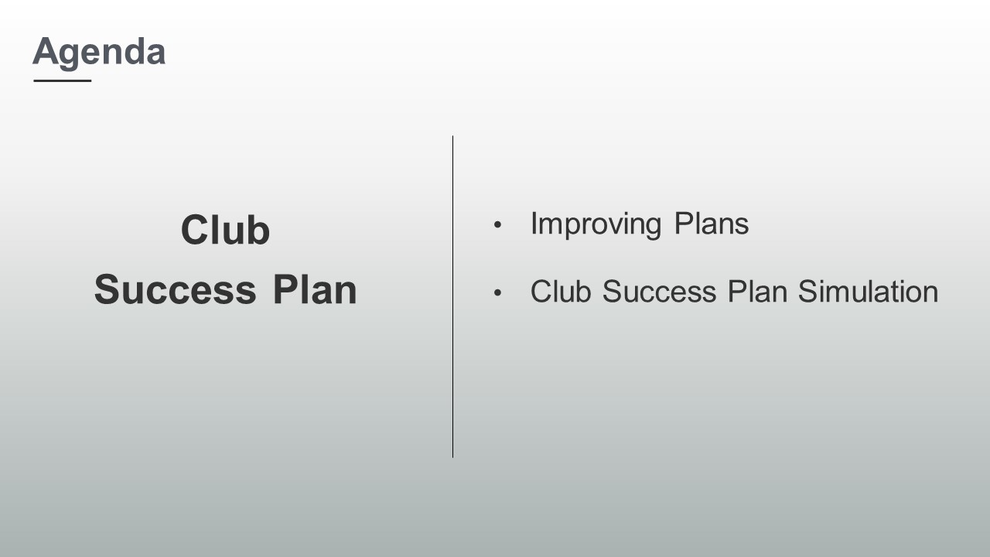
SHOW the Objectives slide.
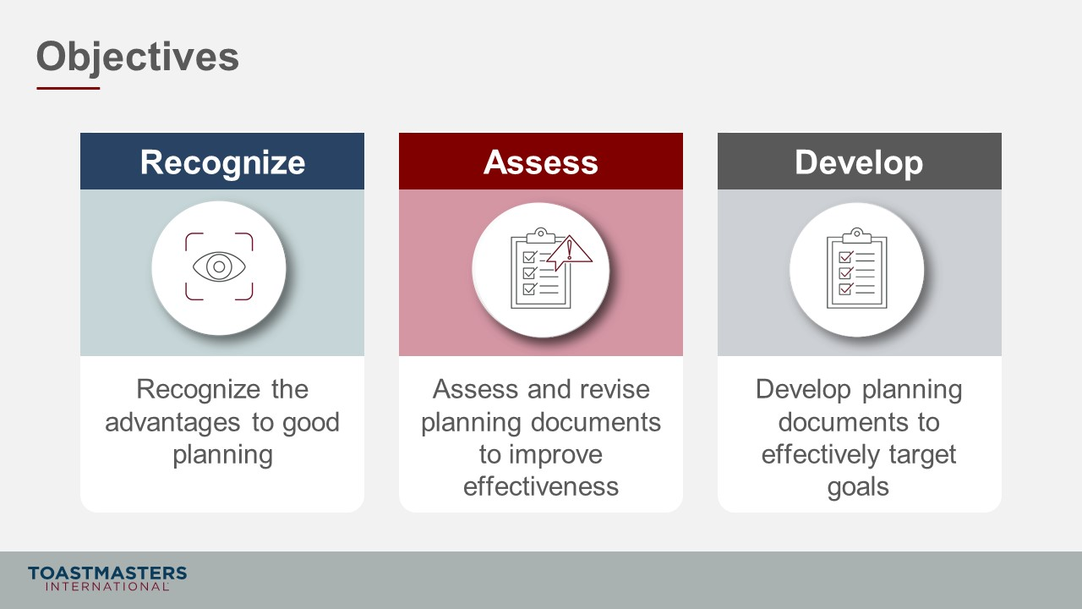

Improving Plans
(30 minutes)
note to facilitator
Remind participants to open their pre-work so they can refer to concepts and their responses to questions. This reminder will help guide their participation in the discussions they will have in the first section.
This section emphasizes to club officers that plans need deliberate attention and maintenance to address the current situation, plan for the possible future, and adjust the plan as new information becomes available throughout the program year.
PREPARE Breakout Rooms by randomly assigning a minimum of 3 and a maximum of club officers to each room.
SHOW the Section Title slide.
PRESENT
- Discussing in advance the what, when, how, and by who bridges the gap between where we are today and where we want to be. We reduce risks, waste, provides direction, and it is a critical task in leadership.
- Our key planning document is the Club Success Plan, which outlines how we will grow our club, train our leaders, educate our members, meet compliance targets, and achieve success.
- The Club Success Plan needs deliberate attention and maintenance first to address the current situation, plan for the possible future, and adjust the plan as new information becomes available throughout the program year.
note to facilitator
The following Breakout Room Activity provides participants with the collaborative experience of assessing and editing elements of the Club Success Plan. In teams, they will rewrite plans and identify what barrier the plan represents. These barriers were part of their pre-work.
SHOW the Breakout Room Activity slide.
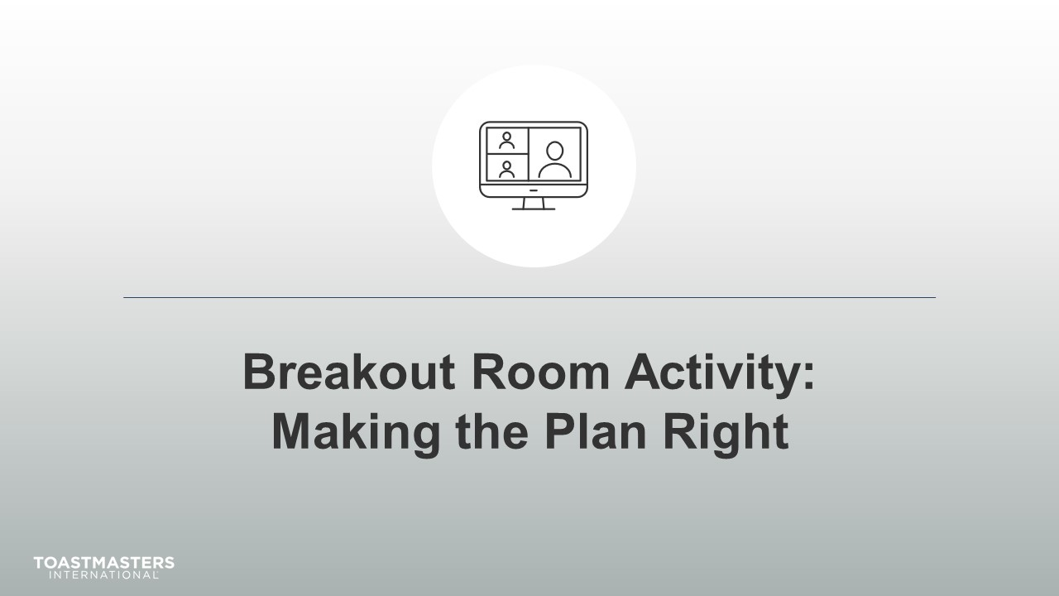
PRESENT
- It is easy to quickly fill out the Club Success Plan and get that task off our list as leaders. Today, we will be looking at poor planning samples and a club scenario to refine our planning skills.

note to facilitator
The following slide's purpose is to remind club officers about a few of the tools available to them in virtual Breakout Rooms. You may need to adjust these according to the platform that you are using to deliver this material. Plan to spend less than one minute on the next slide.
Ideally, you would like to see a minimum of three and a maximum of four club officers per group for this activity.
SHOW the Breakout Room Tips slide.
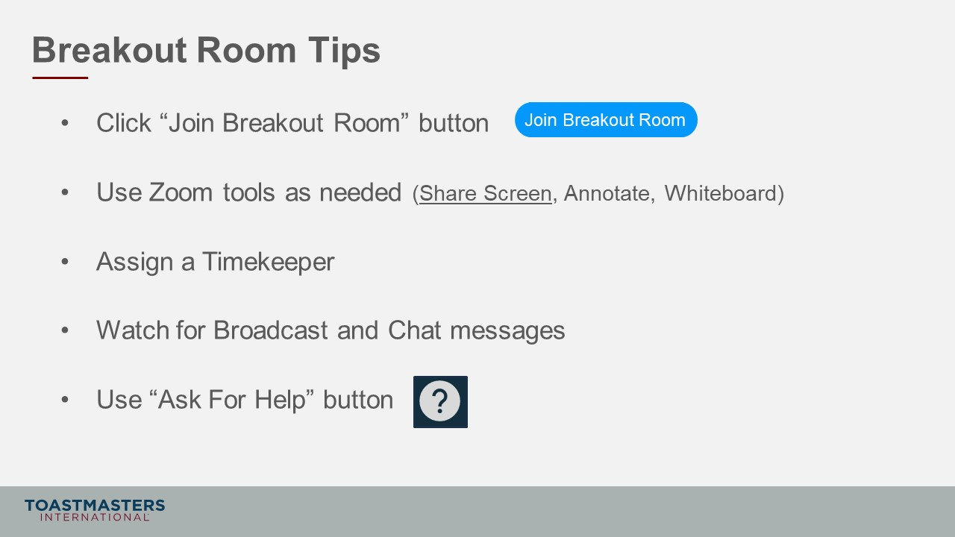

SHOW the Instructions slide.
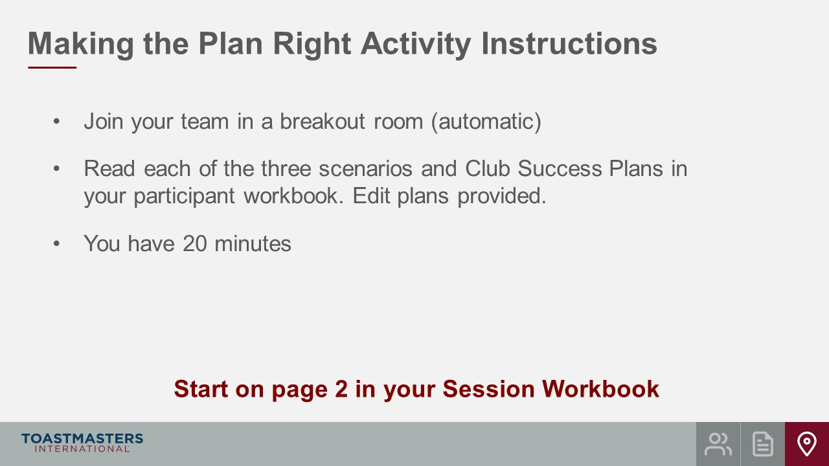
PRESENT
- We will send a two-minute warning before the end of the activity.
- I will be available to answer questions or provide assistance.
note to facilitator
The instructions below are prompts for virtual Breakout Rooms but can be adjusted to deliver in an in-person session.
OPEN Breakout Rooms for activity (3-4 club officers per room).
MONITOR requests for assistance from Breakout Rooms.
VISIT Breakout Rooms to offer assistance and guidance, as needed.
SEND broadcast after 10 minutes has elapsed: you have 10 more minutes.
SEND broadcast after 15 minutes has elapsed: you have 5 more minutes.
SEND broadcast after 18 minutes has elapsed: in approximately 2 minutes, you will be asked to return to the main session room.
CLOSE breakout rooms after 20 minutes.
note to facilitator
The purpose of the next two slides is to debrief the activity by asking club officers to share a few key insights from the activity. Plan to spend no more than 5 minutes on the next two slides. Be prepared to ask follow-up questions.
You may wish to ask leaders to answer in Chat, or aloud, or a combination of both.
SHOW the Whole Room Discussion slide.
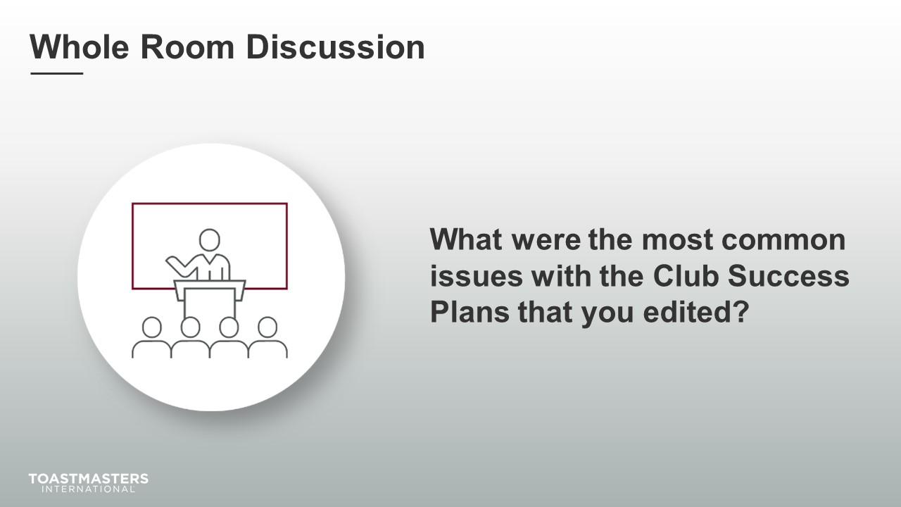
DISCUSS responses for up to two minutes.

SHOW the Whole Room Discussion slide.
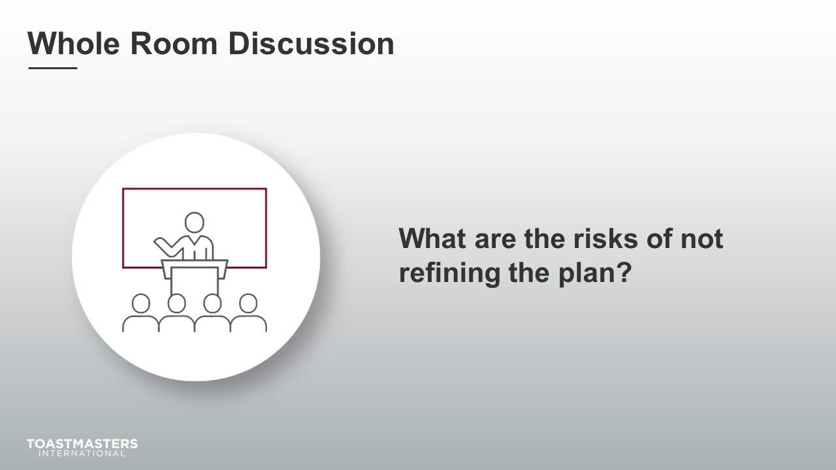
DISCUSS responses for up to two minutes.
SHOW the Review slide.
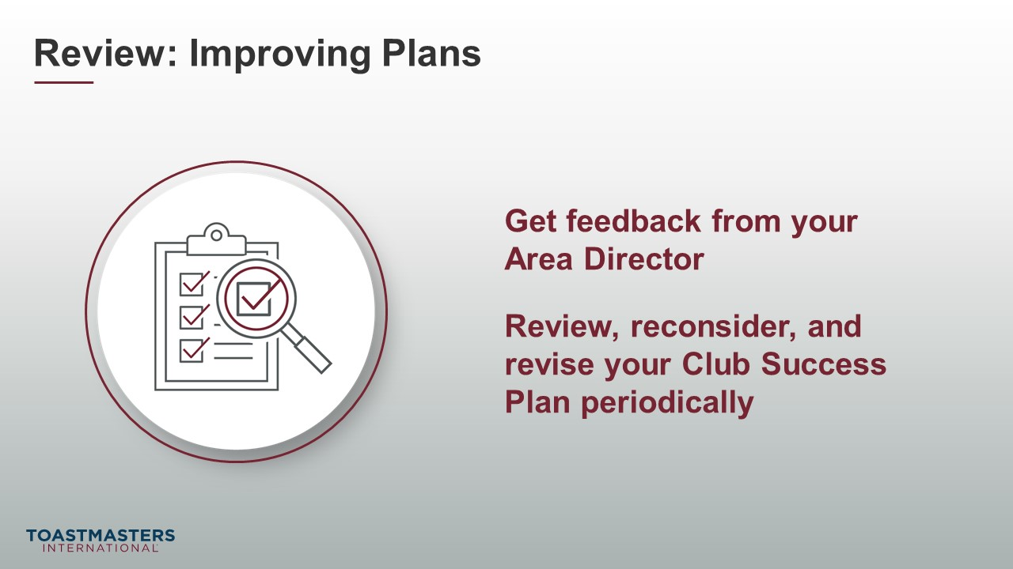

Club Success Plan Simulation
(335 minutes)
note to facilitator
This section allows club officers to analyze a club scenario and write parts of a Club Success Plan. They will then review sample plans for those same scenarios to compare to their work. Before the Breakout Room Activity, the Whole Room Discussion reminds them of their Pre-work reading and their personal experience with planning.
PREPARE Breakout Rooms by randomly assigning a minimum of three and a maximum of four club officers to each room.
SHOW the Section Title slide.
PRESENT
- The great thing about planning is that the more you do it and receive feedback, the better you get at it. Quantity equals quality. You have already done a fair amount of planning, professionally and personally.
SHOW the Whole Room Discussion slide.
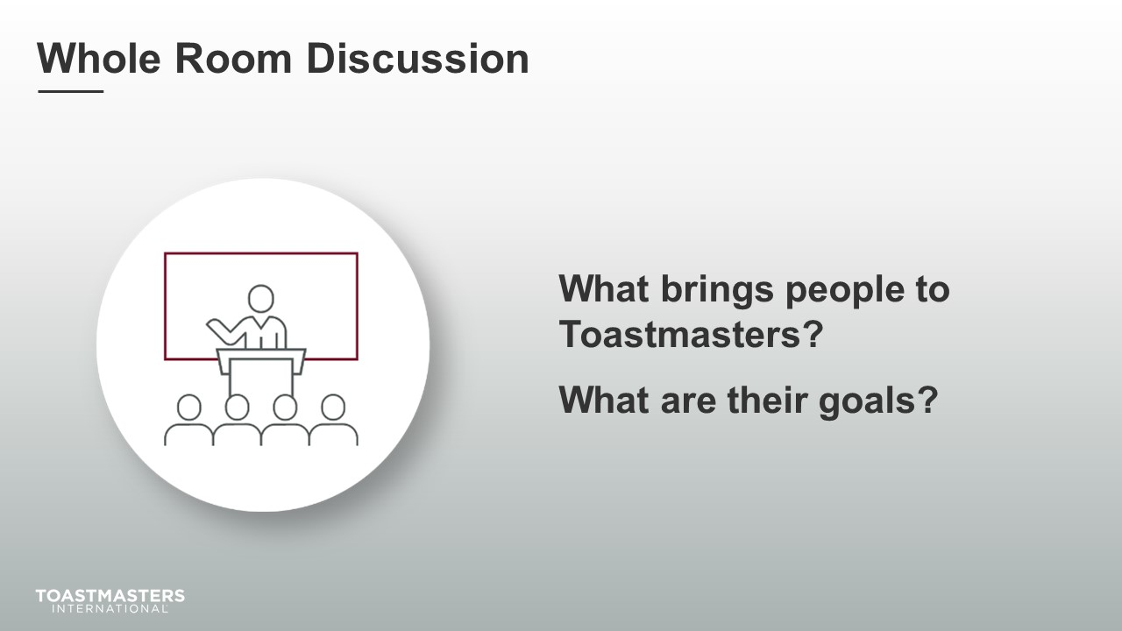
DISCUSS responses for up to two minutes.
note to facilitator
The following Breakout Room Activity provides participants with the collaborative experience drafting elements of the Club Success Plan. In teams, they will write to address dashboard information and scenarios using planning best practices. They will see sample answers after the activity.
SHOW the Breakout Room Activity slide.
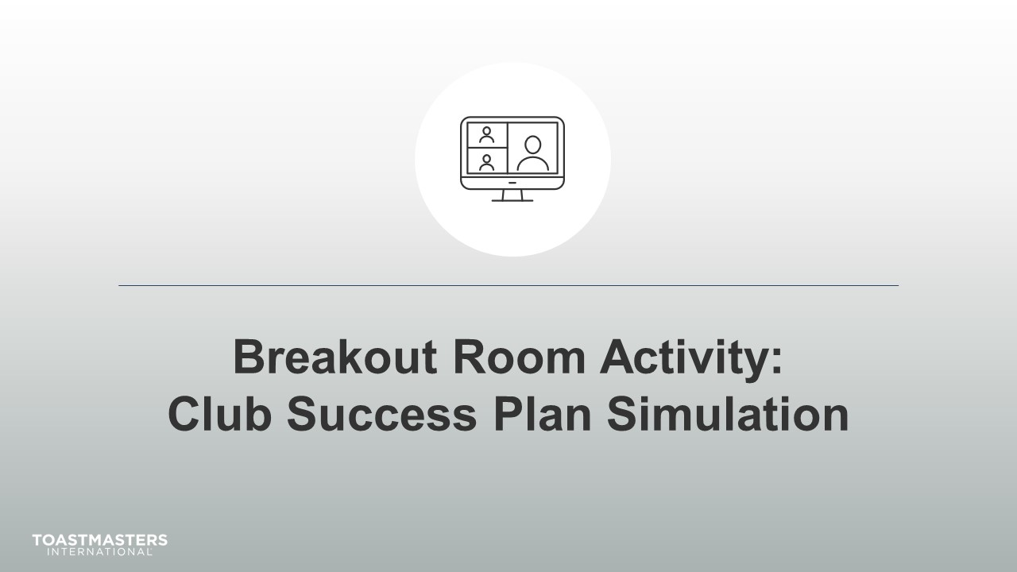
Note To Facilitator
The following slide's purpose is to remind club officers about a few of the tools available to them in virtual Breakout Rooms. You may need to adjust these according to the platform that you are using to deliver this material. Plan to spend less than one minute on the next slide.
Ideally, you would like to see a minimum of three and a maximum of four club officers per group for this activity.
SHOW the Breakout Room Tips slide.
SHOW the Instructions slide.
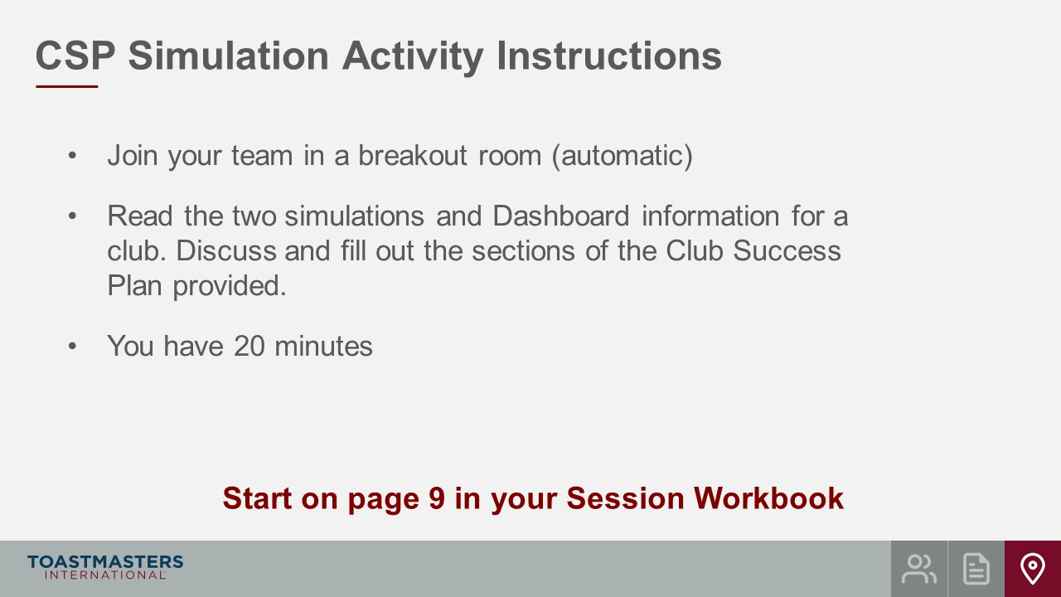
PRESENT
- We will send a two-minute warning before the end of each scenario.
- I will be available to answer questions or provide assistance.
OPEN Breakout Rooms for activity (3-4 club officers per room).
MONITOR requests for assistance from Breakout Rooms.
VISIT Breakout Rooms to offer assistance and guidance, as needed.
SEND broadcast after 10 minutes has elapsed: you have 10 more minutes.
SEND broadcast after 15 minutes has elapsed: you have 5 more minutes.
SEND broadcast after 18 minutes has elapsed: in approximately 2 minutes, you will be asked to return to the main session room.
CLOSE Breakout Rooms after 20 minutes.
note to facilitator
As club officers return form their Breakout Rooms, share your screen with the Simulation Model Answers that are located at the end of this guide. It is important that you stress that these are model answers, not correct answers. Each team will have answers based on assumptions they made. Go through the model answers and discuss. Discuss for up to eight minutes.
SHOW the Review slide.
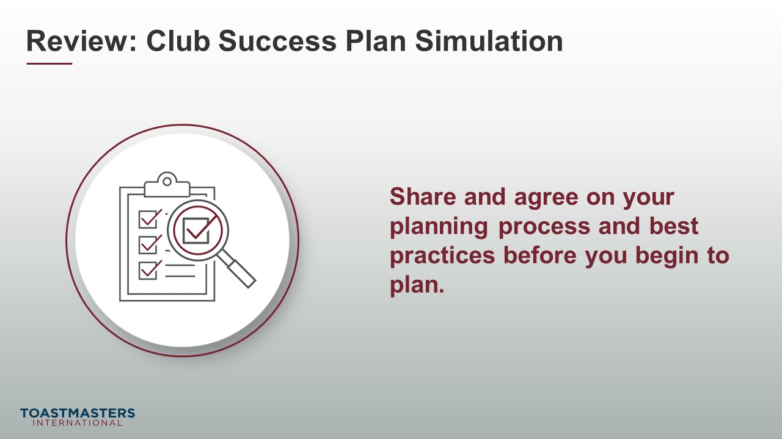

Conclusion
(10 minutes)
SHOW the Conclusion slide.
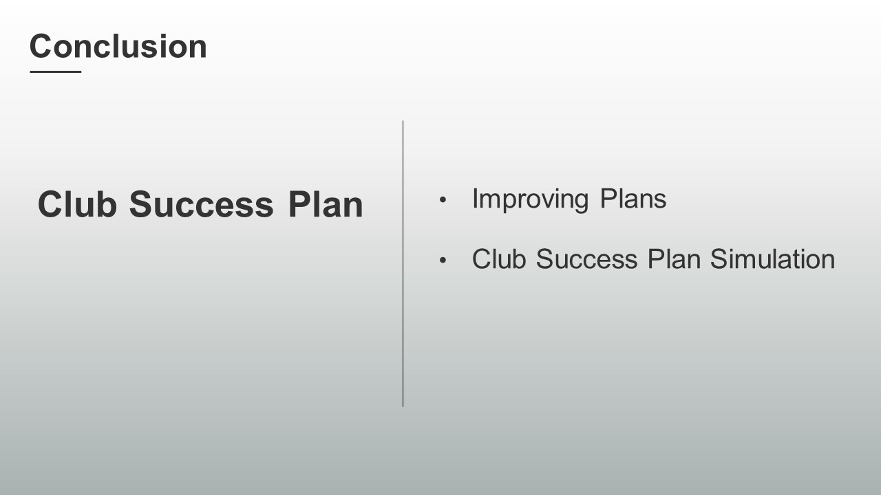
PRESENT
- There are resources in your Session Workbook on page 14 and a reflection activity on page 15 for you to complete on your own.

SHOW the Chat slide.
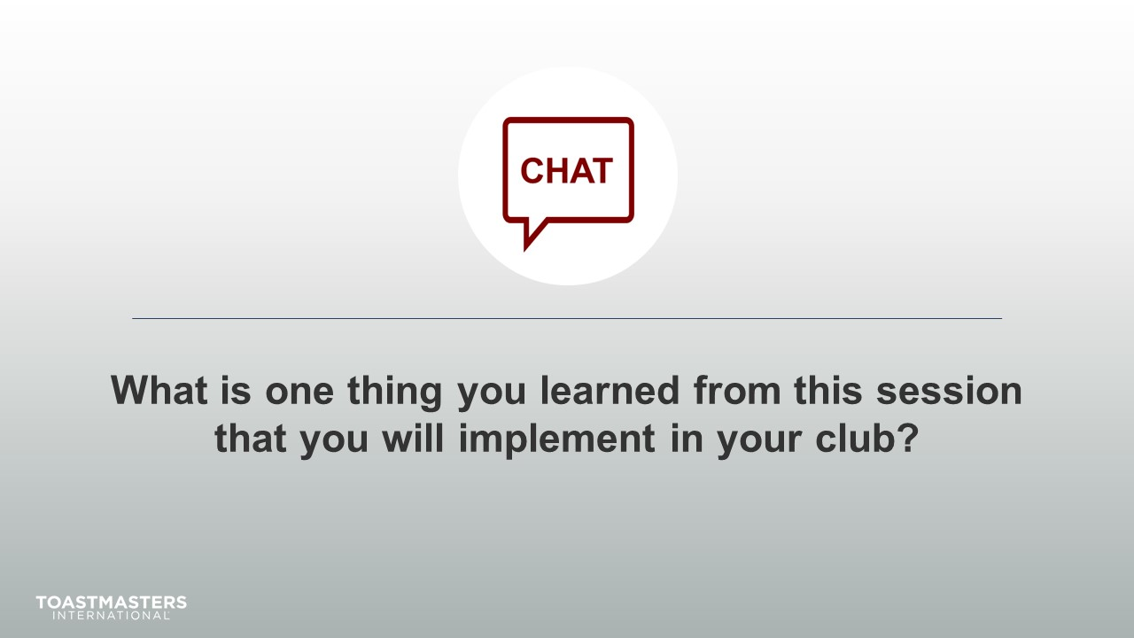
MONITOR chat responses.
DISCUSS responses for up to two minutes.
note to facilitator
The following two slides should be edited to fit your requirements.
SHOW the Session Assessment slide.
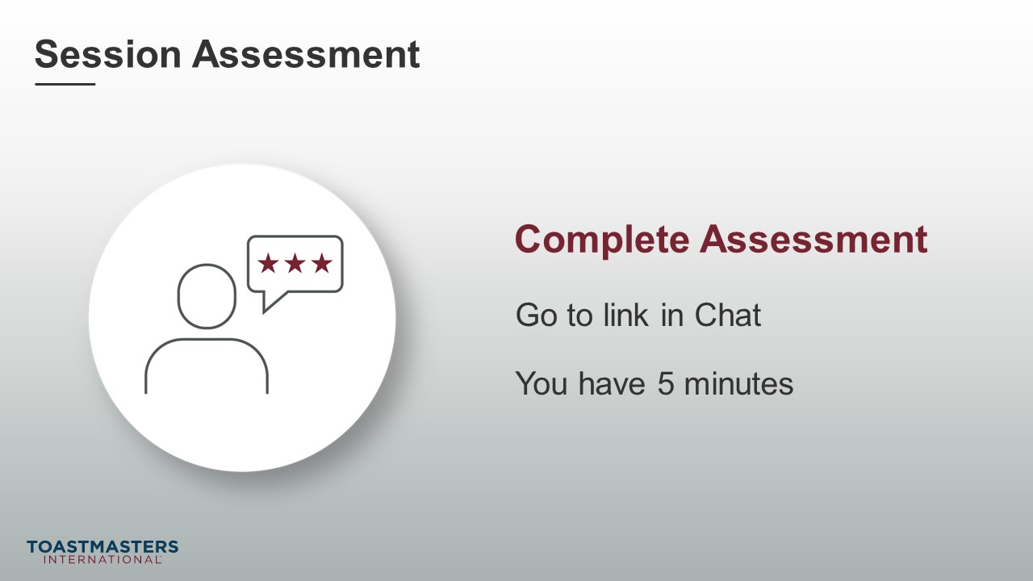
SEND chat message to everyone: [insert link to assessment]
SHOW the What is Next slide.
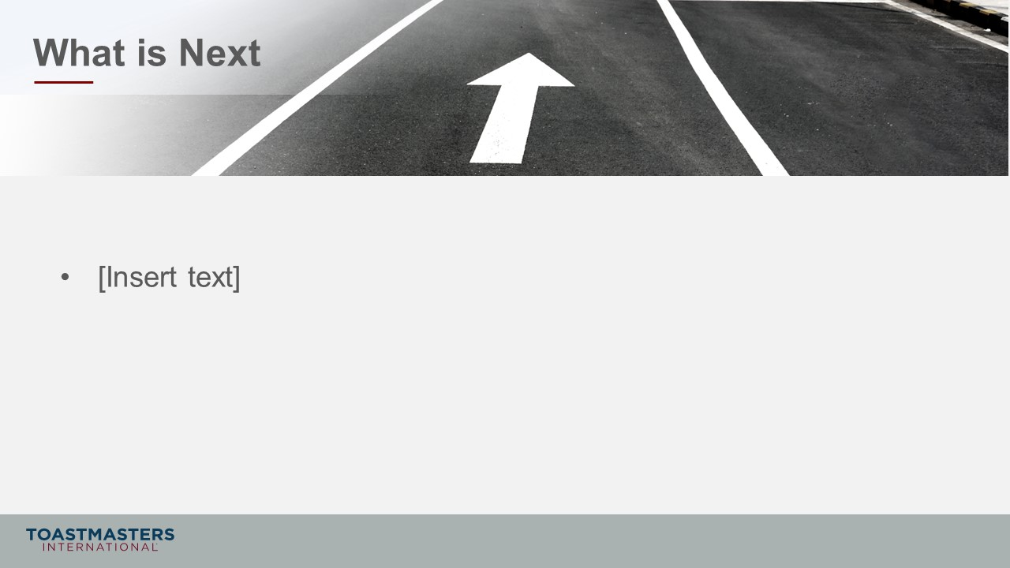
PRESENT
- [insert your talking points here]

Simulation Model Answers
Simulation 1:
- Our club is looking to grow 10% beyond the requirements.
- We traditionally struggle with converting leads to members. We are a club that is known for giving aggressive feedback to help member growth. We think this turns visitor off from joining our club.
- Our club struggles with getting guests information and following up with information.
- We currently rely on word-of-mouth marketing, but we need to look beyond that now.
- We are a club with primarily retired or soon to be retired members. A lot of the people who contact us are from local colleges and universities. They don’t usually choose to join.
From the Dashboard
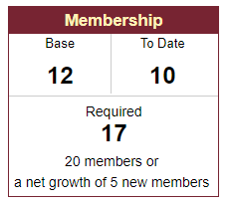
Club Success Plan
STARTING POINT
What is your club’s membership base? 12
Qualifying Requirement

To be considered for recognition, your club must have either 20 members or a net growth of at least five new members as of June 30.
How many members does your club aim to have as of June 30? 17+
How much net growth does your club aim to have as of June 30? 5+
How many of the 10 goals does your club aim to achieve? 5+

MEMBERSHIP: GOALS 7 AND 8

7. Four new, dual, or reinstating members

8. Four more new, dual, or reinstating members

Situation Analysis
Review the current situation in your club regarding membership.
What is the current membership situation? On average, how many new members join your club each year?
Our club has had great growth over the past few years. Every year we get between 10-14 new members, but we also lose 6-8 members every renewal period as well. However, the past six months have not been kind due to COVID. We haven’t any new members join in the last six months.
What are your club’s current obstacles in achieving its membership goals?
Lately it has been having potential members come to the club. Additionally, our VPM doesn’t always respond to the club leads emails that TI sends us.
Additional notes:
Membership Action Plan
Membership Action 1
Describe how your club will gain four new, dual, or reinstating members. Specifically, what action will be taken? Refer to this action as Membership Action 1.
Open houses, membership drives, word of mouth recruiting, social media marketing, networking meetings, community events, Speechcrafts, or educational workshops

Resources for Membership Action 1
What equipment, materials, funding, or people—individuals or committees—can be used to help accomplish Membership Action 1?
We have a club budget of $300 for marketing expenses and materials. The VPM and the Social Reception Committee are responsible for coordinating membership building efforts and programs. We currently have 3 guest packets made but will need more.

Assignment for Membership Action 1
Who is responsible for Membership Action 1? If it is a committee, who are the members of the committee and what is each person’s specific responsibility?
The VPM and the Social Reception Committee are responsible for coordinating membership building efforts and programs. Rodrigo in charge as the VPM, and Luaong and Suzanne are there to assist in spearheading the marketing events the club will perform.

Timetable for Membership Action 1
When will Membership Action 1 begin?
As quickly as possible with timelines spread throughout the year.

When will Membership Action 1 be complete?
When Goals 7&8 are achieved.
How will progress be tracked?
Progress will be tracked through the DCP Dashboards, internal club spreadsheets, and the club roster.

Simulation 2:
- Members get through the education but very slowly. They seem more focused on participation in meetings than completing their path.
- Members give great speeches but focus their speeches on subjects that are not within their path and often do not address their chosen path at all.
- Dual members have a habit of giving awards to their other club(s) instead assigning them here.
- The most active members take up most of the spots for roles and there are not many opportunities for other members to volunteer.
- We have a few long-time members who do not want to work in Pathways.
- Members do not seem excited about achieving awards.
From the Dashboard
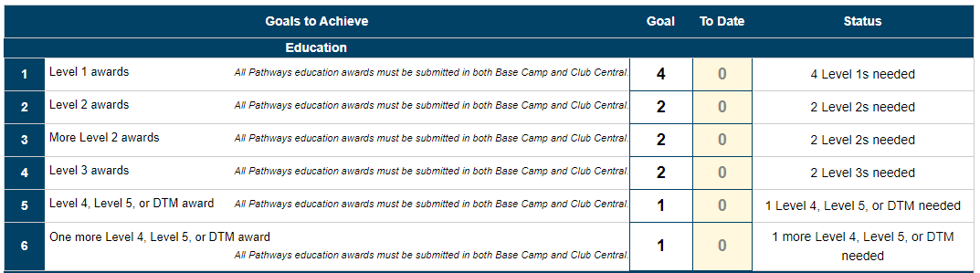
1

1

Club Success Plan
EDUCATION: GOALS 1 THROUGH 6
1. Four Level 1 awards achieved
2. Two Level 2 awards achieved
3. Two more Level 2 awards achieved
4. Two Level 3 awards achieved
5. One Level 4, Level 5, or DTM award achieved
6. One more Level 4, Level 5, or DTM award achieved

Situation Analysis
The purpose of a situation analysis is to assess the state of your club right now. Only once your club identifies where it is can you plan where it is going.

Review the current situation in your club regarding educational goals.

What is the current status of club members in the education program? Who is due to earn an education award?
Wally has earned his level 3, Maki l has earned his Level 2, Tafadzwa has earned his Level 5. Our new members since last July (8 members) are working on their Level 1. Beatriz, Margaret, Yuki, Annie, Leon, Abebe, and Oliver are all working on their Level 2. Ji-yoo, Koh, Kevin, and Alexandre are working on Level 3.

How motivated are members to progress through the education program?
Some members are motivated, however, most need to be prompted by the VPE to sign up for roles.

What obstacles keep members from completing projects?
People have commitments outside of the club that keep them from attending club meetings. Also, some members need additional pushing when managing the larger or longer projects and speeches.

How familiar are members with the education program?
The members receive help from their mentors and the VPE. They should be very comfortable with Base Camp and the education program.

How does your club promote the education program?
Our VPE makes sure the people are signing up to project speeches and every speaking role is filled at the club meeting. Our VPE sends out requests for volunteers 2 weeks in advance.

Additional notes:

Education Action Plan
Identify the actions your club will take to meet the needs identified in the situation analysis.

Education Action 1
Describe how to help members complete Levels 1 and 2 in Pathways. Specifically, what action will be taken? Refer to this action as Education Action 1.
The members receive help from their mentors and the VPE. They are motivated by the VPE to progress along their path and sign up for speaking roles as quickly as possible. Also, the club officers will look for members who are close to finishing a level and motivate them to complete any outstanding requirements.

Resources for Education Action 1
Your club has many resources at its disposal—equipment, materials, people, and potential funding. Committees can be formed to carry out specific goals, especially when certain members are interested or have skills in a given field.
What equipment, materials, funding, or people—individuals or committees—can be used to help accomplish Education Action 1?
The VPE and the Education Committee are in charge of using the Base Camp Manager Dashboards and the club excel sheet to track member’s progress to complete their awards.

Assignment for Education Action 1
In creating a plan, it is important to assign an individual or a group to each action. This way, the responsible party is held accountable for the completion of the assigned action.

Who is responsible for Education Action 1? If it is a committee, who are the members of the committee and what is each person’s specific responsibility?
Leo (VPE) and Emma and Wally (Education Committee Members) are responsible. Leo reviews the club excel sheet and see which members are close to completing their level. Wally is in charge of keeping the excel sheet up to date after every meeting when someone gives a speech. Alessia is in charge of contacting all the members to see where there are in their project and put them in touch with Leo when they are ready for a role.

Timetable for Education Action 1
Determining a timetable allows the Club Executive Committee to track progress toward each goal. Once the timetable is defined, the committee should review it periodically to determine whether your club is on track to complete each action or if adjustments must be made to reach the goal.
When will Education Action 1 begin?
Should be as quickly as possible with timelines spread throughout the year.

When will Education Action 1 be complete?
When the club has achieved its desired number of education goals, and the club officers have submitted all member achievements.

How will progress be tracked?
Progress will be tracked through DCP Dashboards, internal club spreadsheets, and the club roster.

