Marketing

Location of the material: https://www.toastmasters.org/leadership-central/district-leader-tools/training/club-officer-training-materials

5/05/2021
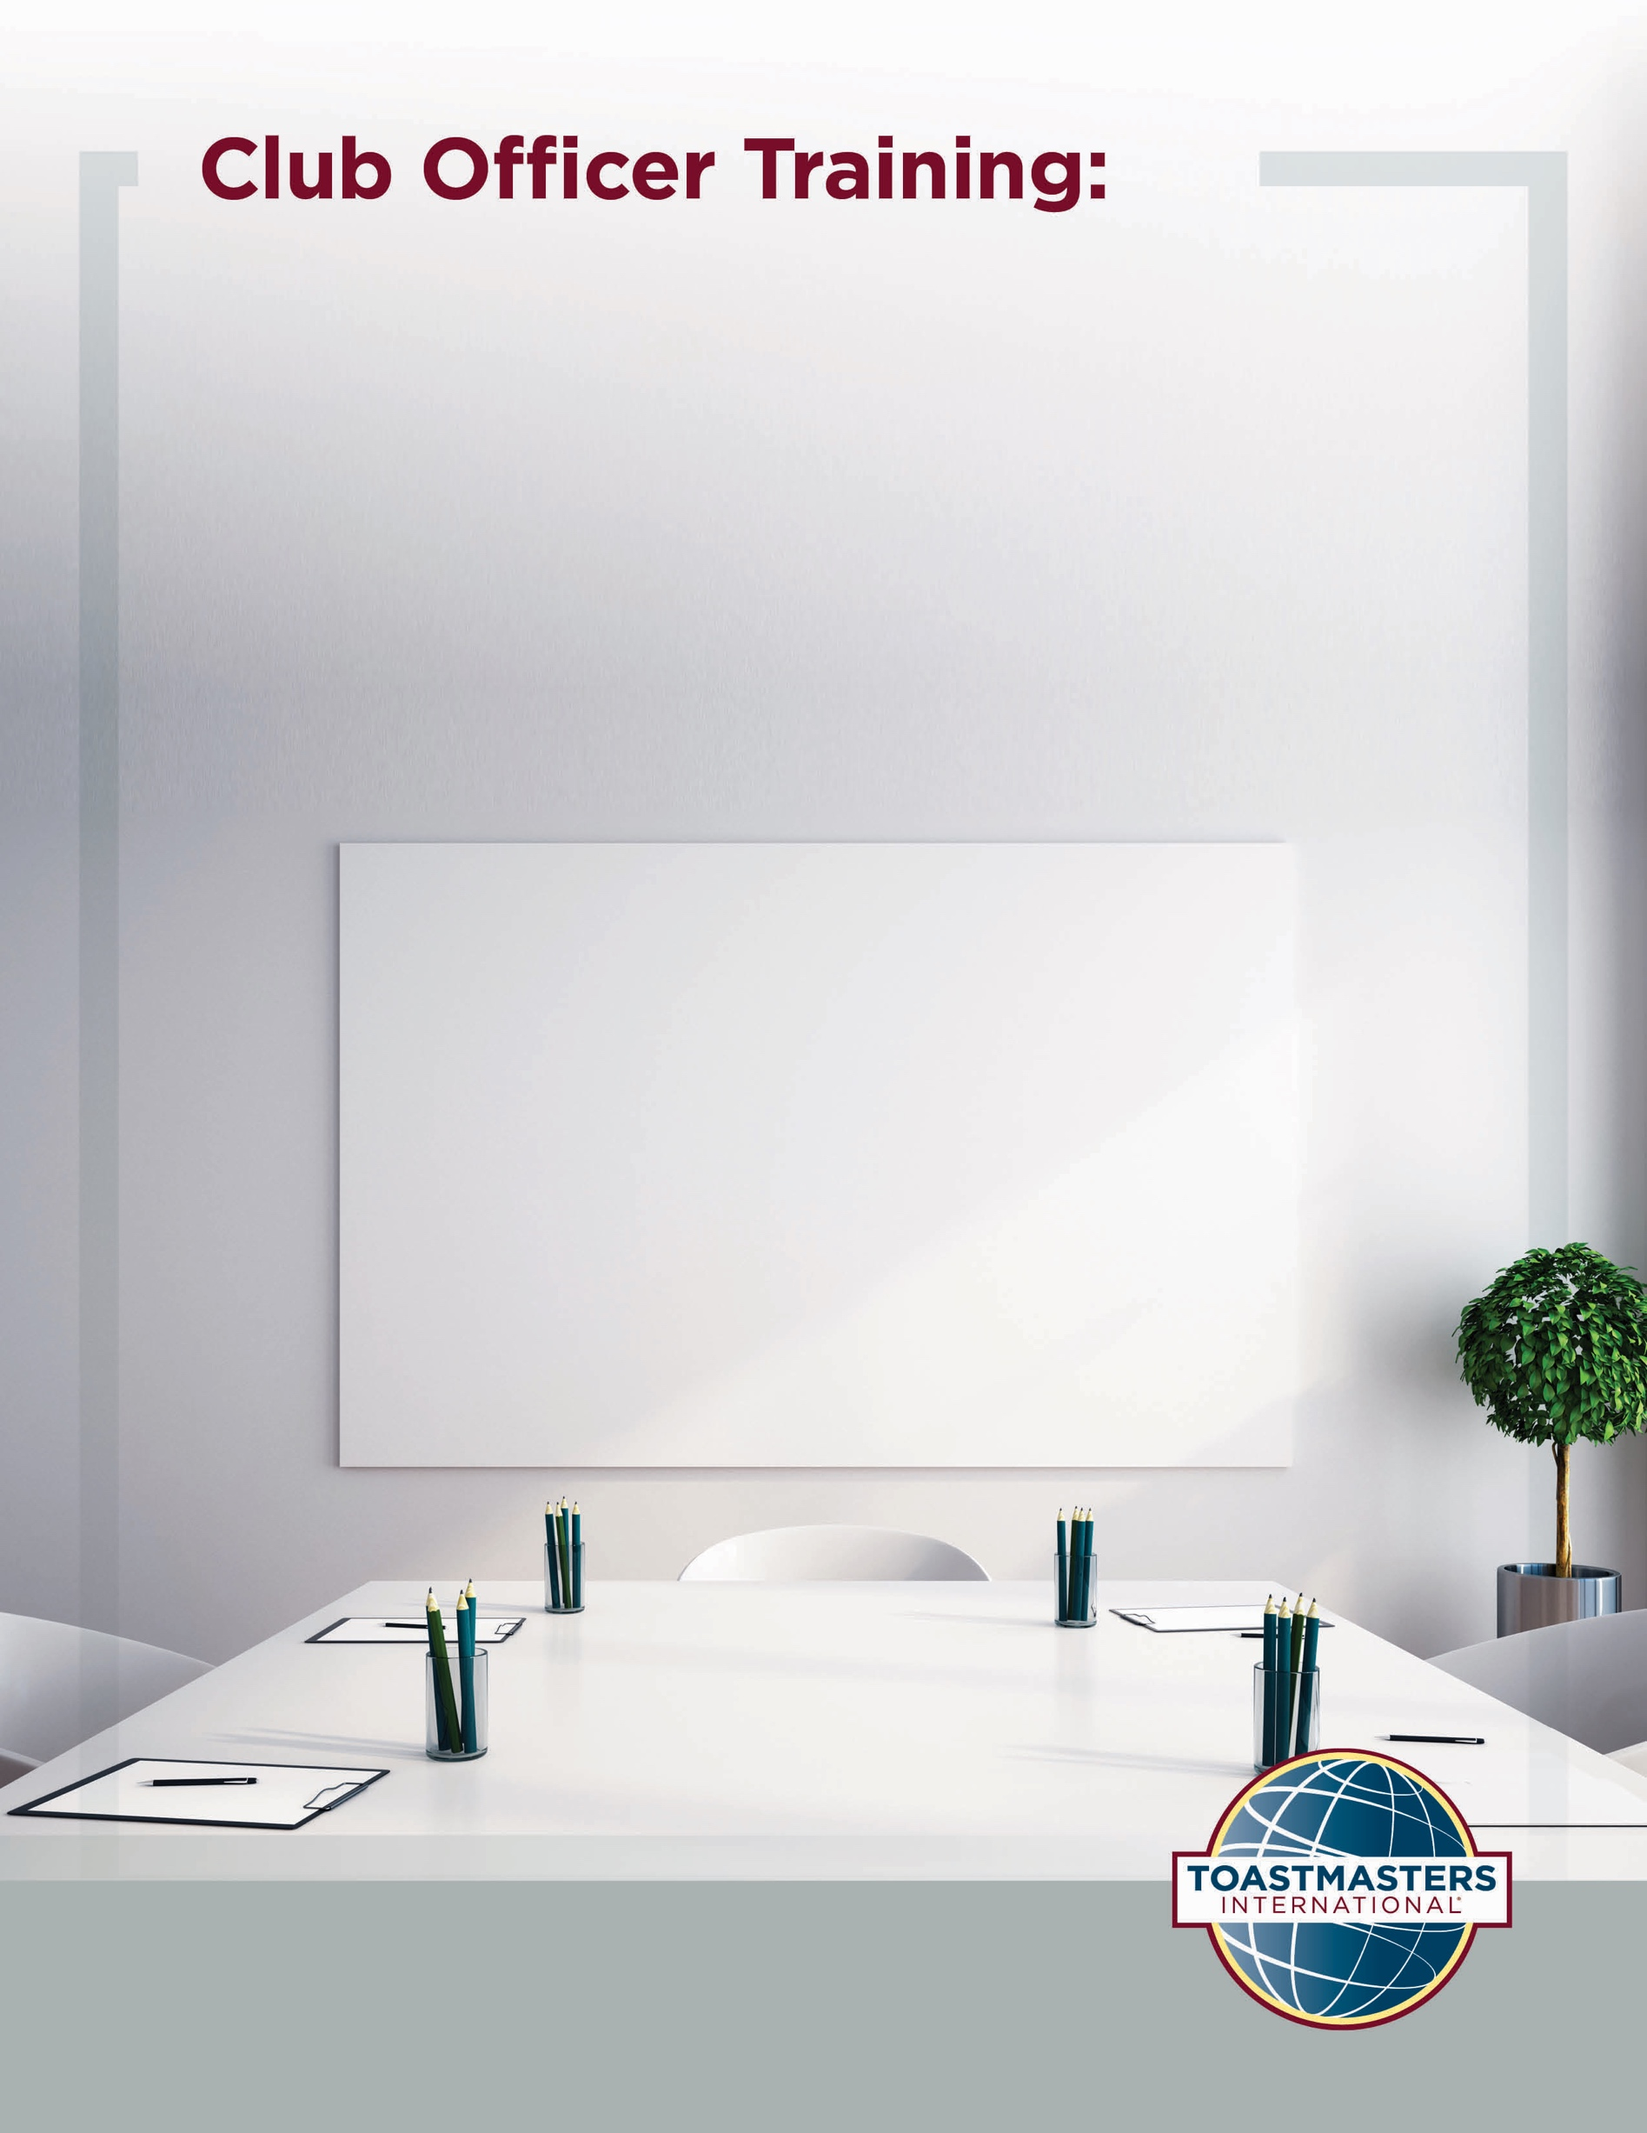

Marketing
Introduction
The purpose of this session is to develop alignment between marketing and prospective member motivations, develop channels for communicating value to prospective members, and identify tools and resources for marketing.
Overview
First, club officers will select a member goal from the 2020 Member Goals report and then outline how their club, directly and indirectly, supports members in achieving that goal. Then, they will select a member persona from the 2020 Member Personas Report. Then, they will identify how they can communicate with prospective members that fit that persona and demonstrate they can help them achieve the primary goal. Finally, they will participate in a discussion on tools and resources that clubs can use for marketing.
In this session, facilitators discuss the following topics:
- Effective Messages
- “Speaking” to Prospective Members
- Tools and Resources
Objectives
After completing this session, club officers will be able to do the following:
- Align marketing with prospective member goals
- Develop strategies for compelling communication with prospective members
- Identify resources available for club marketing
By meeting these objectives, club officers will be able to effectively demonstrate, through marketing, the value of joining their club to prospective members.
Materials
- PowerPoint
- Session Workbook PDF
Time
These session materials are designed for a session that takes approximately 1 hour and 40 minutes. However, you may choose to present this topic over multiple days or in a shorter format, depending on your preference.
- This session divides into two shorter sessions by dividing the topics into standalone sessions. The review slide in each session would become the conclusion slide, and the Pre-work and Session Workbook is adjustable to match the material.
You should add at least one 5-minute break in any session that lasts longer than 60 minutes.
Session Preparation
- Familiarize yourself with pre-work for this session, where club officers will:

  - Review the 2020 Member Goals report excerpt
    - These goals will shape the activities in this session and are critical when creating marketing strategy.

  - Review the 2020 Member Personas excerpt
    - These personas are critical to complete the activities in the session. They are also incredibly useful when selecting who to market to and how.

  - Complete Questions to Consider
    - These questions promote reflection on the Pre-work and their experiences. These add depth to the discussion in each Breakout Room Activity and the Whole Room Discussions.

  - Complete Online Media Audit
    - This activity will bring participants to inspect how and where their club is communicating through social media.
- Review the entire Facilitator Guide
  - You will find Notes to Facilitator throughout the guide which are informational and are not intended to be read aloud to participants. Use them to help formulate your talking points and identify your objectives.
  - This session may be delivered online through a video conference platform or in person. This guide contains tips and notes that you will need to apply to how the material will be delivered.
- Practice with your co-facilitator(s) to ensure smooth transitions throughout the session
- Consider assigning a technical assistant to help with the logistics of the session and (breakout rooms, chat, technical issues, etc.) when delivering this session online
- Review the instructions and materials for each Breakout Room Activity
- There is a slide at the end of this session that gives 5 minutes for participants to fill out a survey. Consider creating a survey to gather feedback on your session or remove the slide.

Pre-Session
START the meeting 30 minutes ahead of time.
START SHARING the slides.
note to facilitator
The following slide should be updated to reflect who will be handling technology support.
SHOW the Pre-Session slide.
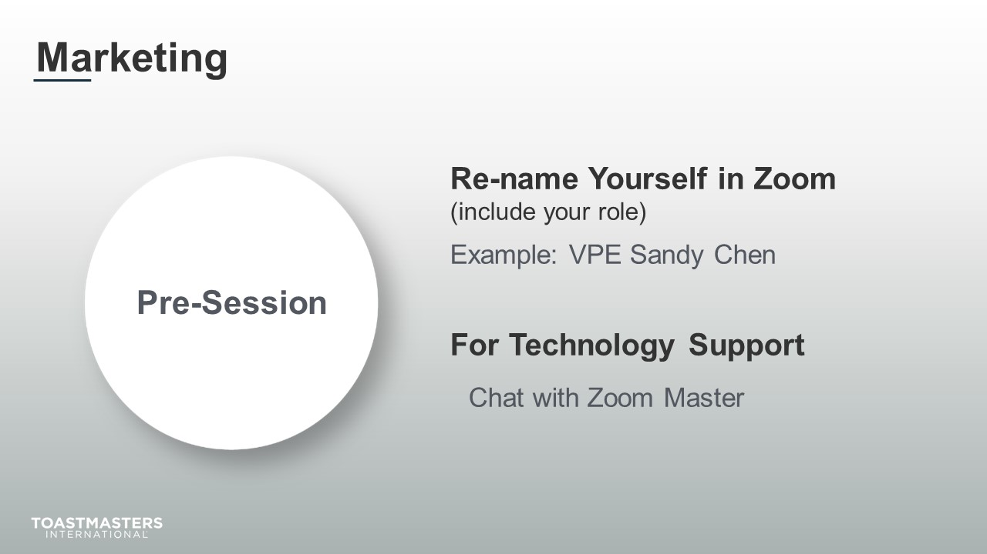
MONITOR chat messages.

Introduction
(5 minutes)
note to facilitator
Use this time to introduce yourself formally to the club officers. A good introduction sets the tone for the session and highlights your experience and credibility. This is an excellent time to share a story related to the topic from your background as a Toastmaster leader.
Throughout this session, it is essential to encourage club officers to use the pre-work insights and apply them to their current interactions.
This session intends to give participants some guidance on making their marketing efforts more effective by targeting their marketing for their best opportunities at growth through the best medium.
The following slide should be updated to reflect where this session falls in your training program.
SHOW the Session Title slide.
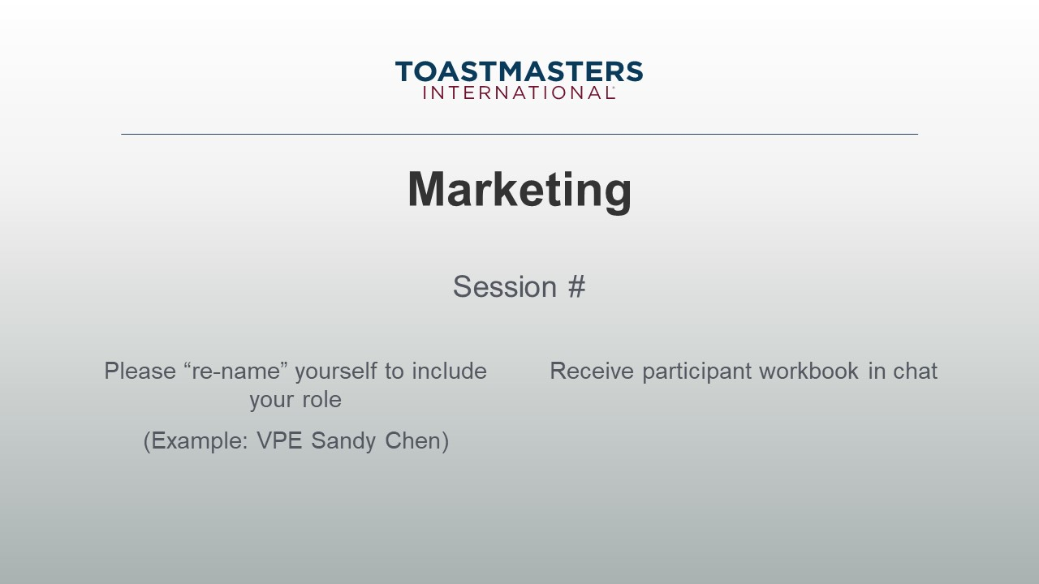
PRESENT
- [insert your talking points here]
SEND session workbook to club officers in chat.

note to facilitator
The following slide sets the context for the rest of the session. We use marketing to refer to communication with a lot of different goals and audiences. For this session, we are using marketing to cover all aspects of what we do to inform, enable, and entice prospective members to be aware of Toastmasters, visit a meeting, and join a club.
SHOW the Whole Room Discussion slide.
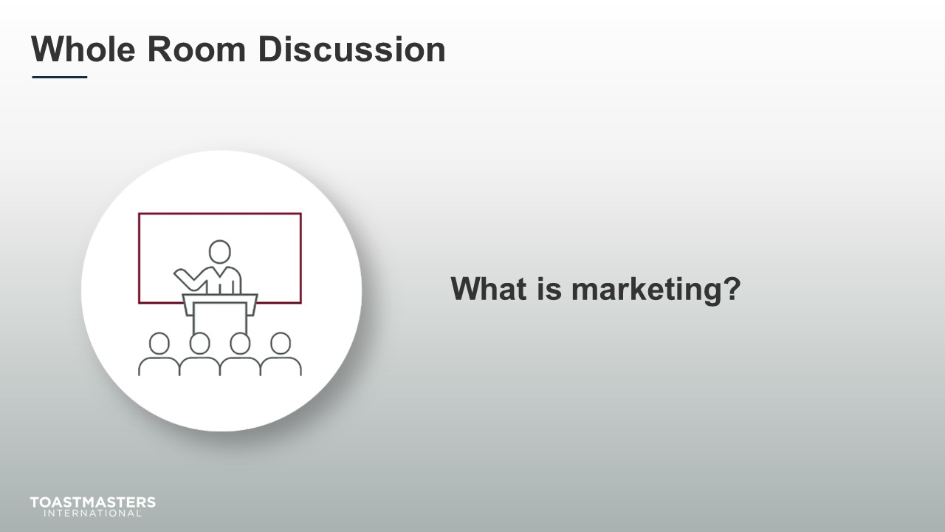
SHOW the Agenda slide.
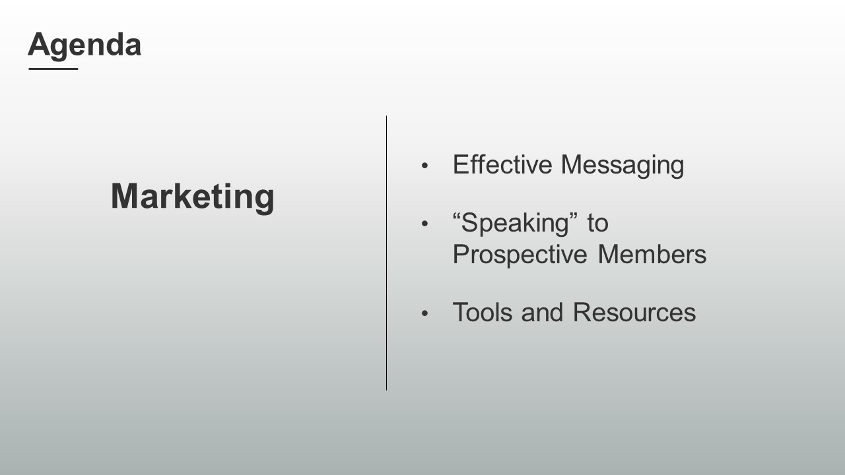
SHOW the Objectives slide.
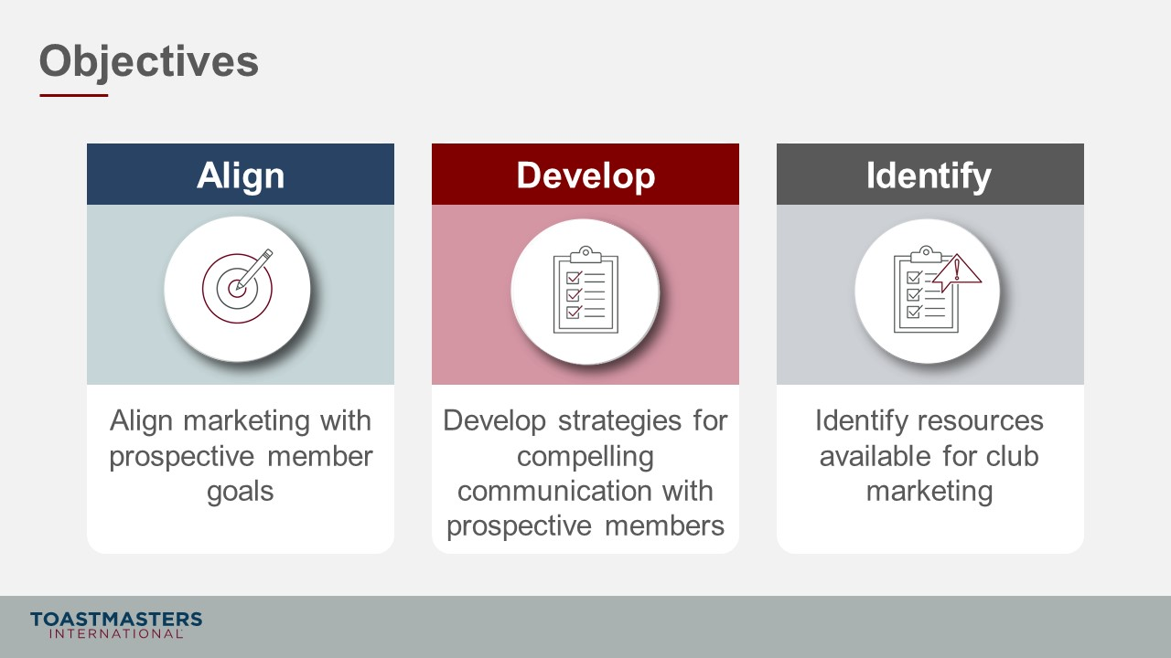

Effective Messaging
(35 minutes)
note to facilitator
Remind participants to open their pre-work so they can refer to concepts and their responses to questions. This reminder will help guide their participation in the discussions they will have in the first section.
This section gets participants to connect what their clubs do to support their members, the content of their marketing, and prospective members' goals.
PREPARE Breakout Rooms by randomly assigning a minimum of three and a maximum of four club officers to each room.
SHOW the Section Title slide.
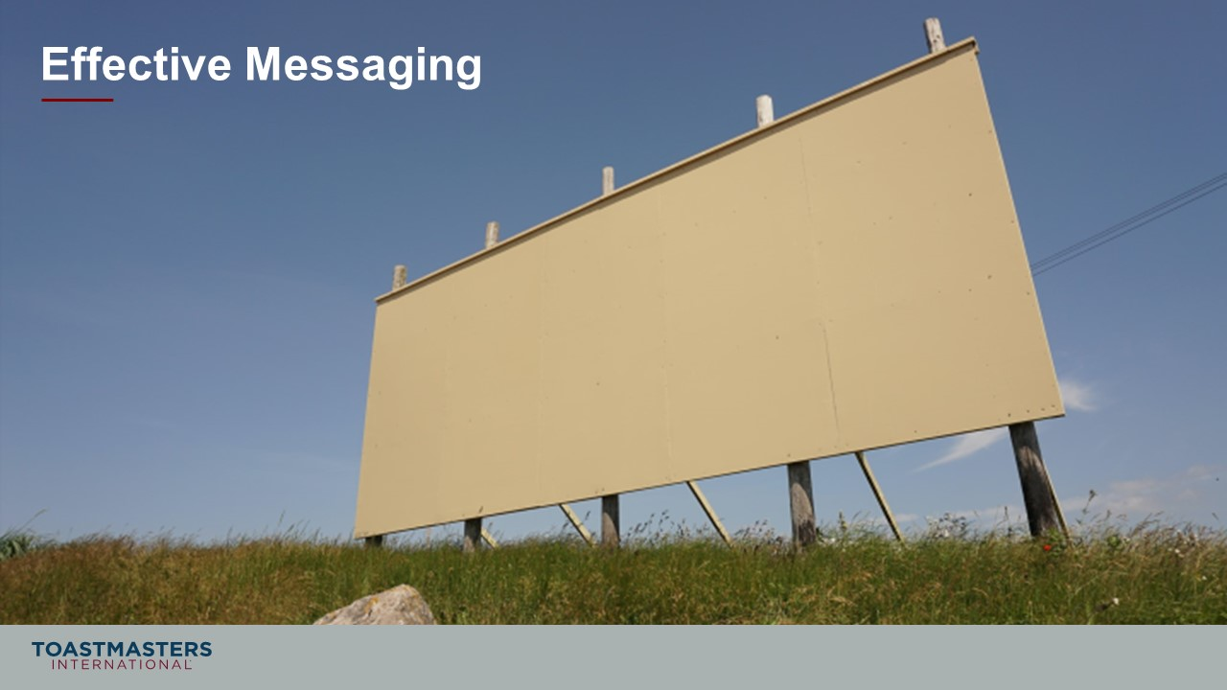
PRESENT
- Successfully recruiting new members is a function of good marketing. It is a critical factor in your club’s success, but membership retention is the most crucial factor if you want your club to thrive.
- Having a solid foundation of engaged members will stimulate member growth because prospective members will see meetings and events that are fun and hear about the great member experience your club offers.
SHOW the Breakout Room Activity slide.
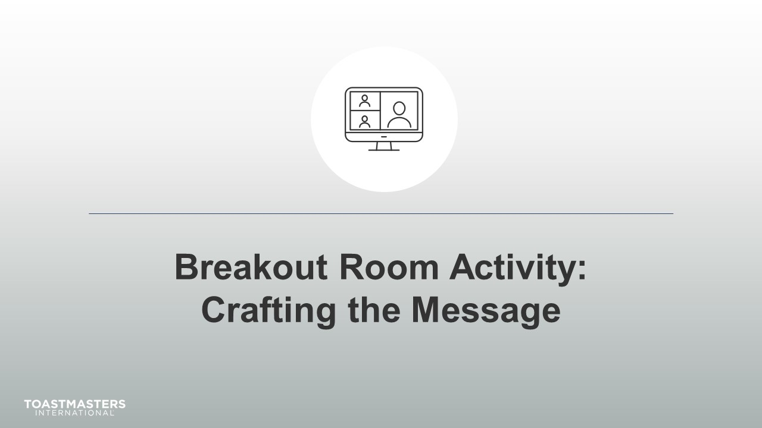
PRESENT
- Through feedback from your members, the 2020 Member Goals report your reviewed in your pre-work, and your own experience, we have a clear picture of what members are striving to accomplish.
- This activity will help in connecting what your club does and member goals.

Note To Facilitator
The following slide's purpose is to remind club officers about a few of the tools available to them in virtual Breakout Rooms. You may need to adjust these according to the platform that you are using to deliver this material. Plan to spend less than one minute on the next slide.
Ideally, you would like to see a minimum of three and a maximum of four club officers per group for this activity. You will be keeping the same groups for the next activity. That activity has a presentation at the end of the activity. You may have to adjust the number per group based on the number of participants because you will be asking them to share highlights of their results. Adjust group sizes and speaking time for each spokesperson to keep your session within the schedule parameters.

SHOW the Breakout Room Tips slide.
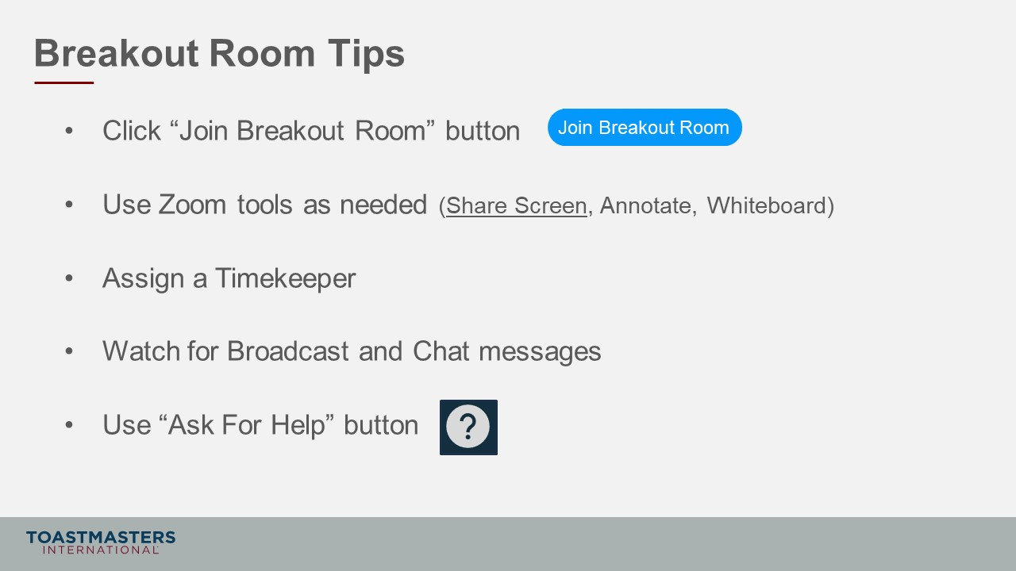
SHOW the Instructions slide.
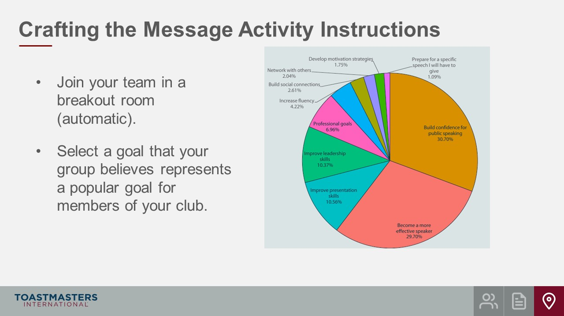

SHOW the Instructions slide.
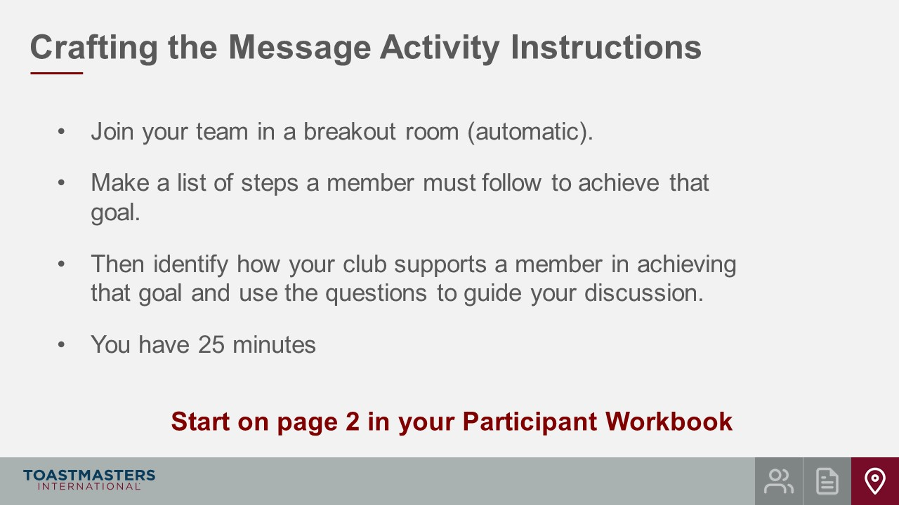
PRESENT
- We will send a two-minute warning before the end of the activity.
- I will be available to answer questions or provide assistance.
OPEN Breakout Rooms for activity (same groups as the previous activity).
MONITOR requests for assistance from Breakout Rooms.
VISIT Breakout Rooms to offer assistance and guidance, as needed.
SEND Broadcast after 15 minutes has elapsed: You have 10 more minutes.
SEND Broadcast after 20 minutes has elapsed: You have 5 more minutes.
SEND Broadcast after 23 minutes has elapsed: In approximately 2 minutes, you will be asked to return to the main session room.
CLOSE Breakout Rooms after 25 minutes.
SHOW the Whole Room Discussion slide.
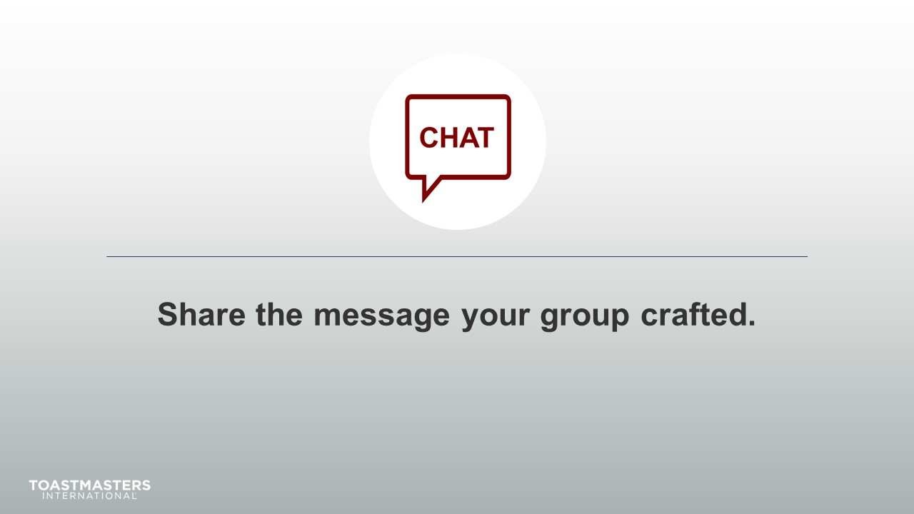
MONITOR chat responses.
DISCUSS responses from club officers for up to 5 minutes.
SHOW the Review slide.
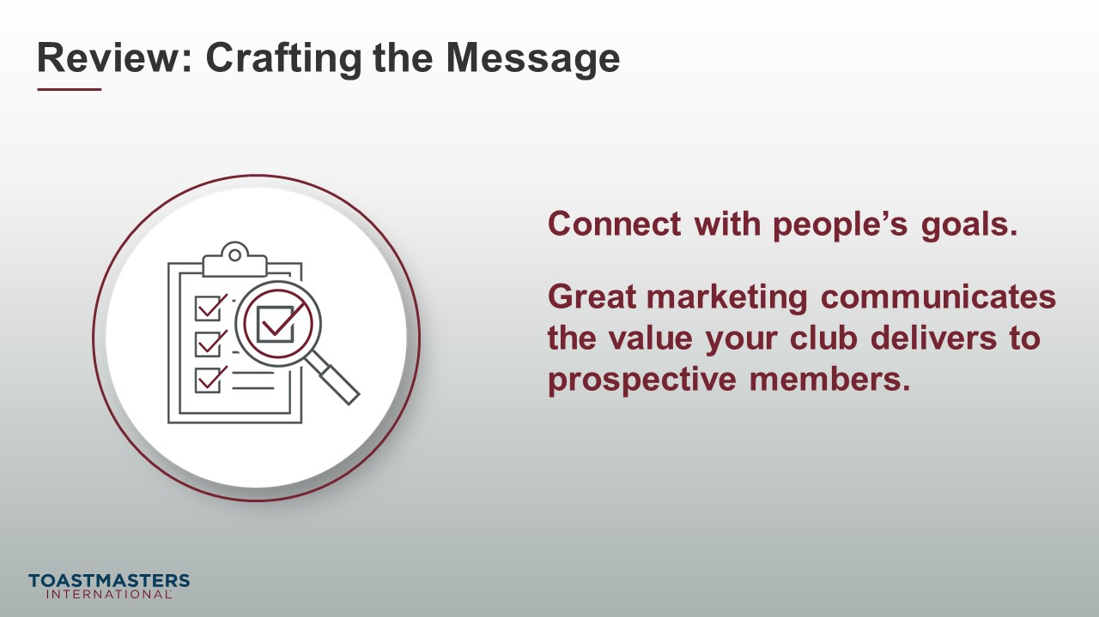
PRESENT
- In your breakout rooms, you demonstrated how your club supports a member in achieving a goal. Your marketing needs to show that you understand what problems or needs a prospective member has and give them confidence that your club can give them the resources and support to achieve their goals.

“Speaking” to Prospective Members
(35 minutes)
note to facilitator
The previous section identified a prospective member goal and how their club supports their members in achieving that goal. This section challenges participants to determine who would be most receptive to their message (and most likely to see the value in joining their club) and identify where and how to communicate that message.
Breakout Rooms should be the same as the previous activity.
SHOW the Section Title slide.
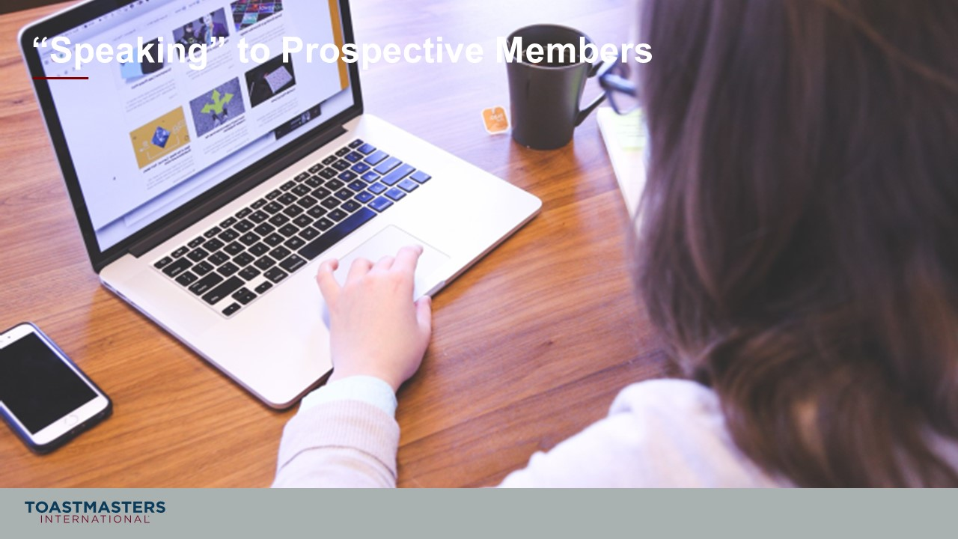
PRESENT
- Now that we have a message that connects what a club does well with a popular goal of a prospective member, we now must deliver that message with impact to the right prospective members.
SHOW the Breakout Room Activity slide.
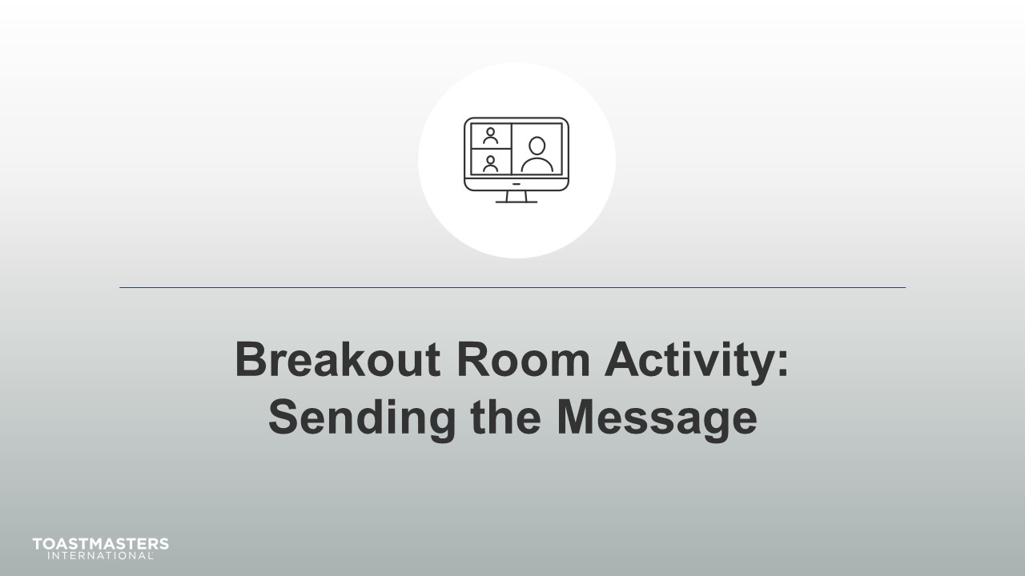
Note To Facilitator
The following slide contains helpful tips for participants to use in Zoom Breakout rooms. You should replace the text on this slide with directions if you are using a different online platform. If you are presenting this session, live you should remove this slide from your deck.
SHOW the Breakout Room Tips slide.
note to facilitator
Keep the groups the same as the previous activity.
SHOW the Present slide.
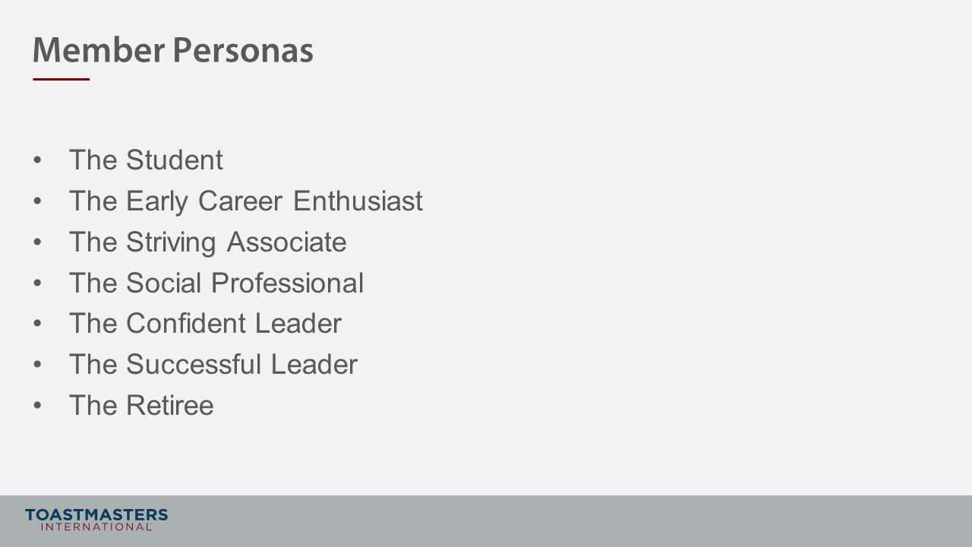
PRESENT
- You will remember these from your pre-work. You will be choosing one of these personas for this activity.
- These will also be included at the end of your session workbook for you to refer to during your collaboration.
SHOW the Instructions slide.
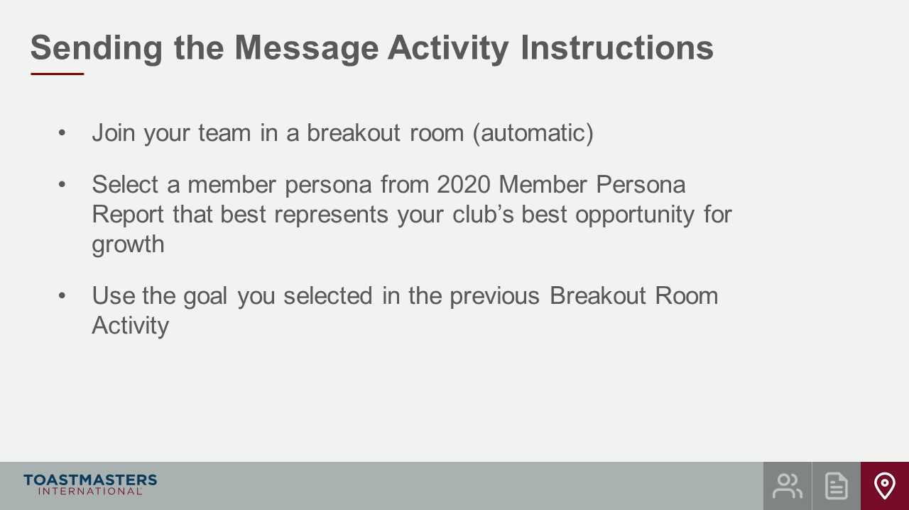
SHOW the Instructions slide.
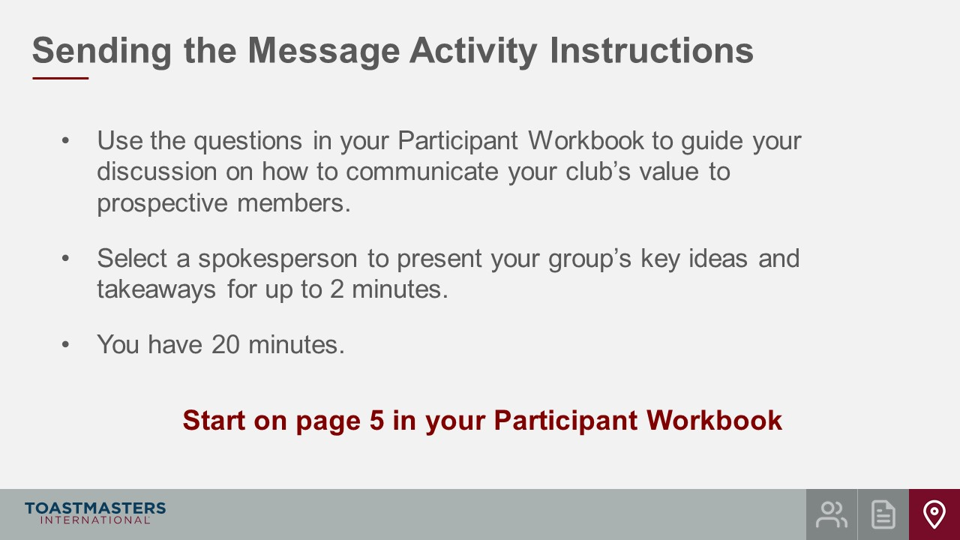
PRESENT
- We will send a two-minute warning before the end of each scenario.
- I will be available to answer questions or provide assistance.
OPEN Breakout Rooms for activity (ideally 3-4 club officers per room).
MONITOR requests for assistance from Breakout Rooms.
VISIT Breakout Rooms to offer assistance and guidance, as needed.
SEND Broadcast after 10 minutes has elapsed: You have 10 more minutes.
SEND Broadcast after 15 minutes has elapsed: You have 5 more minutes.
SEND Broadcast after 18 minutes has elapsed: In approximately 2 minutes, you will be asked to return to the main session room.
CLOSE Breakout Rooms after 20 minutes.
SHOW the Whole Room Discussion slide.
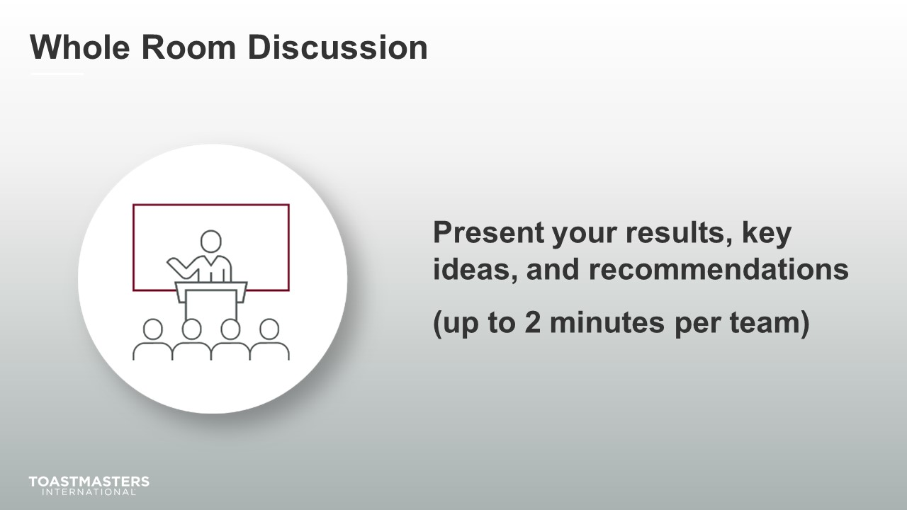
SHOW the Review slide.
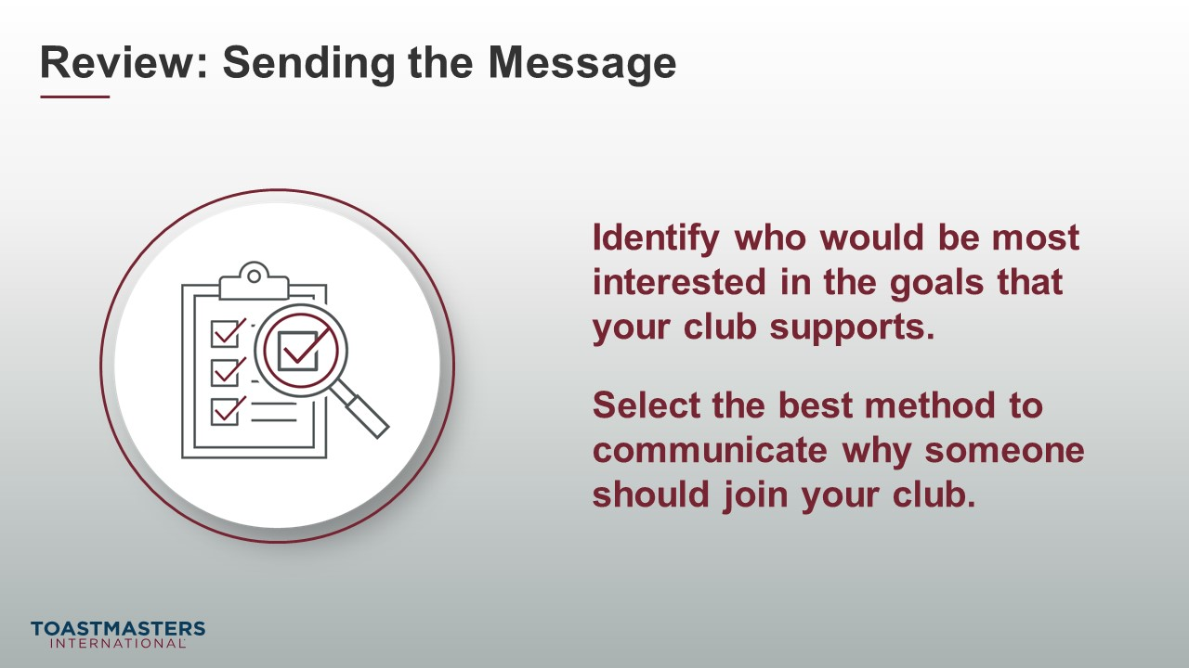

Tools and Resources
(10 minutes)
note to facilitator
In this section, you will lead a discussion on what tools and resources are available to club officers from World Headquarters and your District. Part of the discussion should allow for participants to share what tools and resources they use that are effective or to ask questions of each other. You can find resources created by World Headquarters in the Club Marketing Guide. Coordinate with your District for resources they provide.
SHOW the Section Title slide.
PRESENT
- Luckily there are a lot of tools and resources for marketing your club.
SHOW the Whole Room Discussion slide.
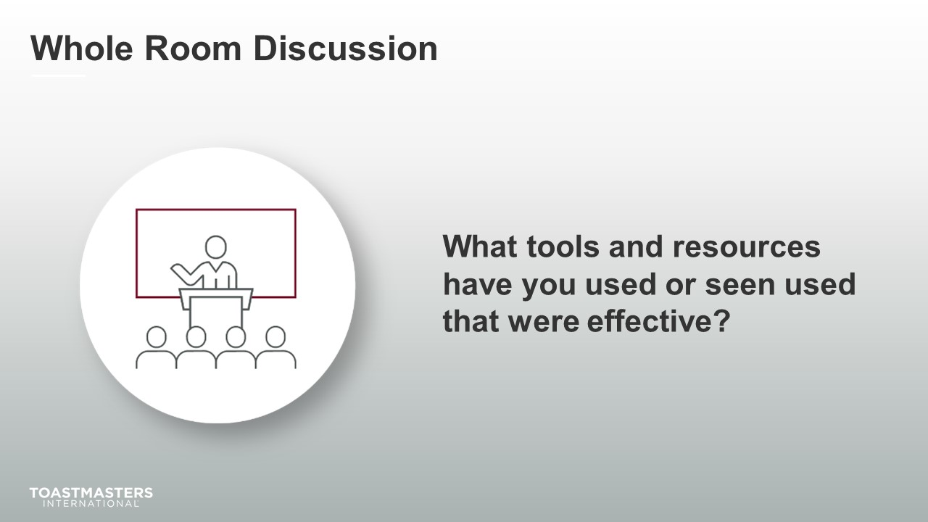
SHOW the Review slide.
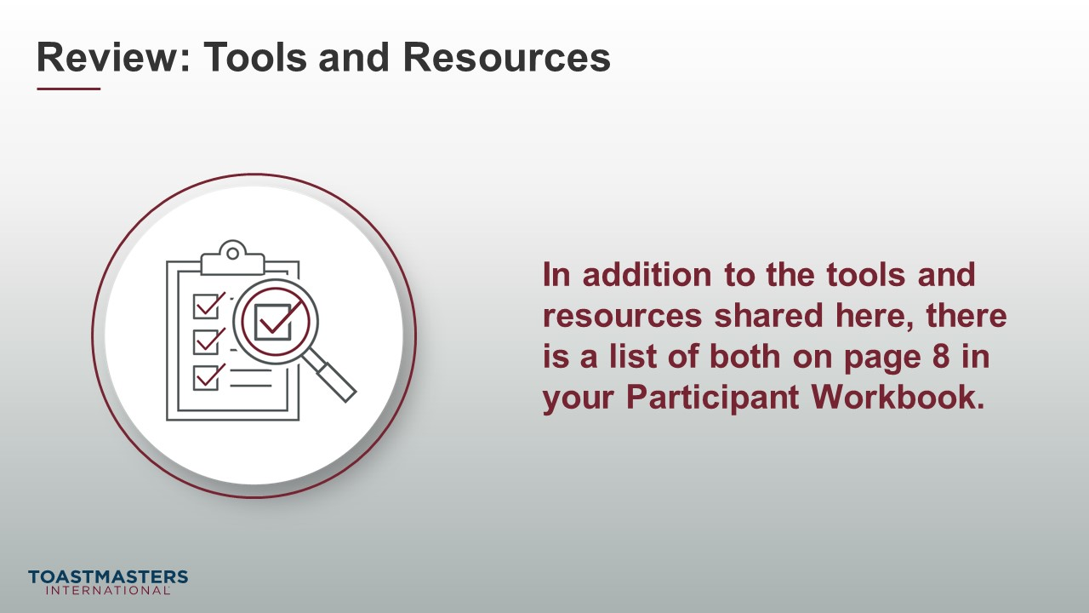

Conclusion
(10 minutes)
SHOW the Conclusion slide.
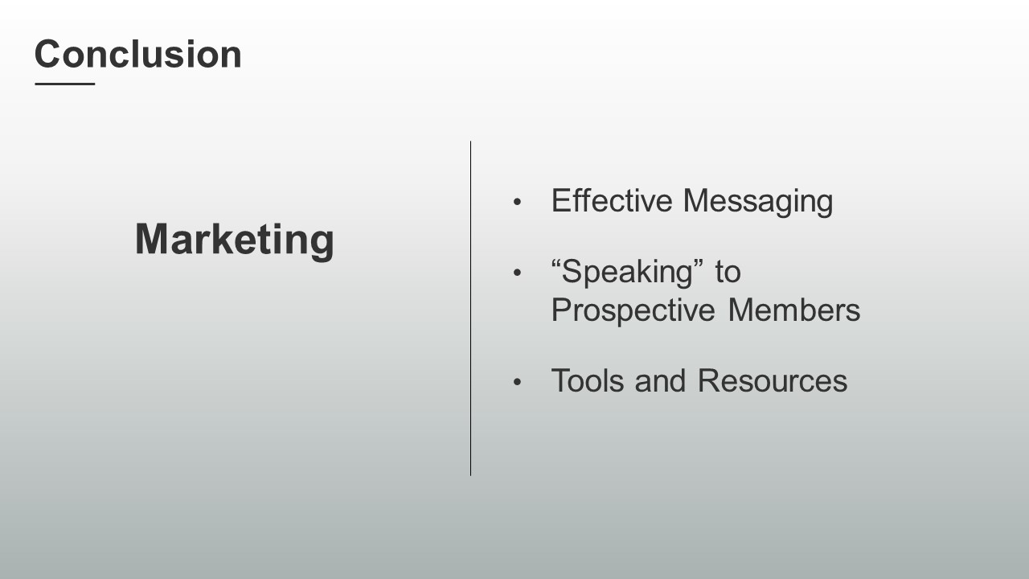
PRESENT
- There are resources in your Session Workbook on page 8 and a reflection activity on page 9 for you to complete on your own.
SHOW the Chat slide.
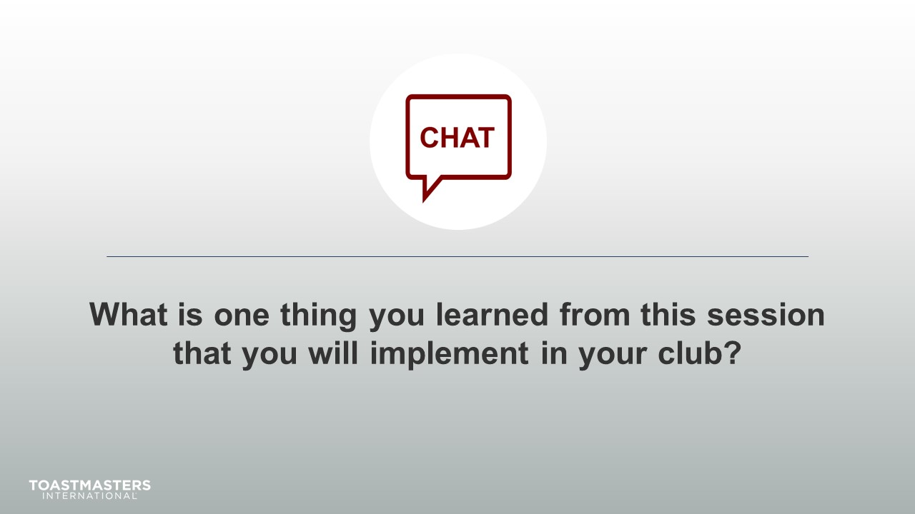
MONITOR chat responses.
DISCUSS responses for up to two minutes.
note to facilitator
The following two slides should be edited to fit your requirements.
SHOW the Session Assessment slide.
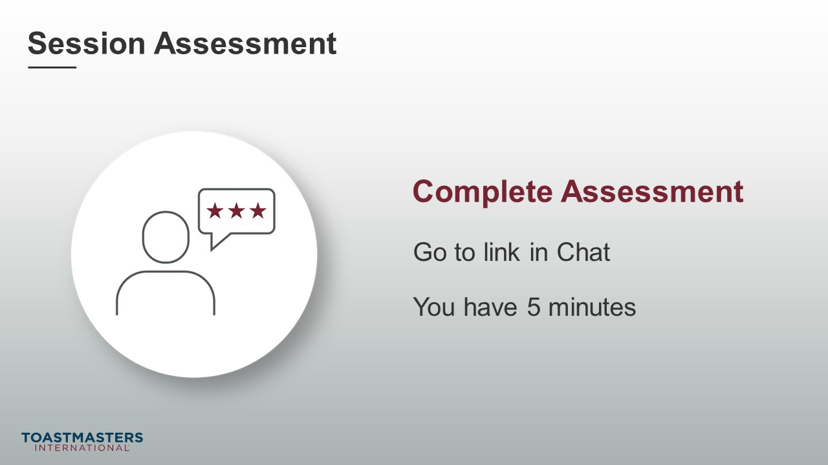
SEND chat message to everyone: [insert link to assessment]
SHOW the What is Next slide.
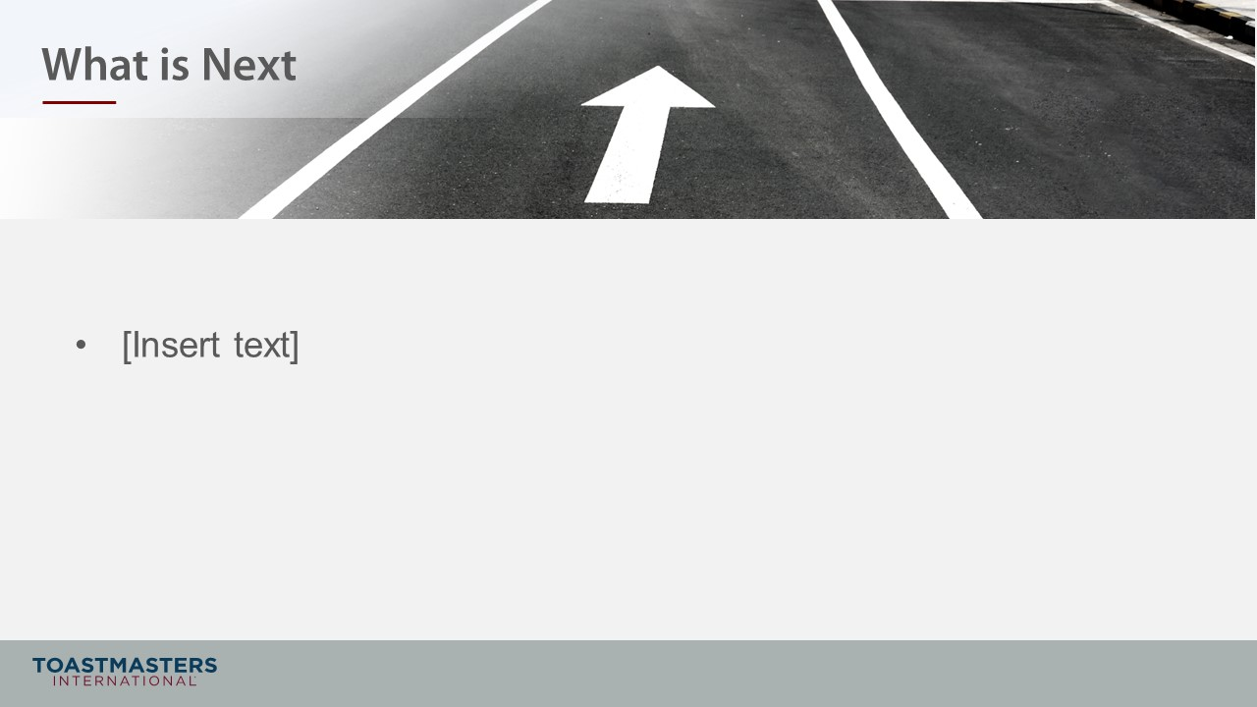
PRESENT
- [insert your talking points here]

