Member Engagement and Retention

Location of the material: https://www.toastmasters.org/leadership-central/district-leader-tools/training/club-officer-training-materials

5/05/2021

Member Engagement and Retention
Introduction
Having an engaged membership leads to higher retention. High engagement, in turn, drives member achievement, which leads to club growth. The purpose of this session is to train club officers in developing strategies for retaining members and re-engaging past members.
Overview
First, club officers will connect what their club does well to member goals. Then, they will create a plan to re-engage past members. Finally, they will share key takeaways from their plan with the rest of the group.
In this session, facilitators discuss the following topics:
- Retaining Members
- Re-engaging Past Members
Objectives
After completing this session, club officers will be able to do the following:
- Develop strategies to retain members
- Develop strategies to re-engage past members
By meeting these objectives, you will address member retention and plan to re-engage past members to improve your members’ experience.
Materials
- PowerPoint
- Session Workbook PDF
Time
These session materials are designed for a session that takes approximately 1 hour and 35 minutes. However, you may choose to present this topic over multiple days or in a shorter format, depending on your preference.
This guide includes suggestions about how to alter the content to suit your needs below:
- This session divides into two shorter sessions by dividing the topics into standalone sessions. The review slide in each session would become the conclusion slide, and the Pre-work and Session Workbook is adjustable to match the material.
- Check the Member Engagement and Retention Session Outline for some options of how you might break this session up.

You should add at least one 5-minute break in any session that lasts longer than 60 minutes.
Session Preparation
- Familiarize yourself with pre-work for this session, where club officers will:
  - Watch Dashboards for Club Officers (Video)
Members who do not have access to YouTube can watch the video by clicking this link.
    - This video will give participants information to reference when reflecting on the Club Success Plan's different sections. Participants will need to access their dashboard to review their renewal numbers.
2020 Member Goals report

  - Review the 2020 Member Goals report
    - This report will be used in a breakout room activity and is critical for forming strategy for member engagement and retention.

  - Complete Questions to Consider
    - These questions promote reflection on the pre-work and their experiences. These add depth to the discussion in each Breakout Room Activity and the Whole Room Discussions.

  - Complete Our Member’s Experience
    - The table divides the member experience into four categories. These categories help participants reflect on what their club does practically to impact the member experience.
- Review the entire Facilitator Guide
  - You will find Notes to Facilitator throughout the guide, which are informational and are not intended to be read aloud to participants. Use them to help formulate your talking points and identify your objectives.
  - This session may be delivered online through a video conference platform or in person. This guide contains tips and notes that you will need to apply to how the material will be delivered.
  - Throughout this guide, you will find highlighted yellow directions. These are callouts to what actions need to be taken when delivering this session online.
  - If you plan to conduct this session in person, some of the instructions or slides will no longer be applicable. Please review the materials carefully and update them to best suit the needs of your session format.
- Practice with your co-facilitator(s) to ensure smooth transitions throughout the session, if applicable.
- Consider assigning a technical assistant to help with the logistics of the session and (breakout rooms, chat, technical issues, etc.) when delivering this session online.
- Review the instructions and materials for each Breakout Room Activity
- There is a slide at the end of this session that gives five minutes for participants to fill out a survey. Consider creating a survey to gather feedback on your session or remove the slide.

Pre-Session
START the meeting 30 minutes ahead of time.
START SHARING the slides.
note to facilitator
The following slide should be updated to reflect who will be handling technical support.
SHOW the Pre-Session slide.
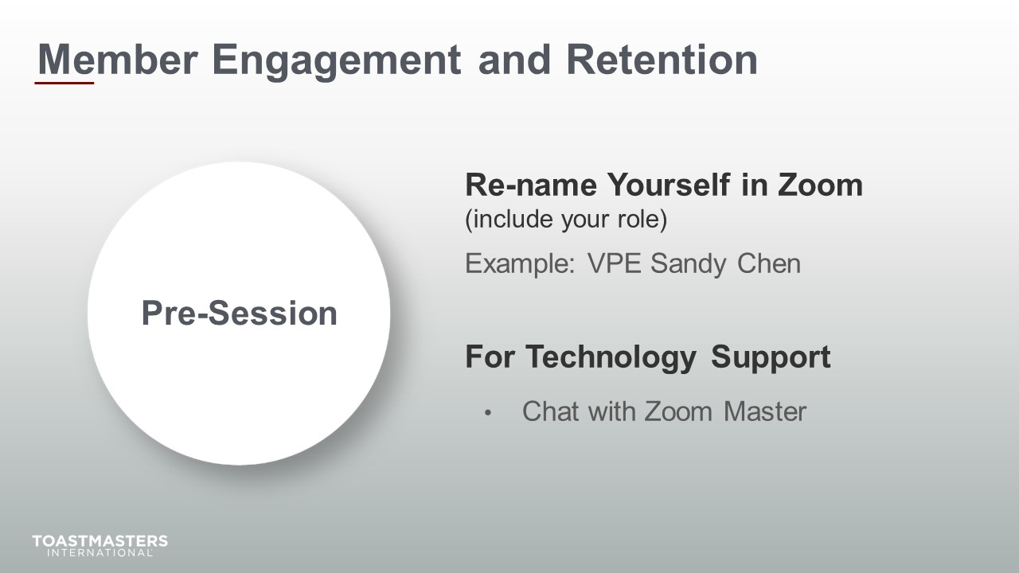
MONITOR Chat messages.

Introduction
(5 minutes)
note to facilitator
Use this time to introduce yourself formally to the club officers. A good introduction sets the tone for the session and highlights your experience and credibility. This is an excellent time to share a story related to the topic from your background as a Toastmaster leader.
Throughout this session, it is essential to encourage club officers to use the pre-work insights and apply them to their current interactions.
This session intends to get club officers to look critically at what their club does to retain members and get past members involved in their club.
The following slide should be updated to reflect where this session falls in your training program.
SHOW the Session Title slide.
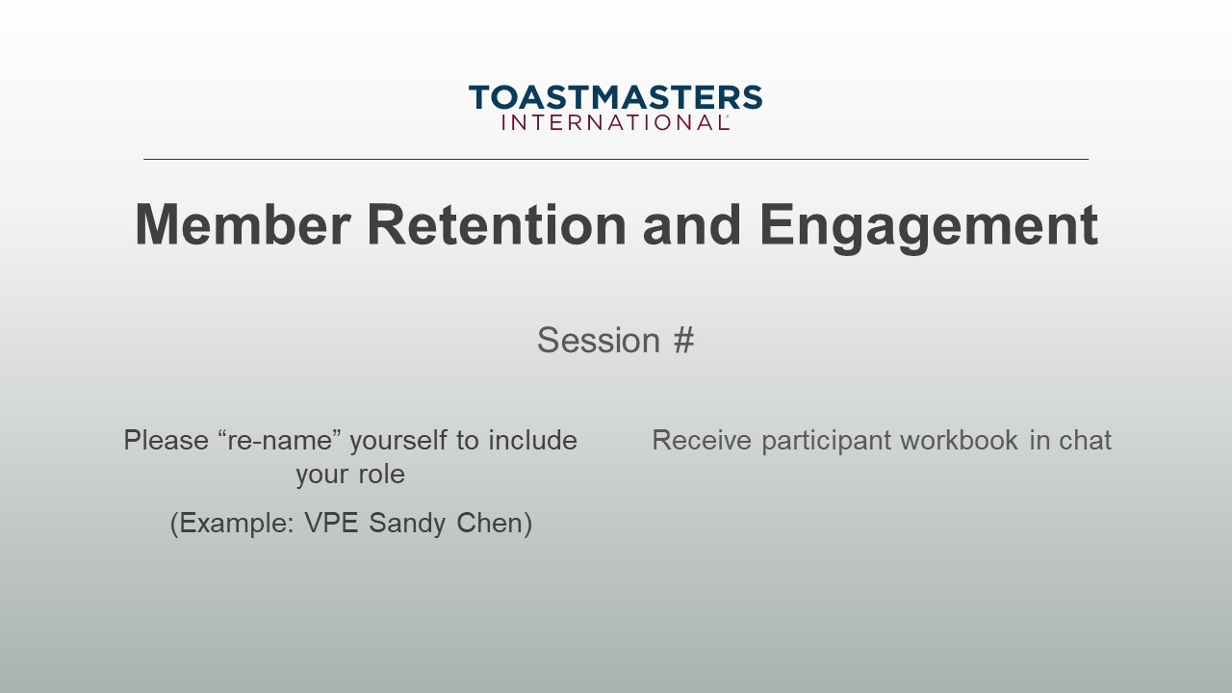
PRESENT
- [insert your talking points here]
SEND session workbook to club officers in chat.

SHOW the Agenda slide.
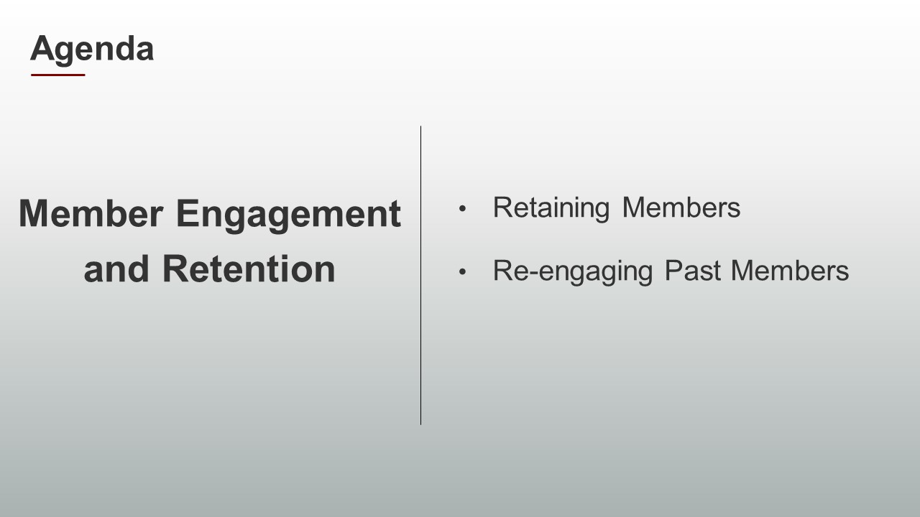
SHOW the Objectives slide.
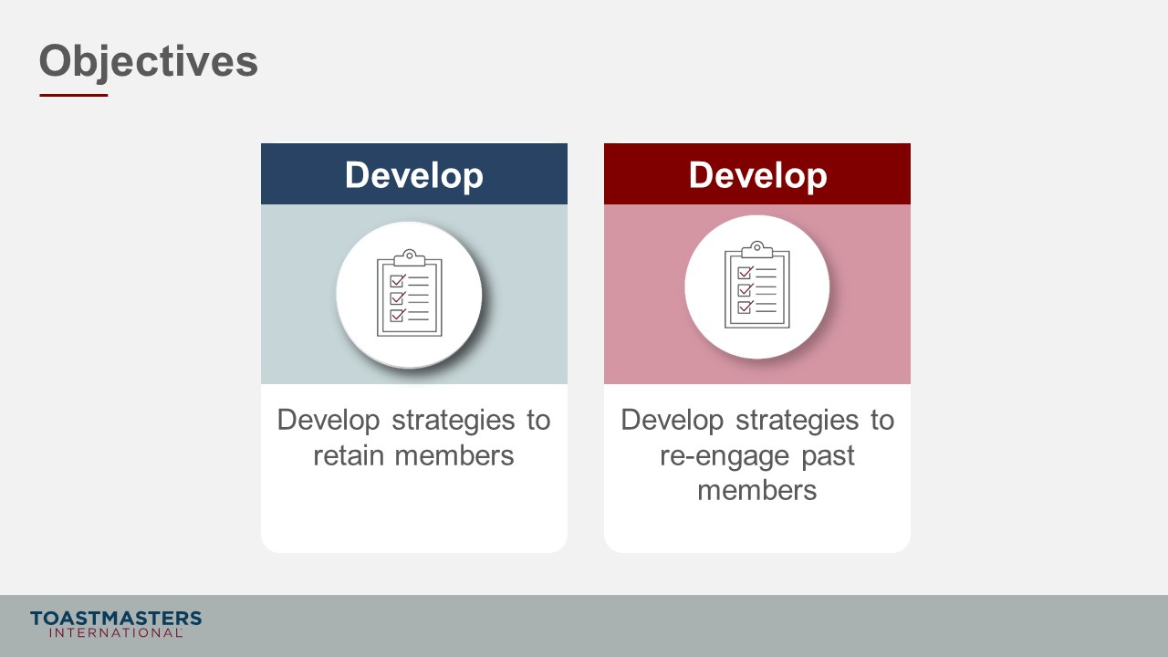

Retaining Members
(40 minutes)
note to facilitator
Remind participants to open their pre-work so they can refer to concepts and their responses to questions. This reminder will help guide their participation in the discussions they will have in the first section.
This section aims to emphasize the importance of member retention and give them participants tools and resources on how to improve their club’s member retention.
PREPARE Breakout Rooms by randomly assigning a minimum of three and a maximum of four club officers to each room.
SHOW the Section Title slide.
PRESENT
- Successfully recruiting new members is a function of good marketing. It is a critical factor in your club’s success, but membership retention is the most crucial factor if you want your club to thrive.
- Having a solid foundation of engaged members will stimulate member growth because prospective members will see meetings and events that are fun and hear about the great member experience your club offers.
note to facilitator
The next two slides are the setup for connecting member goals to member retention necessary for the Breakout Room Activity.
SHOW the Whole Group Discussion slide.
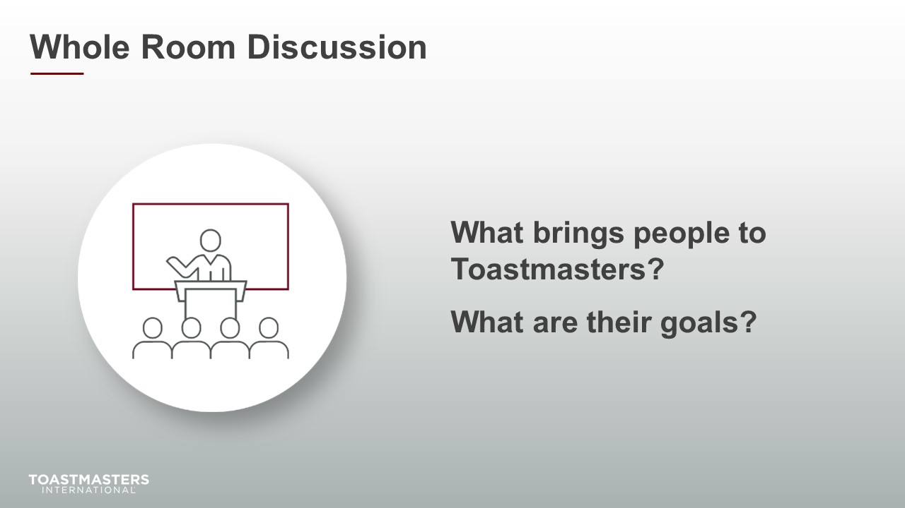
DISCUSS for up to one minute.
SHOW the Present slide.
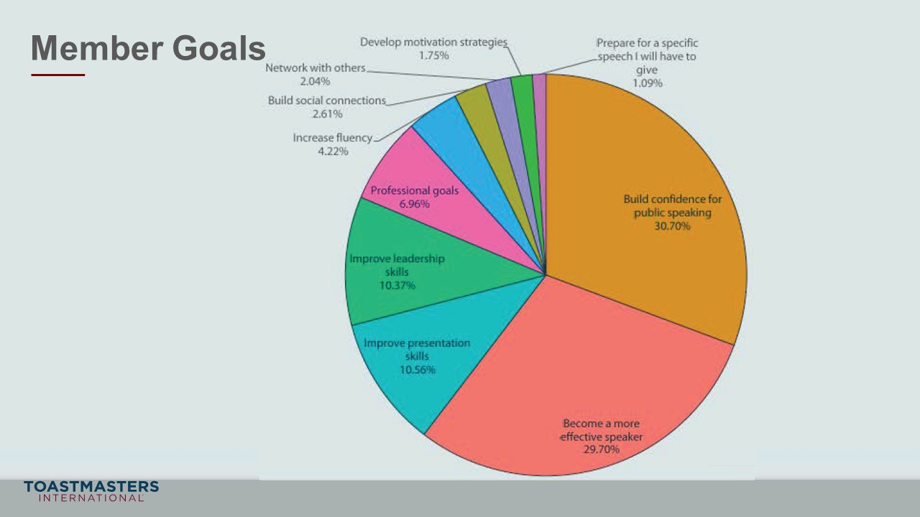
PRESENT
- This pie chart is from the 2020 Member Goals report from World Headquarters that you reviewed in your pre-work.
- We are going to be using these goals in our Breakout Room Activity.

note to facilitator
The following Breakout Room Activity provides participants a framework to think and talk about how their club practically supports member achievement. With support, members will recognize their progress and engage more with their club and the program.
SHOW the Breakout Room Activity slide.
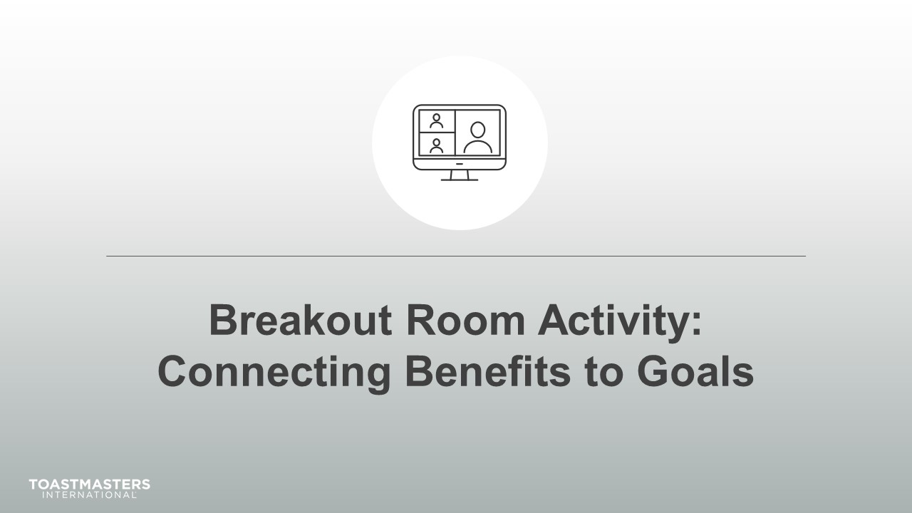
PRESENT
- Through feedback from our members, the 2020 Member Goals report, and our own experience, we have a clear picture of what members are striving to accomplish.
- This activity will help in connecting what your club does and member goals.
note to facilitator
The following slide's purpose is to remind club officers about a few of the tools available to them in virtual Breakout Rooms. You may need to adjust these according to the platform that you are using to deliver this material. Plan to spend less than one minute on the next slide.
Ideally, you would like to see a minimum of three and a maximum of four club officers per group for this activity. You may have to adjust the number per group based on the number of participants because you will be asking them to share highlights of their results. Adjust group sizes and speaking time for each spokesperson to keep your session within the schedule parameters.
SHOW the Breakout Room Tips slide.
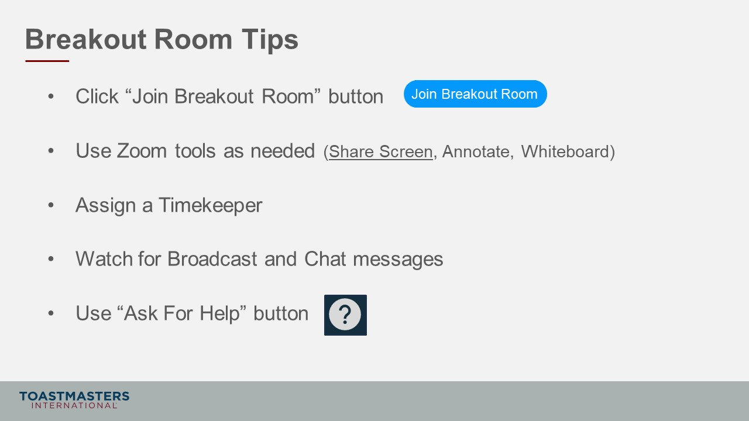
SHOW the Instructions slide.
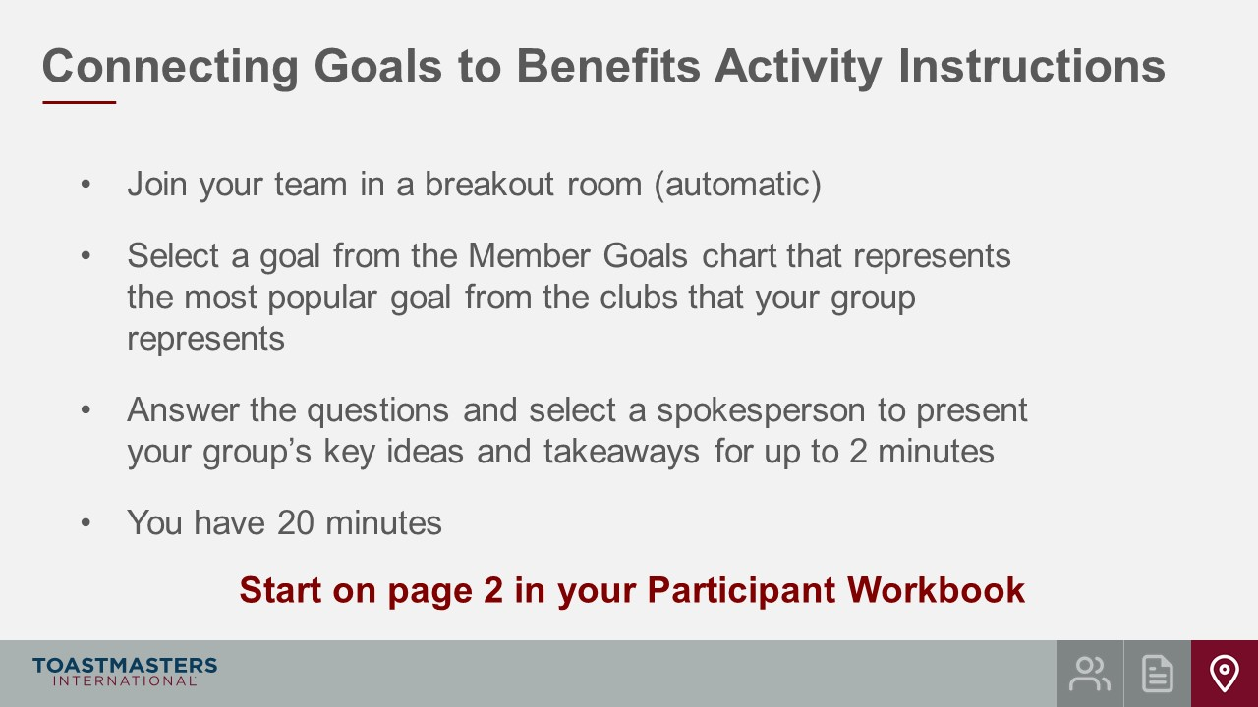
PRESENT
- We will send a two-minute warning before the end of the activity.
- I will be available to answer questions or provide assistance.
note to facilitator
The instructions below are prompts for virtual Breakout Rooms but can be adjusted to deliver in an in-person session.
OPEN Breakout Rooms for activity (3-4 club officers per room).
MONITOR requests for assistance from Breakout Rooms.
VISIT Breakout Rooms to offer assistance and guidance, as needed.
SEND Broadcast after 10 minutes has elapsed: You have 10 more minutes.
SEND Broadcast after 15 minutes has elapsed: You have 5 more minutes.
SEND Broadcast after 18 minutes has elapsed: In approximately 2 minutes, you will be asked to return to the main session room.
CLOSE Breakout Rooms after 20 minutes.
SHOW the Whole Room Discussion slide.
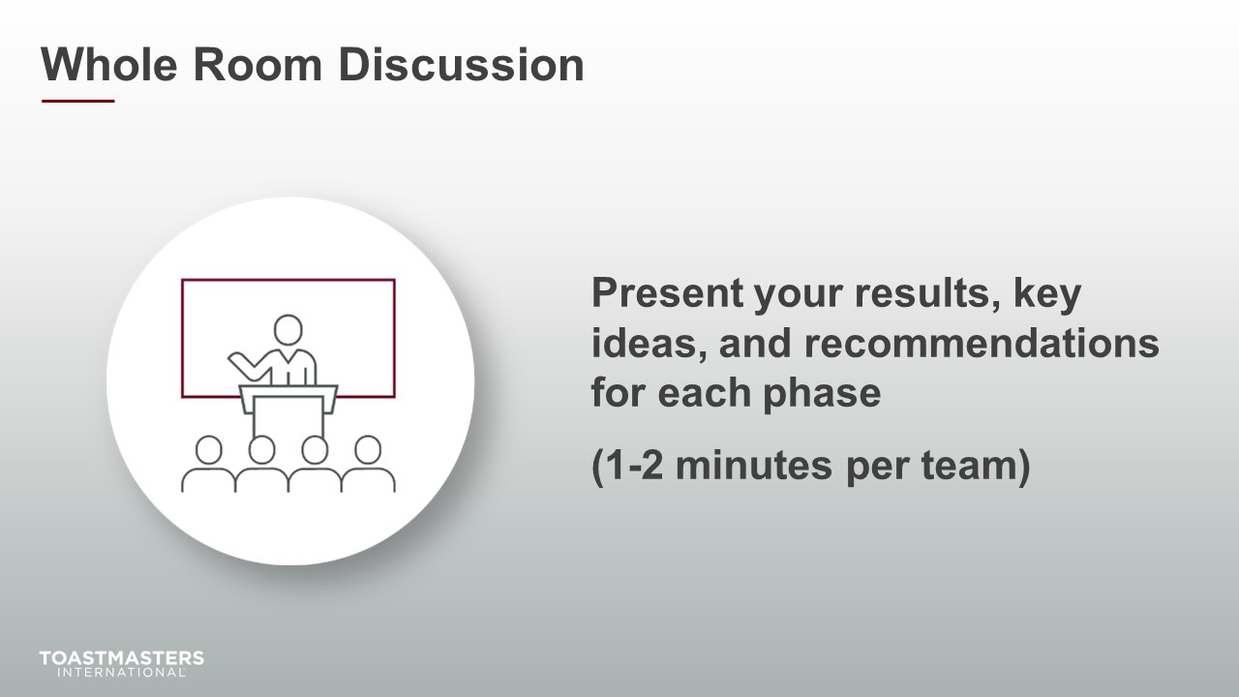
SHOW the Review slide.
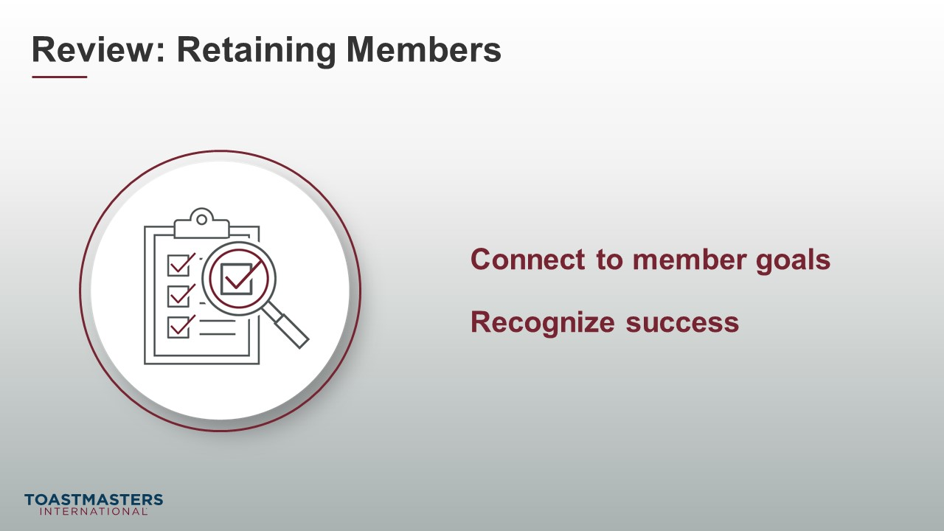

Re-engaging Past members
(40 minutes)
note to facilitator
The purpose of this next section is to guide club offers on how to get past members to be involved in their club. Involvement can mean getting past members to rejoin the club and be active. Still, we want club officers to recognize the opportunities and value of having past members join in meetings, events, celebrations, social gatherings, or social media.
PREPARE Breakout Rooms by randomly assigning a minimum of three and a maximum of four club officers to each room.
SHOW the Section Title slide.
PRESENT
- It is an inescapable fact that some members will transition into past members. The question is whether we can keep them involved and maybe get them to become active members again.
SHOW the Whole Room Discussion slide.
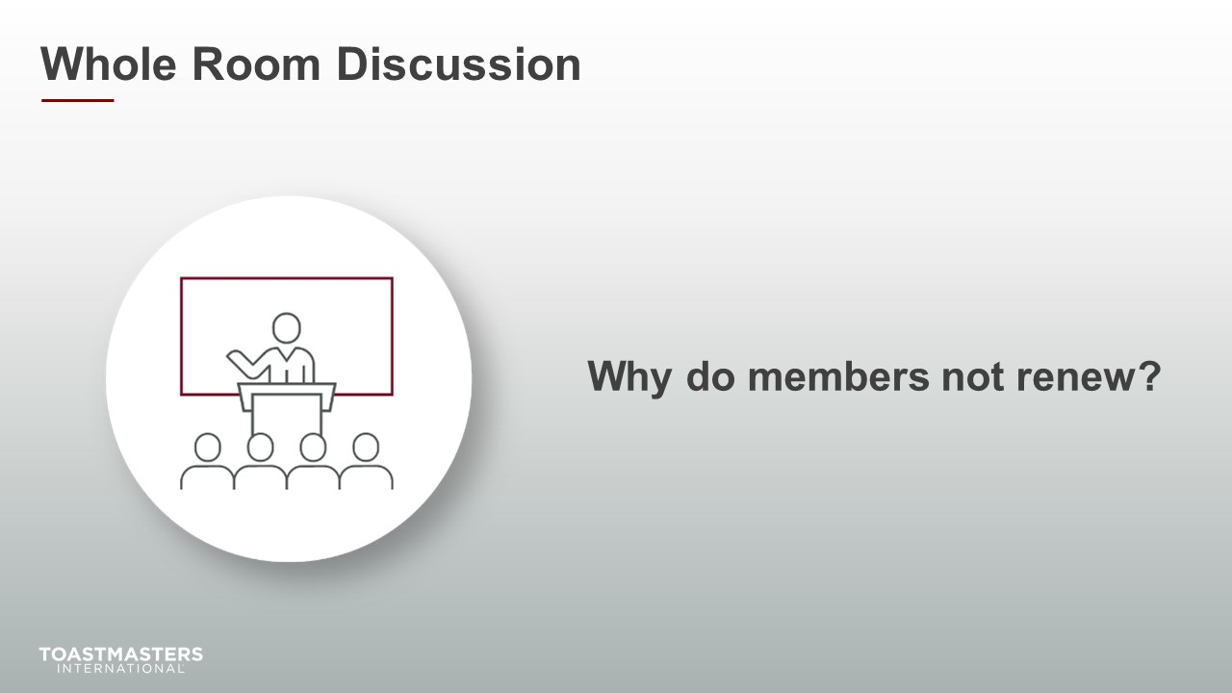
DISCUSS for up to 2 minutes.
SHOW the Present slide.
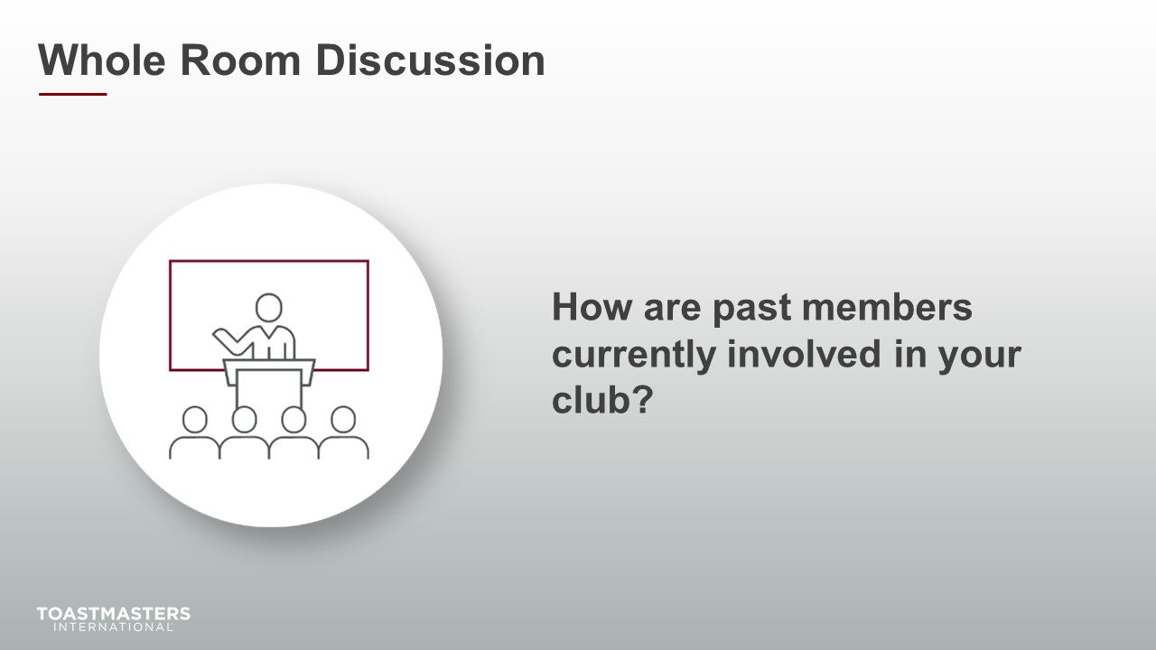
DISCUSS for up to 2 minutes.
note to facilitator
The following Breakout Room Activity provides participants a space to examine how their club engages with past members. Participants reflect on what their club currently does and doesn’t do to engage with past members.
SHOW the Breakout Room Activity slide.
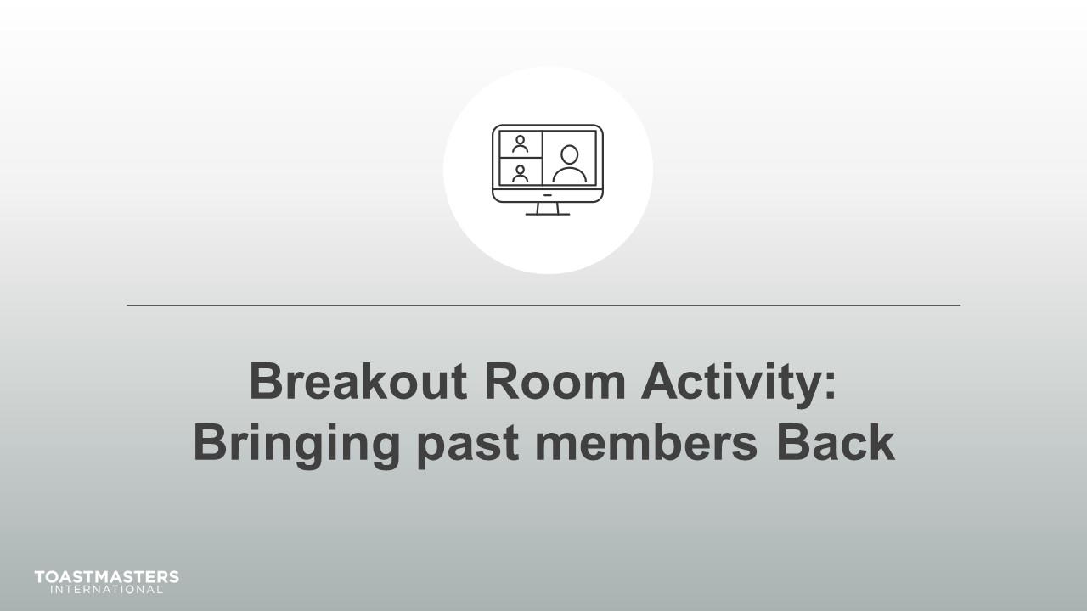
Note To Facilitator
The following slide's purpose is to remind club officers about a few of the tools available to them in virtual Breakout Rooms. You may need to adjust these according to the platform that you are using to deliver this material. Plan to spend less than one minute on the next slide.
Ideally, you would like to see a minimum of three and a maximum of four club officers per group for this activity. You may have to adjust the number per group based on the number of participants because you will be asking them to share highlights of their results. Adjust group sizes and speaking time for each spokesperson to keep your session within the schedule parameters.
SHOW the Breakout Room Tips slide.
SHOW the Instructions slide.
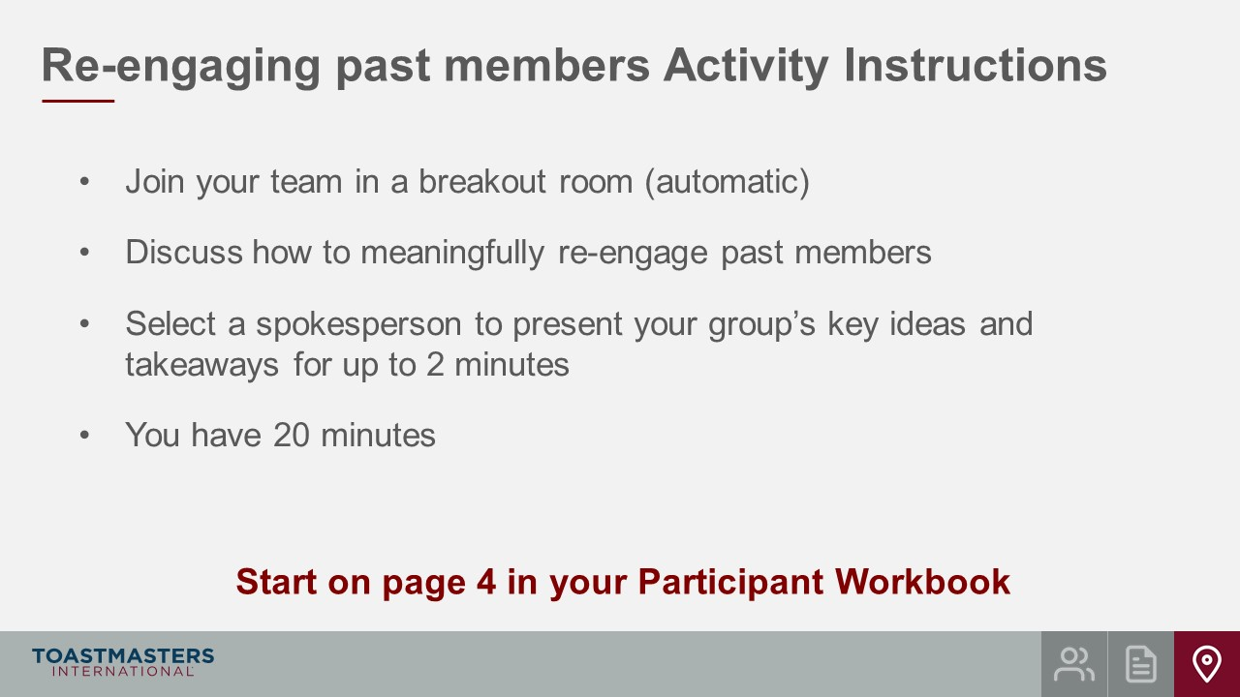
PRESENT
- We will send a two-minute warning before the end of each scenario.
- I will be available to answer questions or provide assistance.
OPEN Breakout Rooms for activity (3-4 club officers per room).
MONITOR requests for assistance from Breakout Rooms.
VISIT Breakout Rooms to offer assistance and guidance, as needed.
SEND Broadcast after 10 minutes has elapsed: You have 10 more minutes.
SEND Broadcast after 15 minutes has elapsed: You have 5 more minutes.
SEND Broadcast after 18 minutes has elapsed: In approximately 2 minutes, you will be asked to return to the main session room.
CLOSE Breakout Rooms after 20 minutes.
SHOW the Whole Room Discussion slide.
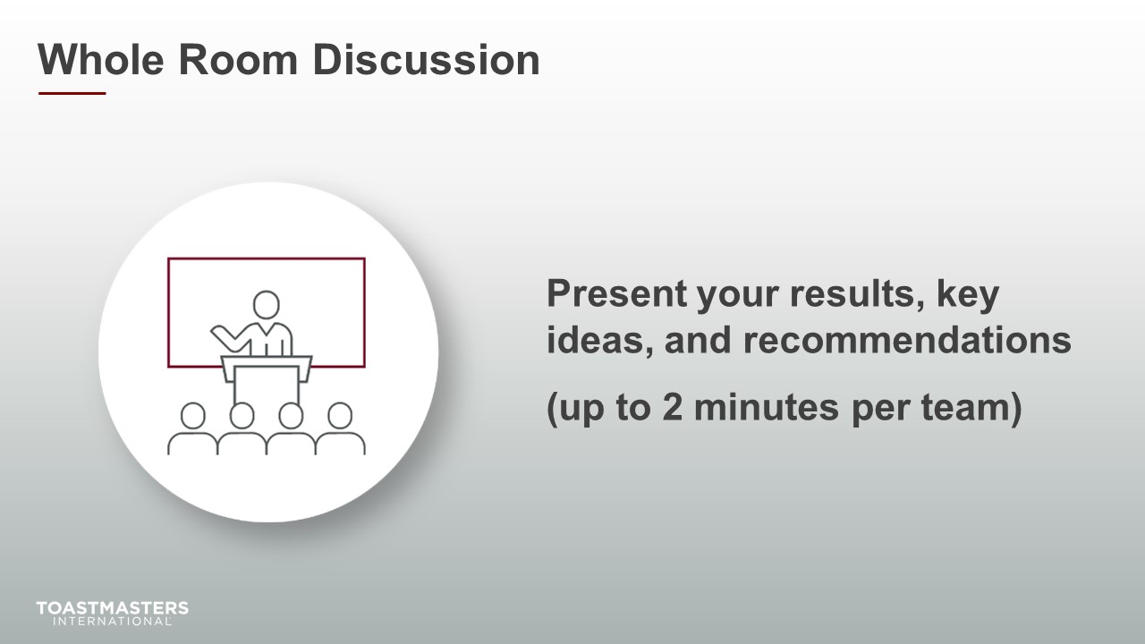
SHOW the Review slide.
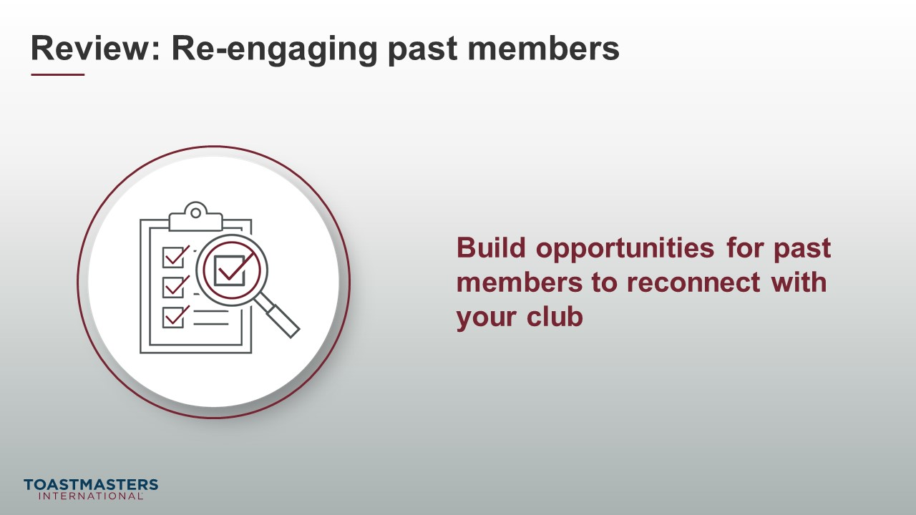
PRESENT
- [insert your talking points here]

Conclusion
(10 minutes)
SHOW the Conclusion slide.
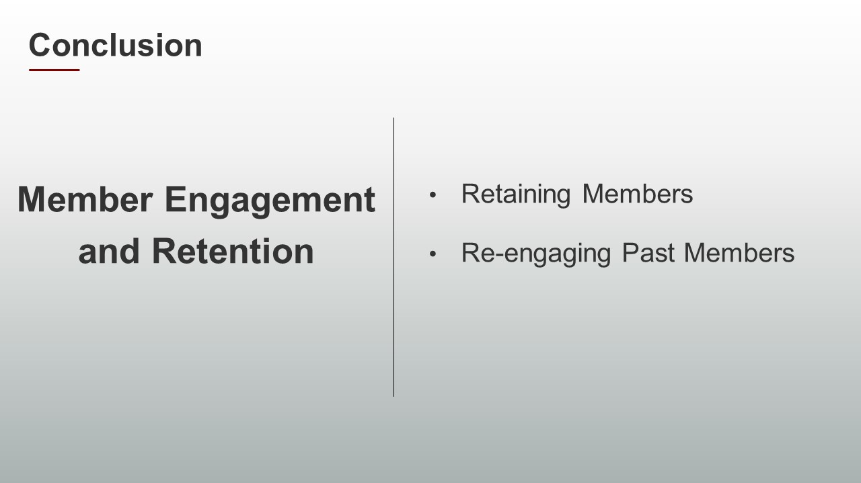
PRESENT
- There are resources in your Session Workbook on page five and a reflection activity on page six for you to complete on your own.
SHOW the Chat slide.
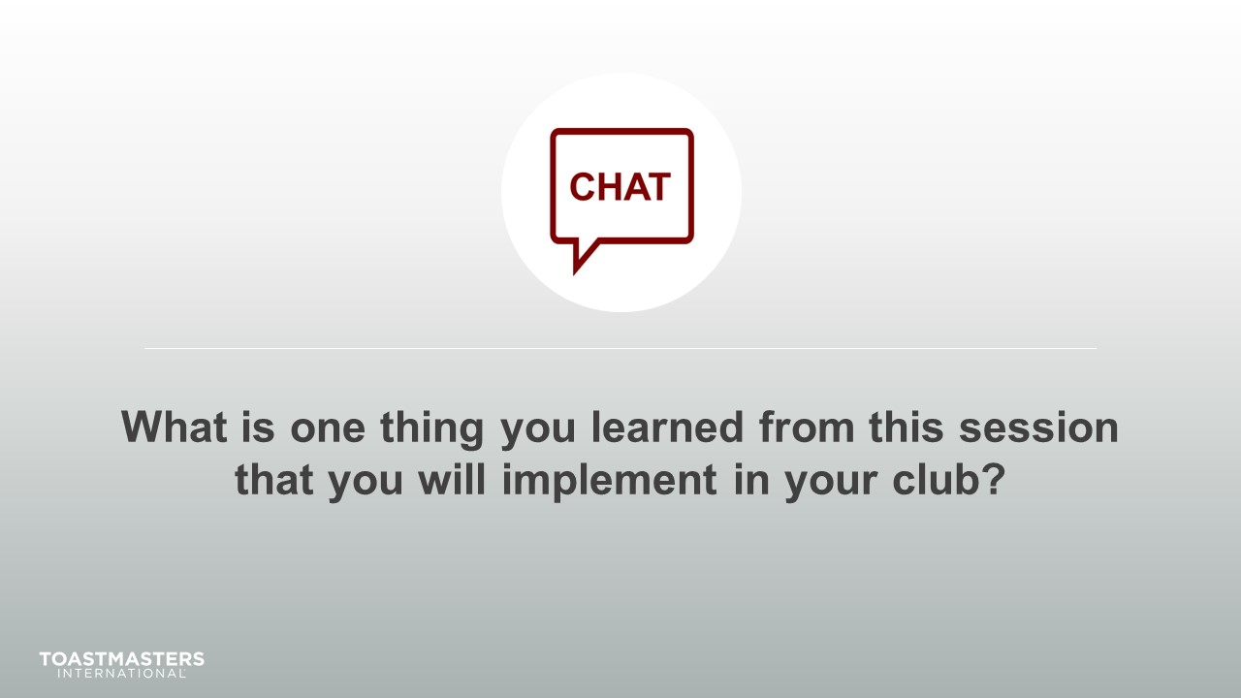
MONITOR Chat responses.
DISCUSS responses from club officers for up to two minutes.
note to facilitator
The following two slides should be edited to fit your requirements.
SHOW the Session Assessment slide.
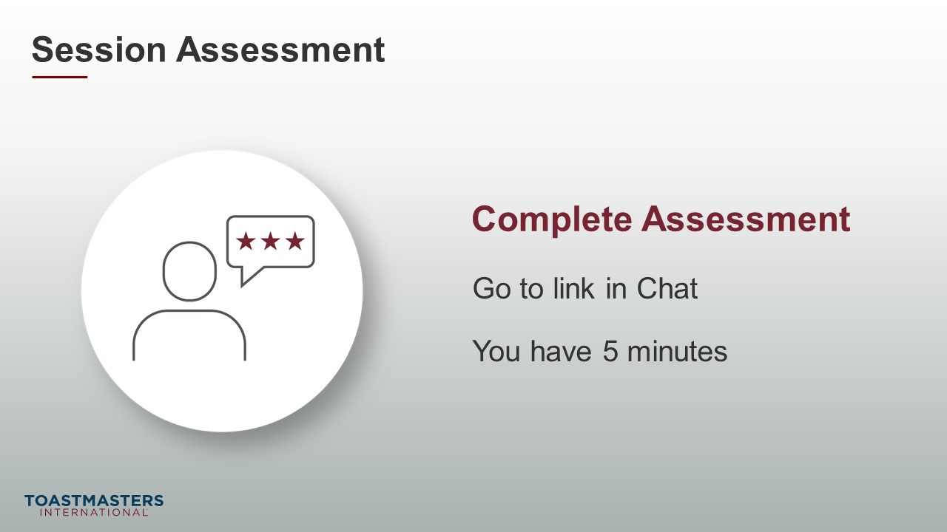
SEND chat message to everyone: [Insert link to assessment]
SHOW the What is Next slide.
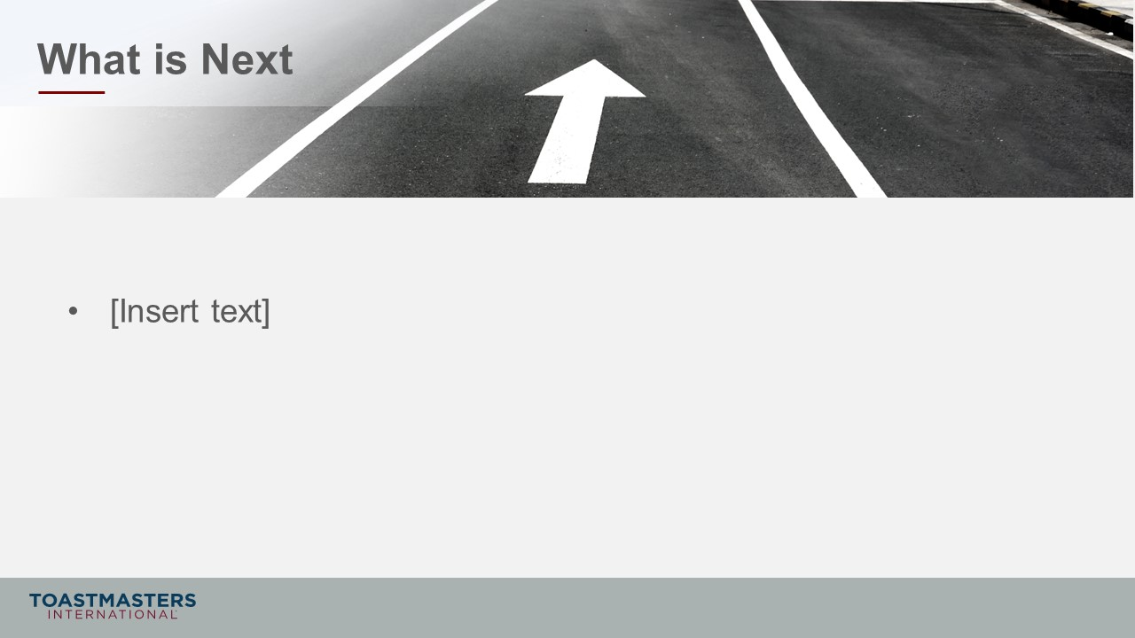
PRESENT
- [insert your talking points here]

