Prospective Member Engagement

Location of the material: https://www.toastmasters.org/leadership-central/district-leader-tools/training/club-officer-training-materials

5/05/2021

Prospective Member Engagement
Introduction
The purpose of this session is to develop strategies for converting prospective members to members using the Prospective Member Journey.
Overview
First, club officers discuss the elements of the Prospective Member Journey. Then, they will brainstorm key activities that their club should perform during the journey. Finally, they will identify resources that are necessary to support the key activities.
In this session, facilitators discuss the following topics:
- Pre-work Debrief
- Prospective Member Journey
Objectives
After completing this session, club officers will be able to do the following:
- Recognize the phases of the Prospective Member Journey
- Identify critical activities during the Prospective Member Journey
- Identify resources for engaging during the Prospective Member Journey
By meeting these objectives, club officers will be able to plan how to grow their clubs through developing sound strategies to support prospective members at each phase of their journey.

Materials
- PowerPoint
- Participant Workbook PDF
Time
These session materials are designed for a session that takes approximately 75 minutes. However, you may choose to present this topic over multiple days or in a shorter format, depending on your preference.
- This session can be delivered in a shorter format by removing the discussion of the stages of the Prospective Member Journey. For this to work, participants would need to preview the stages prior to the session in order for the Breakout Room activity to be meaningful.
- Check the Prospective Member Journey Session Outline for some options of how you might break this session up.

You should add at least one 5-minute break in any session that lasts longer than 60 minutes.
Session Preparation
- Familiarize yourself with pre-work for this session, where club officers will:
  - Complete Questions to Consider (Participant Workbook)
    - These questions promote reflection on the Pre-work and their experiences. These add depth to the discussion in each Breakout Room Activity and the Whole Room Discussions.

  - Read Prospective Member Journey and complete the questions
- Review the entire Facilitator Guide
  - You will find Notes to Facilitator throughout the guide which are informational and are not intended to be read aloud to participants. Use them to help formulate your talking points and identify your objectives.
  - This session may be delivered online through a video conference platform or in person. This guide contains tips and notes that you will need to apply to how the material will be delivered.
- Practice with your co-facilitator(s) to ensure smooth transitions throughout the session
- Consider assigning a technical assistant to help with the logistics of the session and (breakout rooms, chat, technical issues, etc.) when delivering this session online
- Review the instructions and materials for each Breakout Room Activity
- There is a slide at the end of this session that gives 5 minutes for participants to fill out a survey. Consider creating a survey to gather feedback on your session or remove the slide.

Pre-Session
START the meeting 30 minutes ahead of time.
START sharing the slides.
note to facilitator
The following slide should be updated to reflect who will be handling technical support.
SHOW the Pre-Session slide.
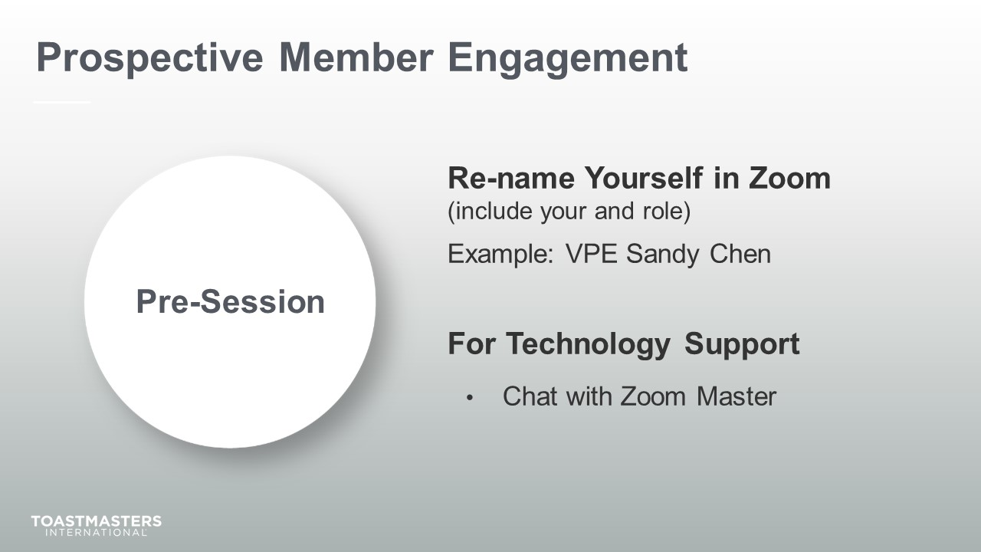
MONITOR Chat messages.

Introduction
(5 minutes)
note to facilitator
Use this time to introduce yourself formally to the club officers. A good introduction sets the tone for the session and highlights your experience and credibility. This is an excellent time to share a story related to the topic from your background as a Toastmasters member and leader.
Throughout this session, it is essential to encourage club officers to use the pre-work insights and apply them to their current interactions.
This session intends to get club officers to look critically at and understand what their club does to engage prospective members and convert them to members.
The following slide should be updated to reflect where this session falls in your training program.
SHOW the Session Title slide.
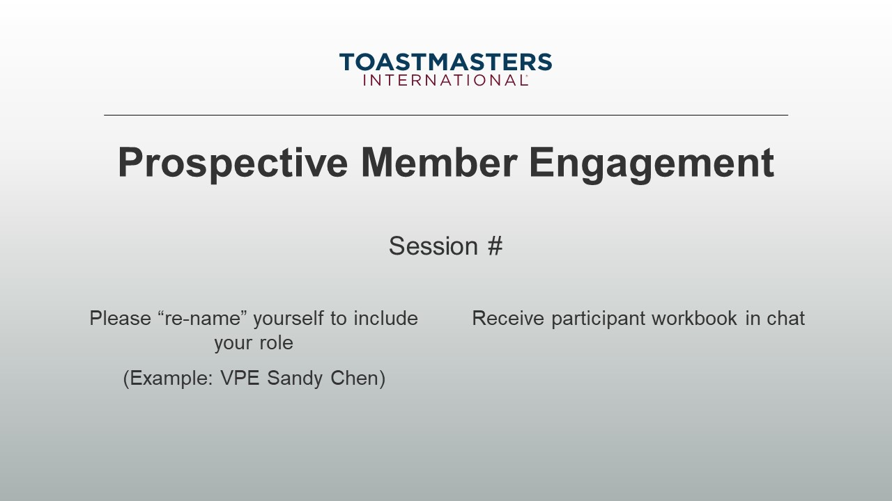
PRESENT
- [insert your talking points here]
SEND session workbook to club officers in chat.

SHOW the Agenda slide.
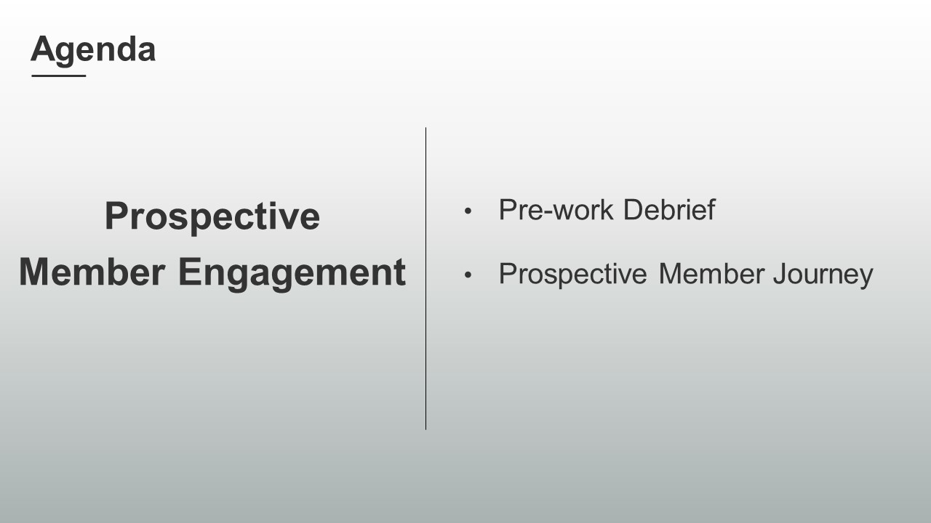
SHOW the Objectives slide.
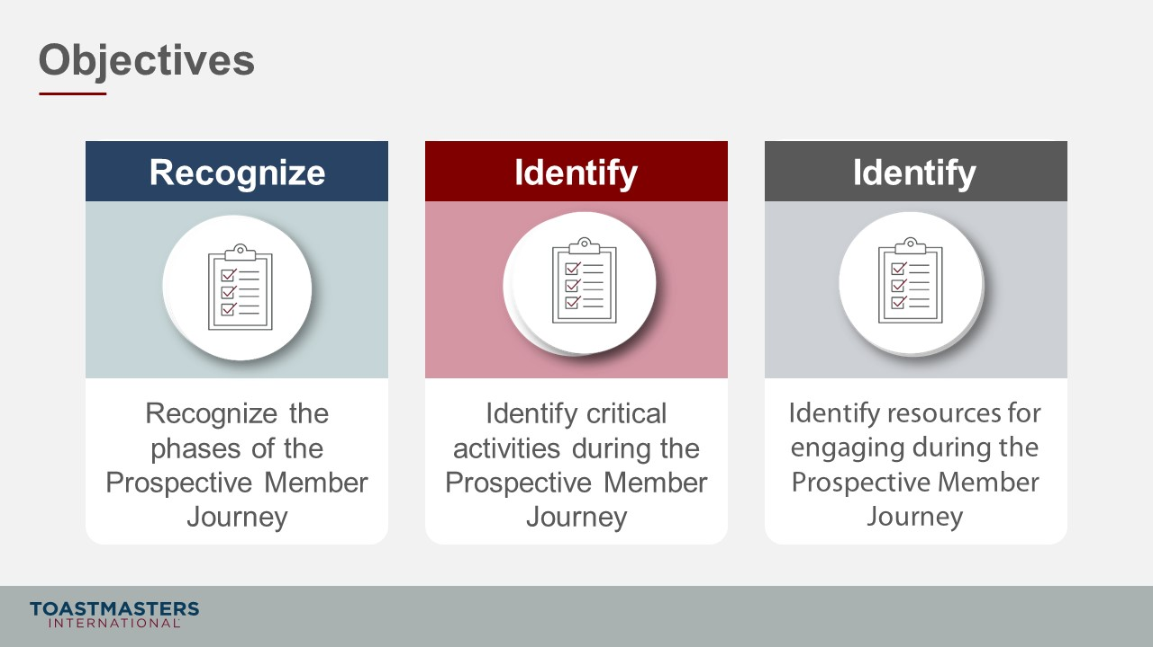

Pre-work Debrief
(15 minutes)
note to facilitator
Remind participants to open their pre-work so they can refer to concepts and their responses to questions. This reminder will help guide their participation in the discussions they will have in the first section.
In this section, participants review the four phases of the Prospective Member Journey from their pre-work. These phases are critical to meaningfully completing their first Breakout Room Activity.
PREPARE Breakout Rooms by randomly assigning a minimum of three and a maximum of four club officers to each room.
SHOW the Session Title slide.
PRESENT
- In your pre-work, you reviewed the Prospective Member Journey with four phases: awareness, evaluation, join, and support. We will be using these phases in our first Breakout Room Activity, so let’s have a quick chat about them and address any questions you have.
note to facilitator
The slides in this section review the four phases of the Prospective Member Journey. Every participant must understand what each phase entails to meaningfully complete the Breakout Room Activity in the time provided. The format for each is a Whole Room Discussion question that prompts them to put together the key concepts that the following Present Slide outlines.
SHOW the Present slide.
PRESENT
- These are the four stages of the Prospective Member Journey. We will be using them in an activity in the next section. You read about them in the pre-work for this session.
- Let’s take a little time to review each stage.

note to facilitator
The following slide introduces the Awareness phase of the Prospective Member Journey. The question intends to emphasize the features of the phase which include identifying goals, prioritizing goals, searching for products and services that help achieve their goals, and identifying brands that may be credible in supplying products and services.
SHOW the Whole Room Discussion slide.
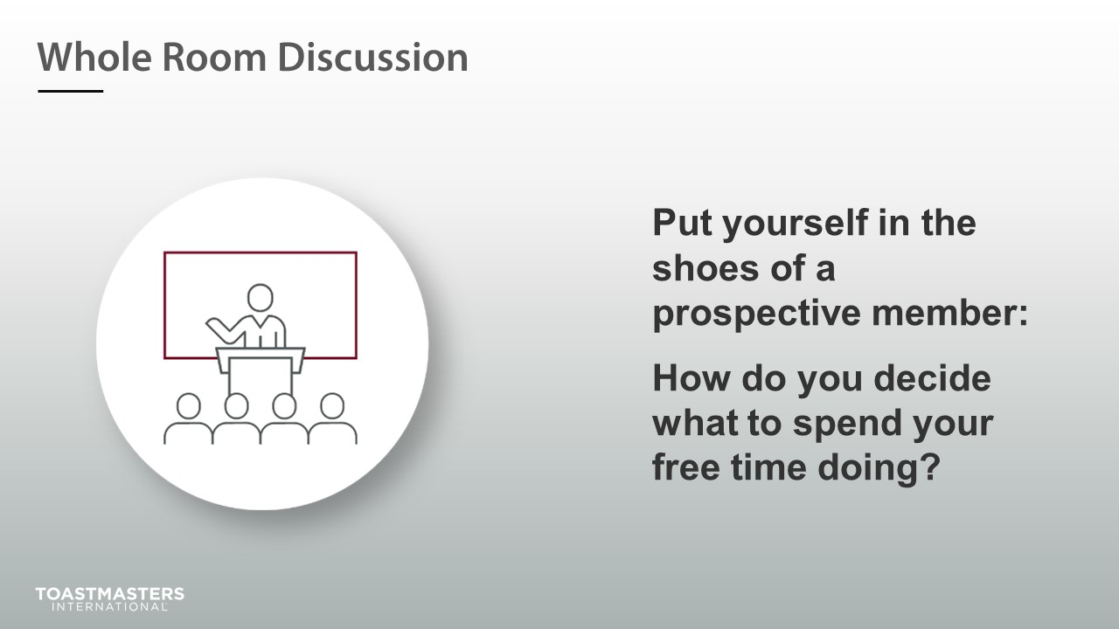

DISCUSS responses for up to two minutes.
SHOW the Present slide.
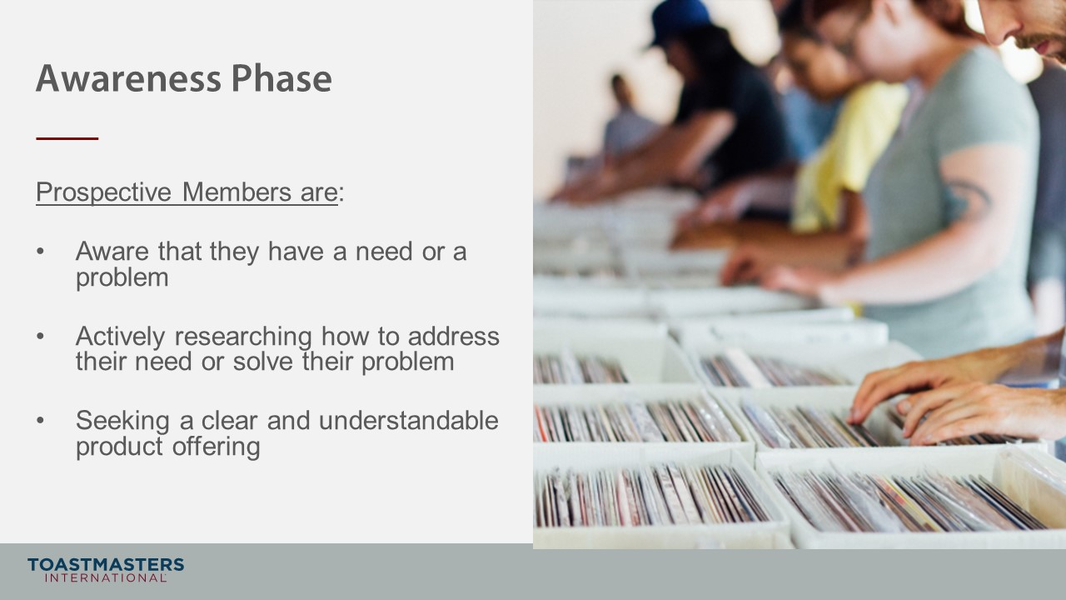
note to facilitator
The following slide introduces the Awareness phase of the Prospective Member Journey. The question intends to emphasize the phase features, including testing products and services by reading testimonials, checking reviews, doing taste tests, trying a product or service for free, etc.
SHOW the Whole Room Discussion slide.
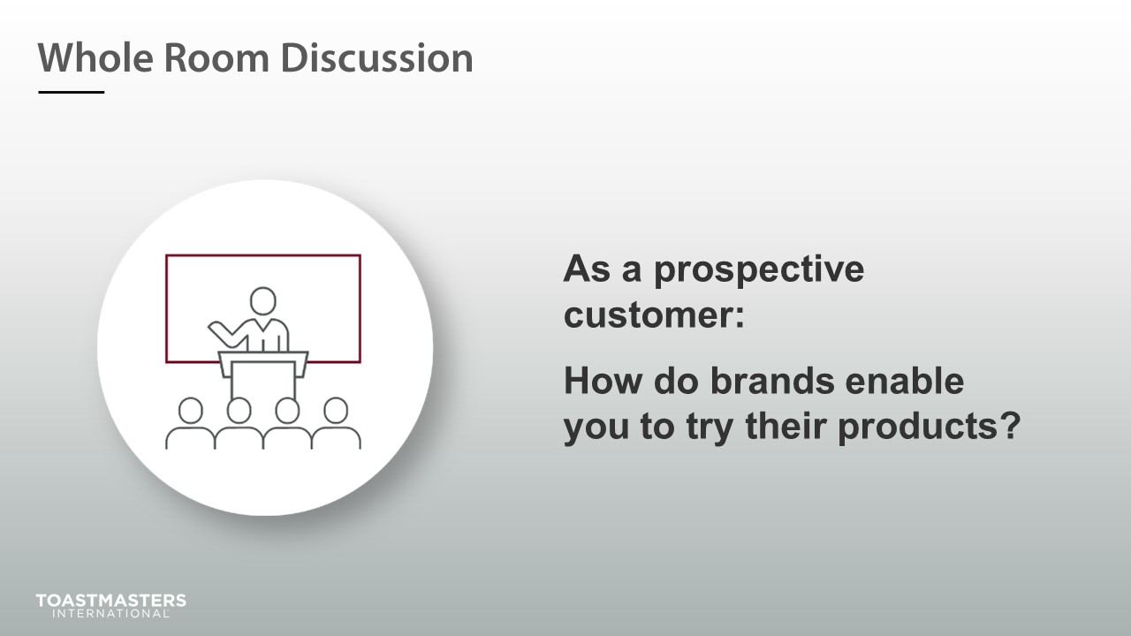

DISCUSS responses for up to two minutes.
SHOW the Present slide.
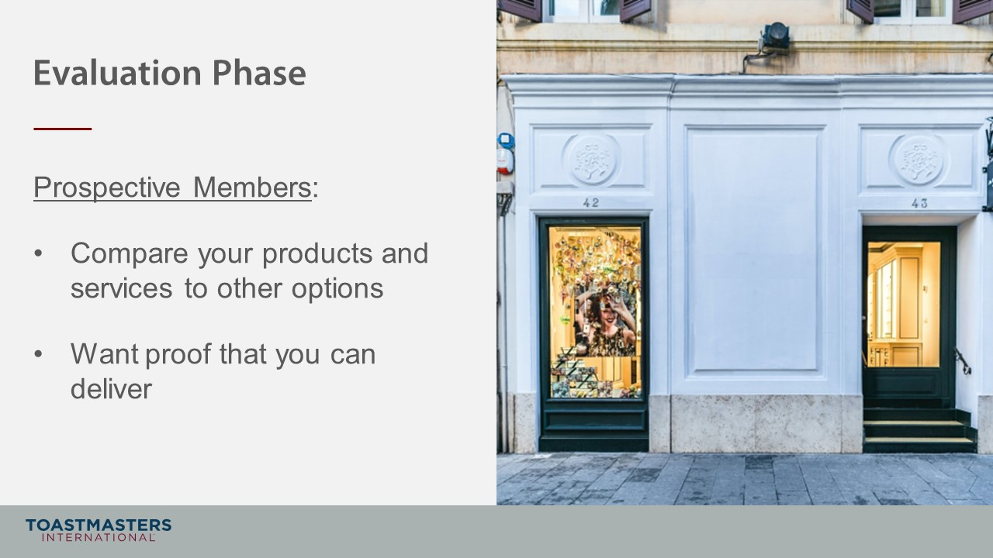
note to facilitator
The following slide introduces the Join phase of the Prospective Member Journey. The question intends to emphasize the phase features, including how easy it is to join, how the prospective member is asked to join, and how easy it is to understand what they get/need to do once they join.
SHOW the Whole Room Discussion slide.
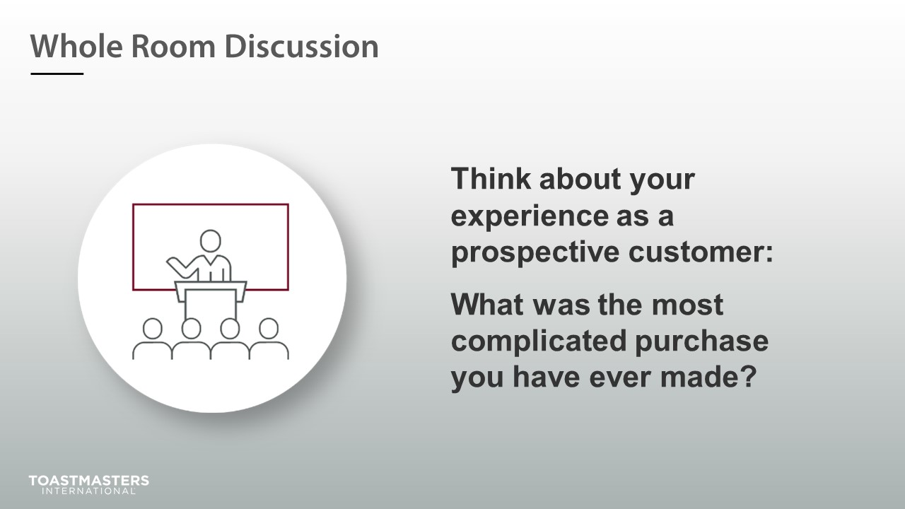

DISCUSS responses for up to two minutes.

SHOW the Presentation slide.
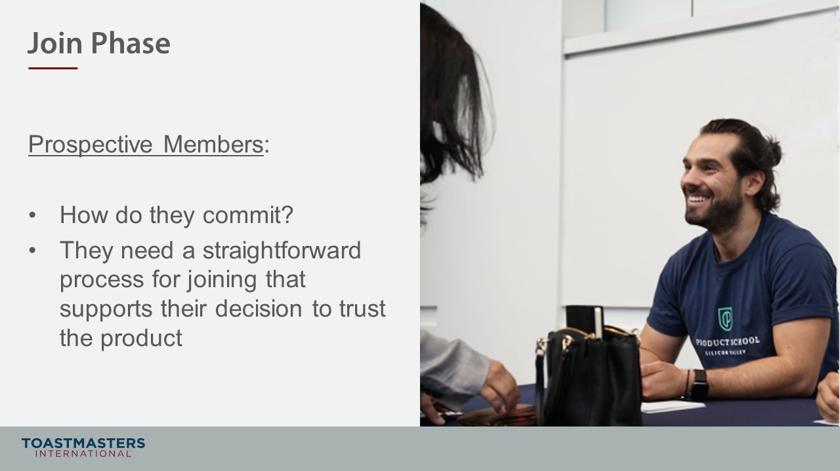
note to facilitator
The following slide introduces the Support phase of the Prospective Member Journey. The question intends to emphasize the phase features, including the type of support that might be expected, how that support is delivered, when it can be accessed, how a member may ask for help, how the club may check in on a member, etc.
SHOW the Whole Room Discussion slide.
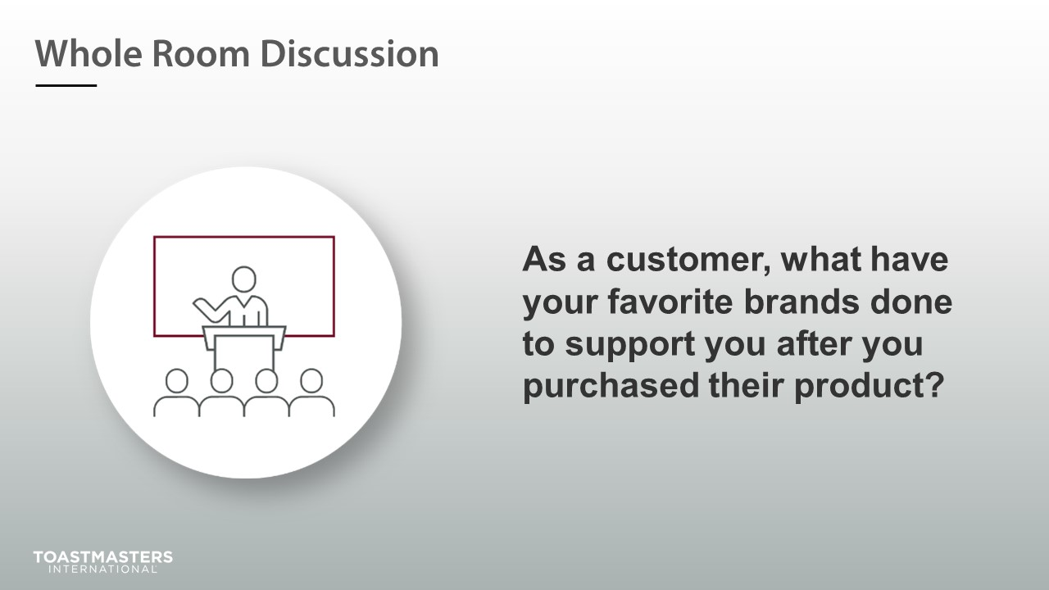

DISCUSS responses for up to two minutes.
SHOW the Present slide.
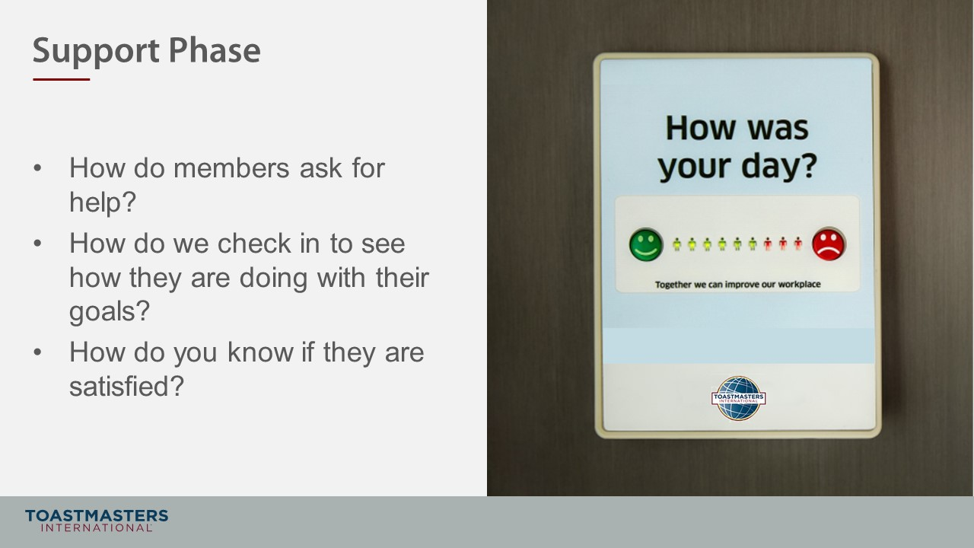
SHOW the Review slide.
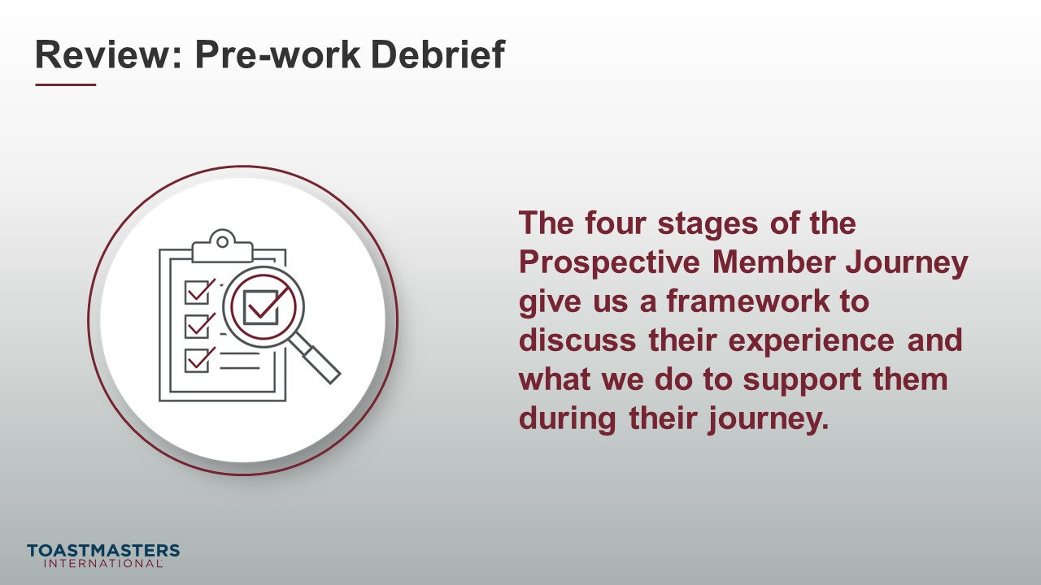

Prospective Member Journey
(35 minutes)
note to facilitator
The purpose of this section is to get participants to think critically about how a prospective member becomes a member of their club. Through the Breakout Room Activity, participants will go through four phases of transitioning a prospective member into a member and identifying what the club needs to do to support the journey.
PREPARE Breakout Rooms by randomly assigning a minimum of three and a maximum of four club officers to each room.
SHOW the Section Title slide.
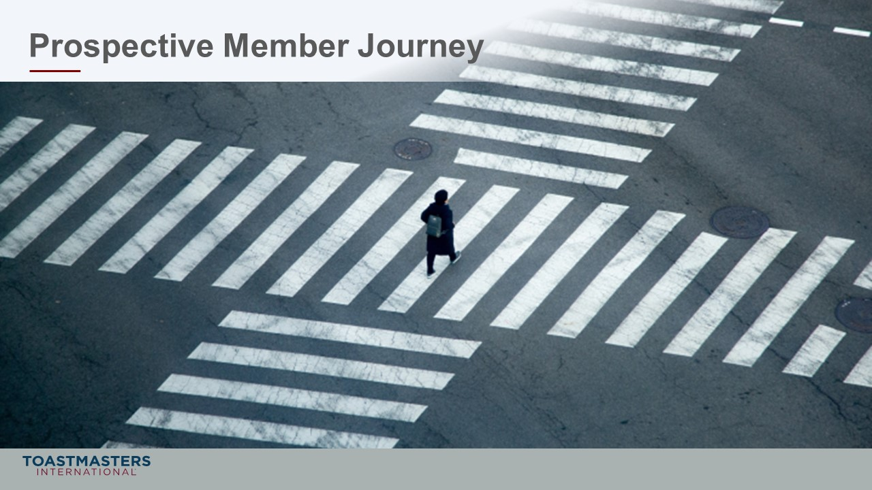
PRESENT
- We are going to be mapping out the process by which a prospective member converts into a member.
- To do this, we will be using the four phases from your Pre-work: Awareness, Evaluation, Join, and Support.

SHOW the Breakout Room Activity slide.
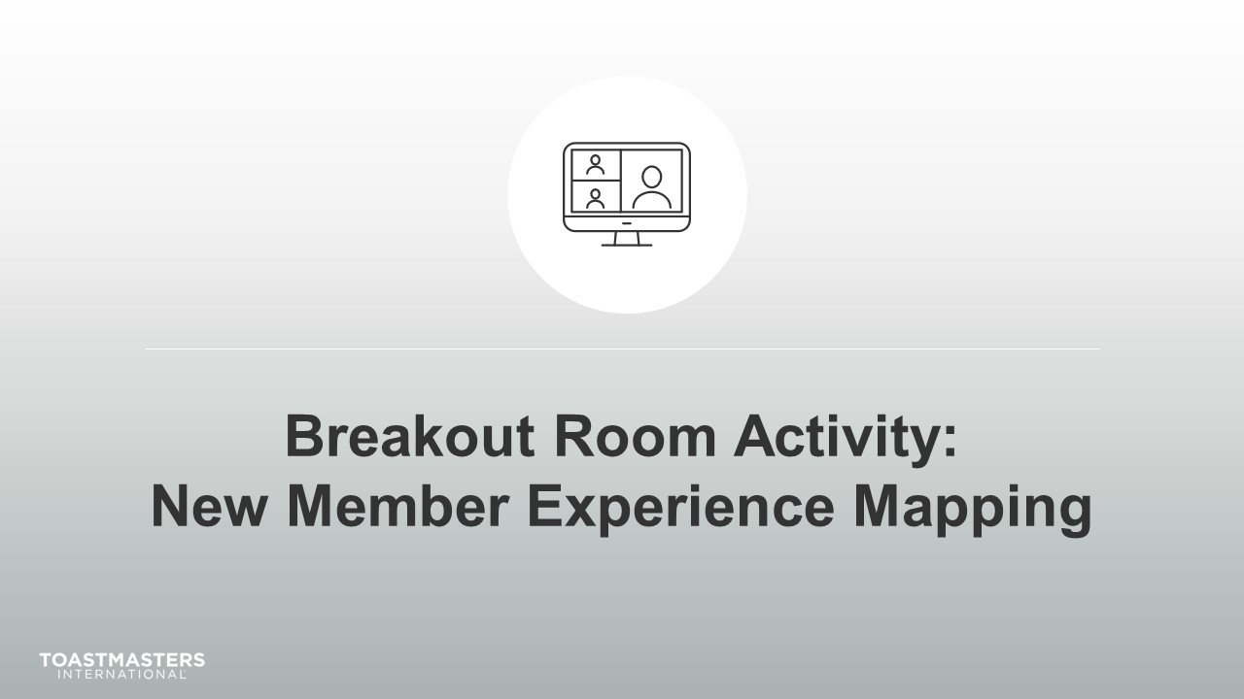
Note To Facilitator
The following slide's purpose is to remind club officers about a few of the tools available to them in virtual Breakout Rooms. You may need to adjust these according to the platform that you are using to deliver this material. Plan to spend less than one minute on the next slide.
Ideally, you would like to see a minimum of three and a maximum of four club officers per group for this activity.

SHOW the Breakout Room Tips slide.
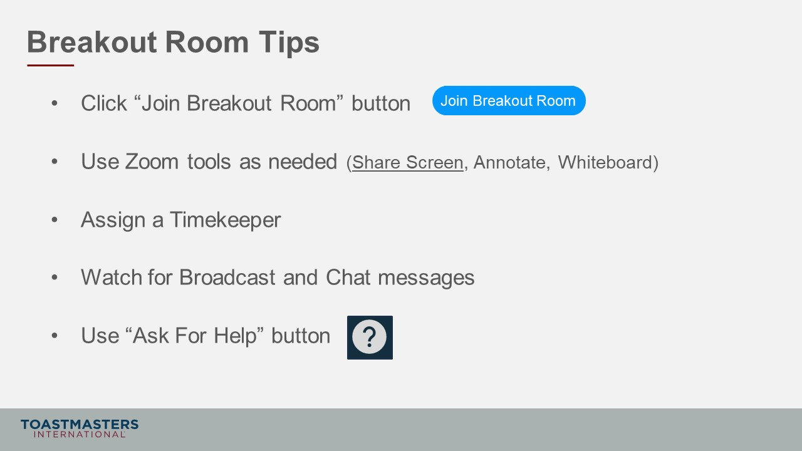
SHOW the Instructions slide.
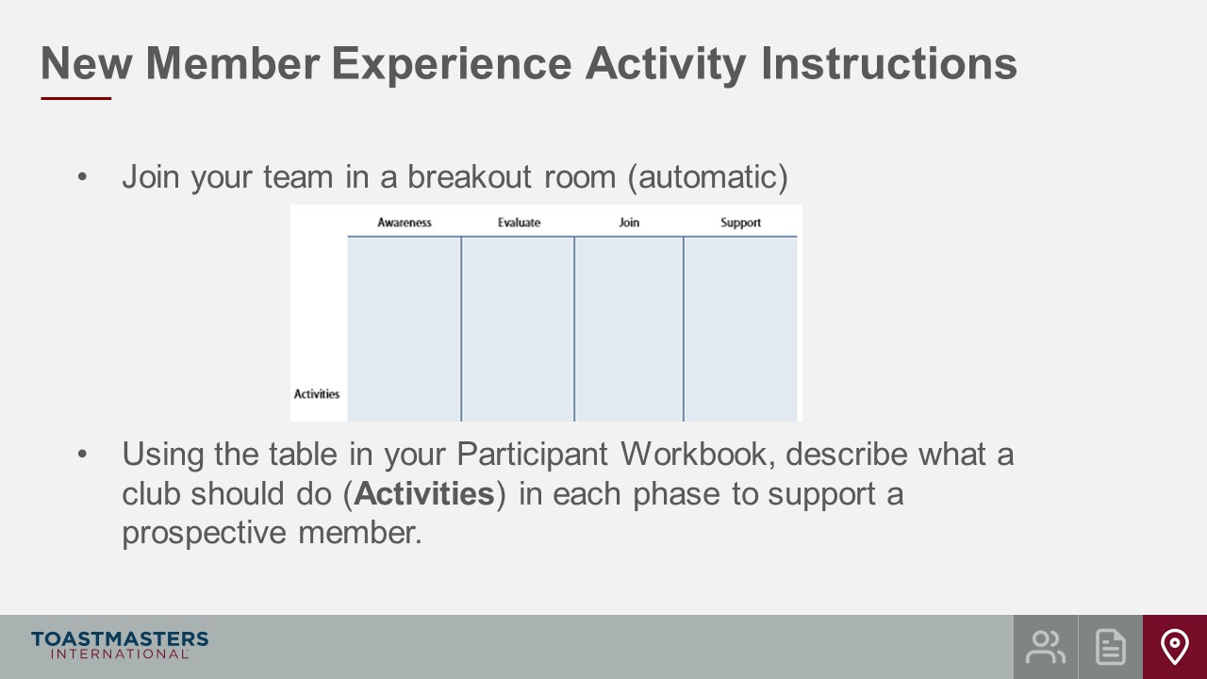
SHOW the Instructions slide.
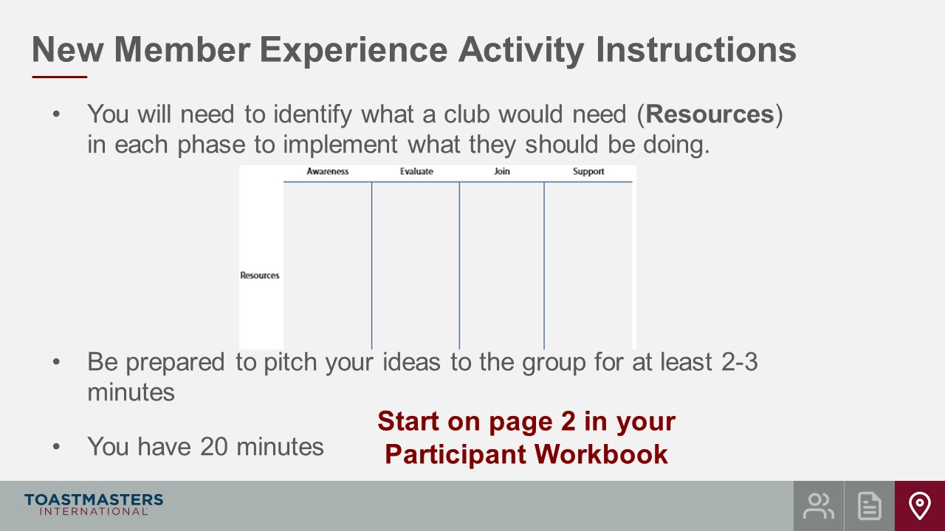
PRESENT
- We will send a two-minute warning before the end the activity.
- I will be available to answer questions or provide assistance.

note to facilitator
The instructions below are prompts for virtual Breakout Rooms but can be adjusted to deliver in an in-person session.
OPEN Breakout Rooms for activity (3-4 club officers per room).
MONITOR requests for assistance from Breakout Rooms.
VISIT Breakout Rooms to offer assistance and guidance, as needed.
SEND Broadcast after 20 minutes has elapsed: You have 10 more minutes.
SEND Broadcast after 25 minutes has elapsed: You have 5 more minutes.
SEND Broadcast after 28 minutes has elapsed: In approximately 2 minutes, you will be asked to return to the main session room.
CLOSE Breakout Rooms after 30 minutes.
SHOW the Whole Room Discussion slide.
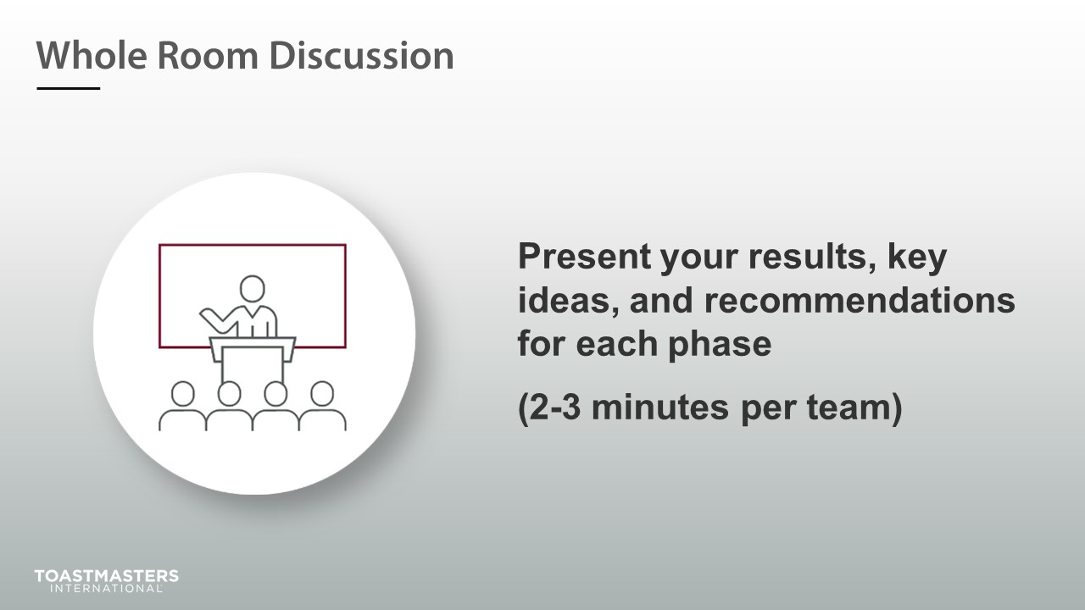
SHOW the Review slide.
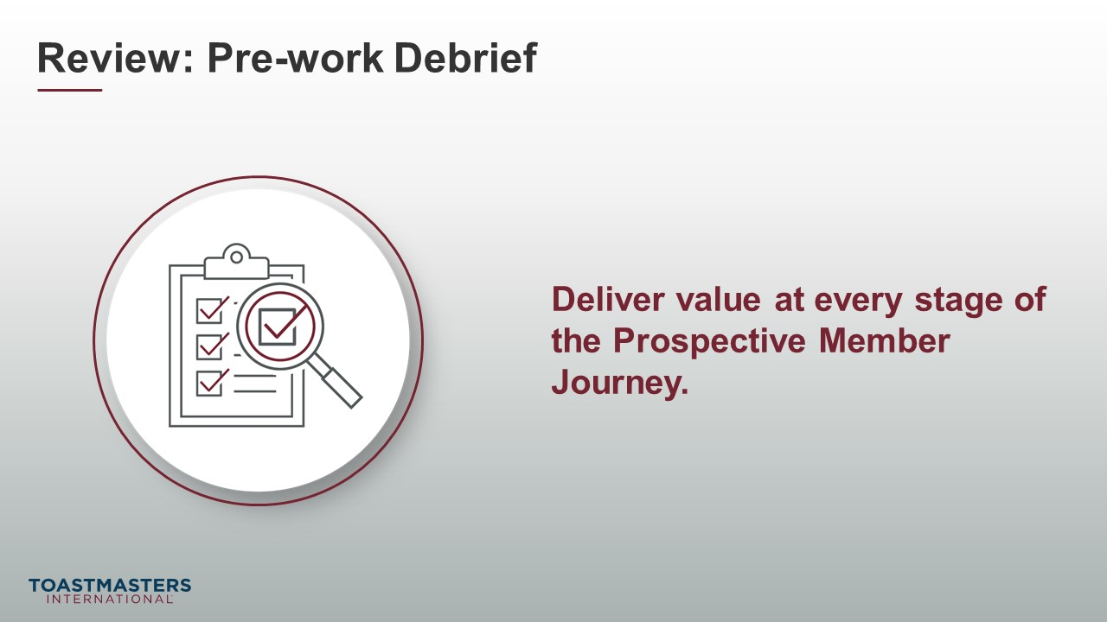
PRESENT
- It isn’t enough to deliver the right activities with the correct resources at just a couple of the stages. You can lose a member at any stage without the right support.

Conclusion
(10 minutes)
SHOW the Conclusion slide.
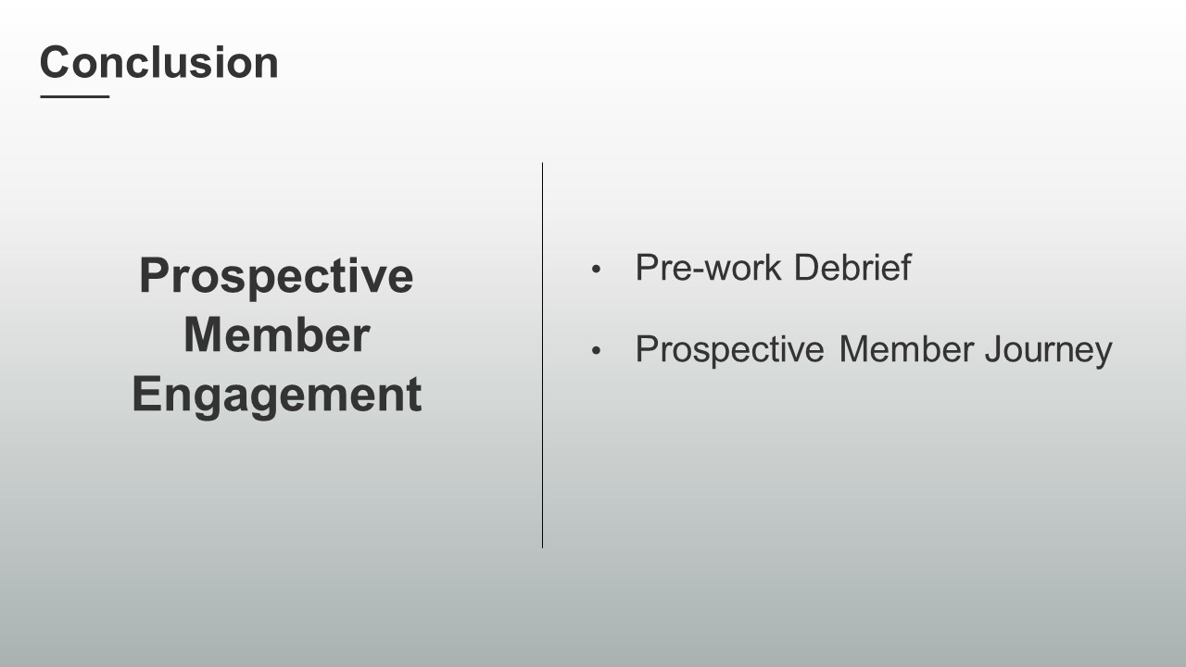
PRESENT
- There are resources in your Session Workbook on page 5 and a reflection activity on page 6 for you to complete on your own.
SHOW the Chat slide.
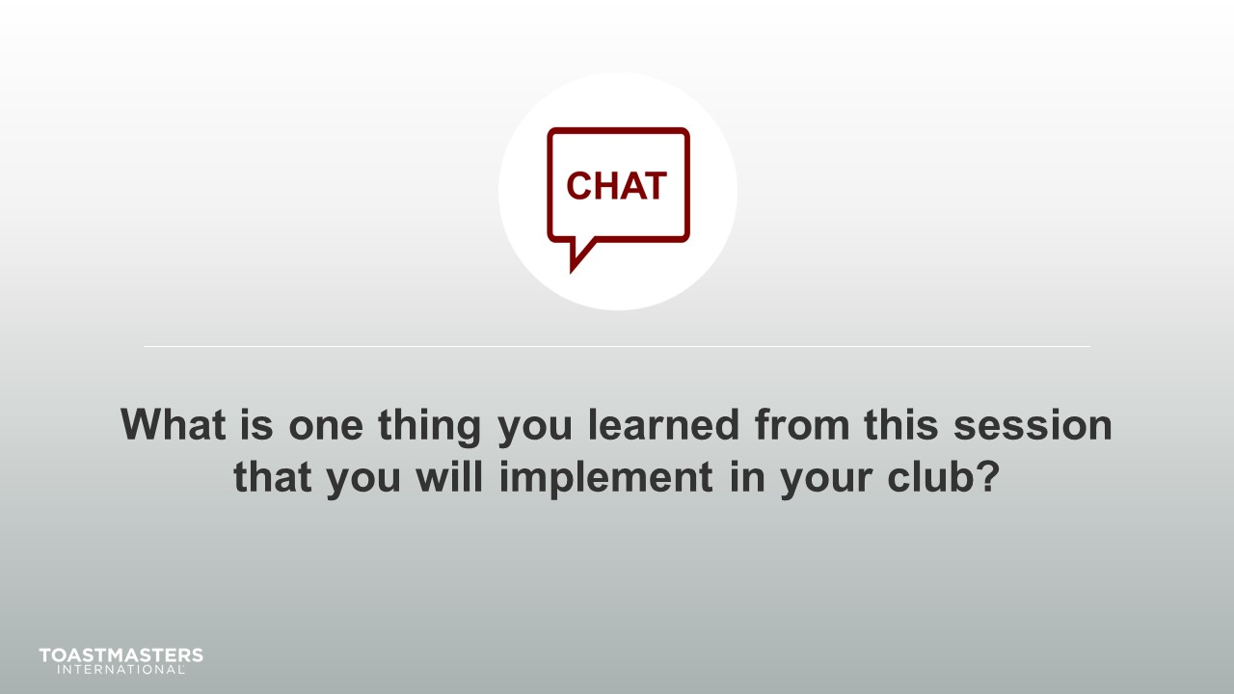
MONITOR chat responses.
DISCUSS responses for up to two minutes.
note to facilitator
The following two slides should be edited to fit your requirements.
SHOW the Session Assessment slide.
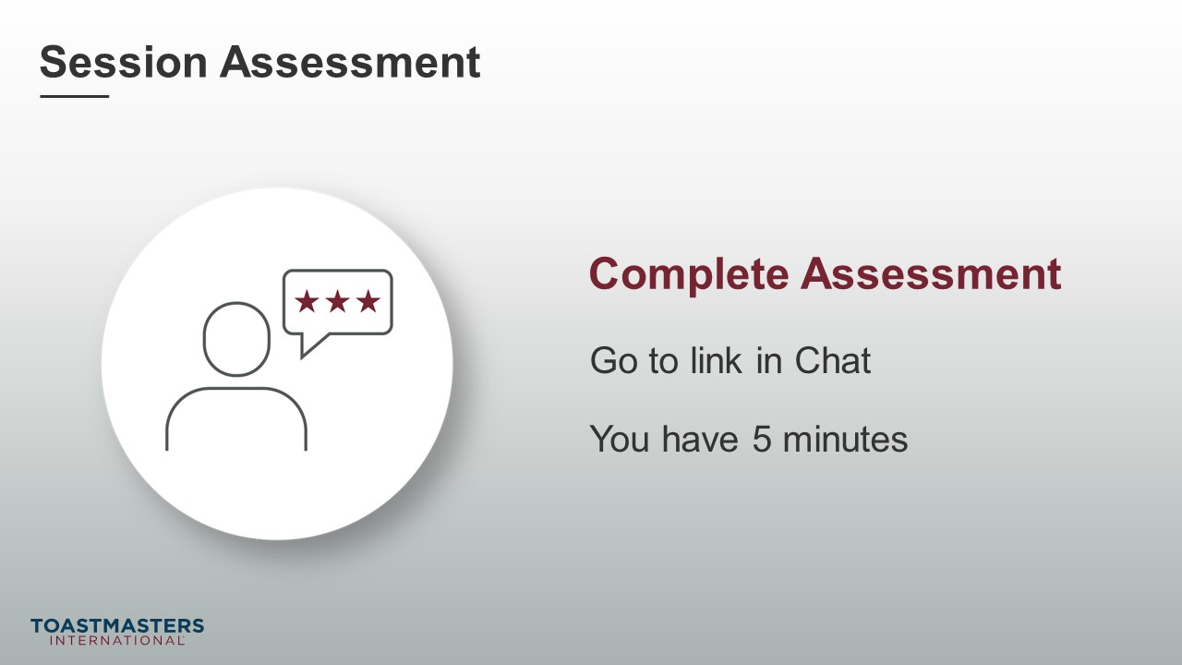
SEND chat message to everyone: [insert link to assessment]
SHOW the What is Next slide.
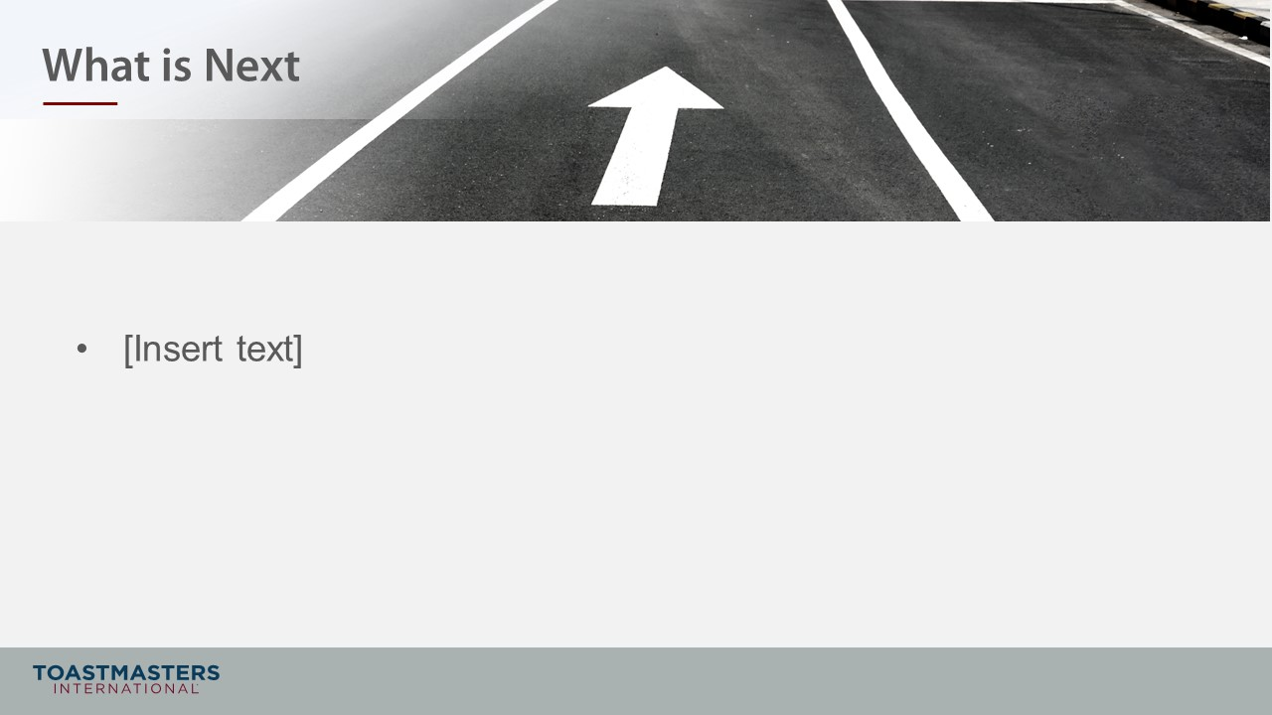
PRESENT
- [insert your talking points here]

