Quality Club Meetings

Location of the material: https://www.toastmasters.org/leadership-central/district-leader-tools/training/club-officer-training-materials

5/05/2021

Quality Club Meetings
Introduction
Club meetings are the premier venue for member achievement in the Toastmasters program, delivering members' opportunity to practice skills and receive feedback. Meetings impact member retention, promote club growth, and are a venue to recognize achievement. The purpose of this session is to foster a shared understanding of what a quality club meeting looks like and assist club officers in developing strategies to deliver great club meetings consistently.
Overview
First, club officers will discuss the impact of quality meetings. Then, they will define the characteristics of a quality meeting. Finally, they will identify what must be done to consistently deliver quality meetings.
In this session, facilitators discuss the following topics:
- Impact of Quality Meetings on a Club
- What is a Quality Meeting?
- Delivering Quality Meetings
Objectives
After completing this session, club officers will be able to do the following:
- Identify what a quality club meeting is
- Identify what goes into preparing quality club meetings
- Develop strategies to consistently deliver quality club meetings
By meeting these objectives, club officers will be well equipped to deliver consistently effective and enjoyable club meetings.
Materials
- PowerPoint
- Session Workbook PDF
Time
These session materials are designed for a session that takes approximately 1 hour and 26 minutes. However, you may choose to present this topic over multiple days or in a shorter format, depending on your preference.
This guide includes suggestions about how to alter the content to suit your needs below:
- This session divides into two shorter sessions by dividing the topics into standalone sessions. In a session divided by topics the first section would always be “Impact of Quality Meetings on a Club” followed by the whichever section that you choose to present. The review slide in each session would become the conclusion slide, and the Pre-work and Session Workbook is adjustable to match the material.
- Check the Quality Club Meetings Session Outline for some options of how you might break this session up.

You should add at least one 5-minute break in any session that lasts longer than 60 minutes.
Session Preparation
- Familiarize yourself with Pre-work for this session, where club officers will:

  - Watch Dashboards for Club Officers (Video)
Members who do not have access to YouTube can watch the video by clicking this link.
    - This video will show club officers where to find renewal numbers and expose them to the features and function of the dashboard.

  - Review their club renewal numbers and complete questions
    - Club renewal numbers are an indicator of club quality. Member engagement and retention are a benefit of having well organized, fun, and productive meetings.

  - Read Categories of Quality
    - These categories will be used in the second Breakout Room Activity. Reading and reflecting on these categories ahead of the session will allow for more meaningful interactions during the activity and allow the activity to be completed within the timeframe.

  - Complete Questions to Consider
    - These questions promote reflection on the Pre-work and their experiences. These add depth to the discussion in each Breakout Room Activity and the Whole Room Discussions.
- Review the entire Facilitator Guide
  - You will find Notes to Facilitator throughout the guide, which are informational and are not intended to be read aloud to participants. Use them to help formulate your talking points and identify your objectives.
  - This session may be delivered online through a video conference platform or in person. This guide contains tips and notes that you will need to apply to how the material will be delivered.
  - Throughout this guide, you will find highlighted yellow directions. These are callouts to what actions need to be taken when delivering this session online.
  - If you plan to conduct this session in person, some of the instructions or slides will no longer be applicable. Please review the materials carefully and update them to best suit the needs of your session format.
- Practice with your co-facilitator(s) to ensure smooth transitions throughout the session.
- Consider assigning a technical assistant to help with the logistics of the session and (breakout rooms, chat, technical issues, etc.) when delivering this session online.
- Review the instructions and materials for each Breakout Room Activity
- There is a slide at the end of this session that gives five minutes for participants to fill out a survey. Consider creating a survey to gather feedback on your session or remove the slide.

Pre-Session
START the meeting 30 minutes ahead of time.
START sharing the slides.
note to facilitator
The following slide should be updated to reflect who will be handling technology support.
SHOW the Pre-Session slide.
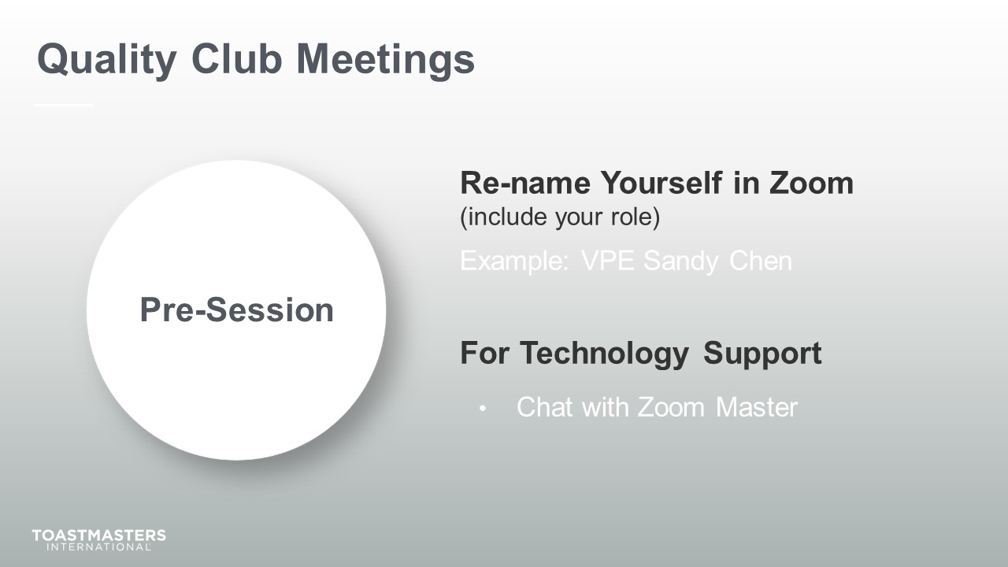
MONITOR chat messages.

Introduction
(5 minutes)
Note To Facilitator
Use this time to introduce yourself formally to the club officers. A good introduction sets the tone for the session and highlights your experience and credibility. This is an excellent time to share a story related to the topic from your background as a Toastmaster leader.
Throughout this session, it is essential to encourage club officers to use the pre-work insights and apply them to their current interactions.
This session intends to emphasize the value of organized, fun, and impactful meetings and look critically at what their club does and doesn’t do to deliver these types of meetings.
The following slide should be updated to reflect where this session falls in your training program.
SHOW the Session Title slide.
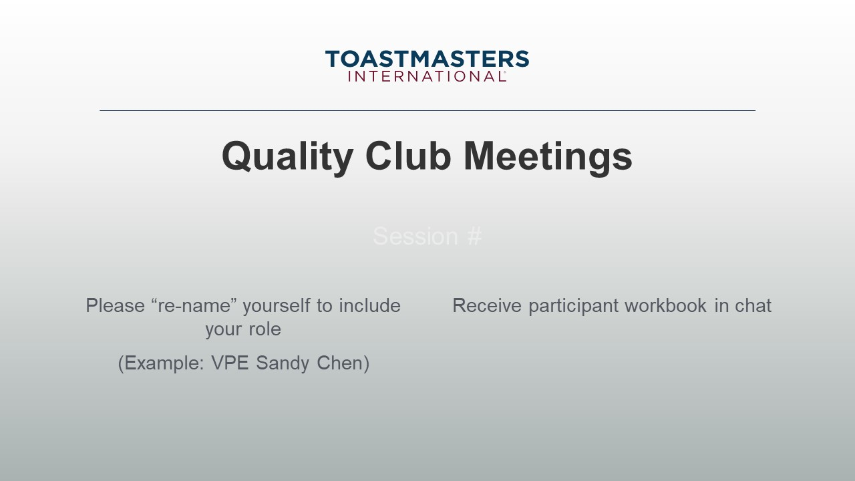
PRESENT
- [insert your talking points here]
SEND session workbook to club officers in chat.

SHOW the Agenda slide.
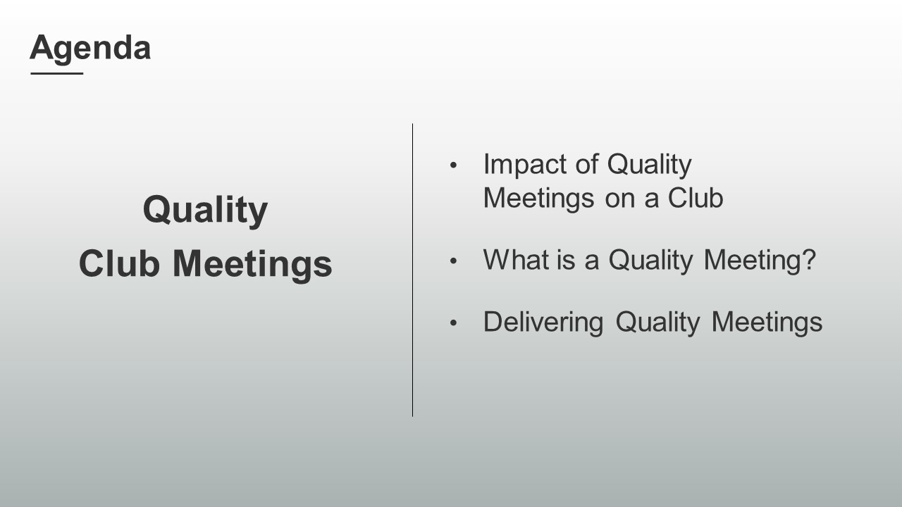
SHOW the Objectives slide.
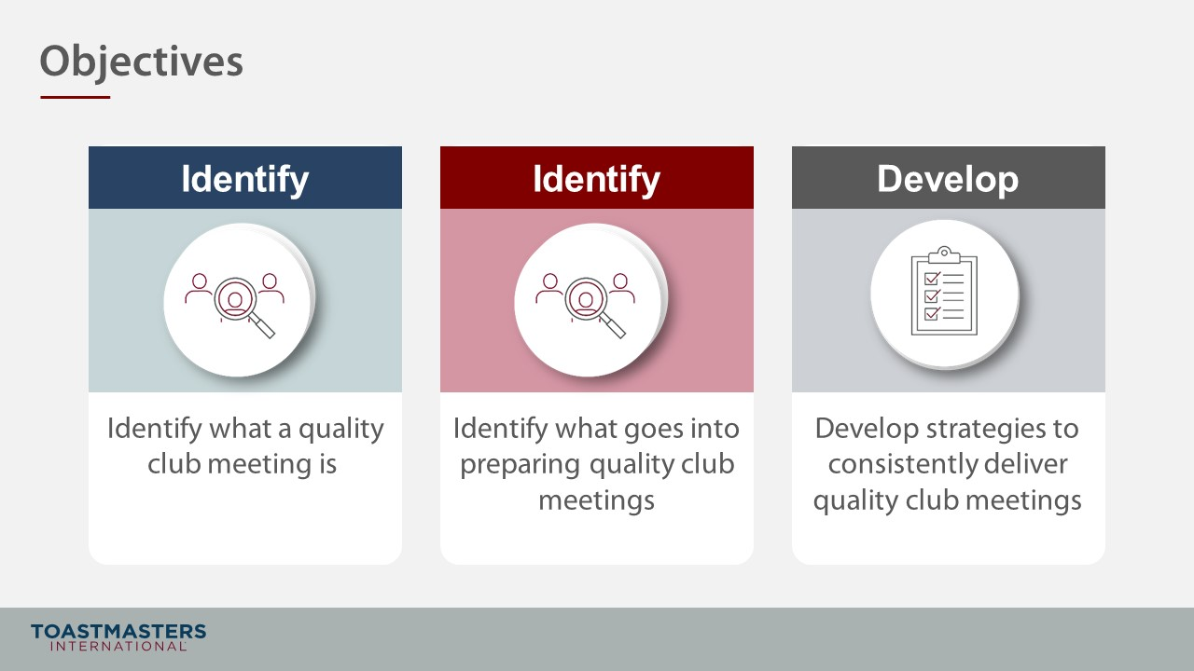

Impact of Quality Meetings on a Club
(15 minutes)
Note To Facilitator
Remind participants to open their pre-work so they can refer to concepts and their responses to questions. This reminder will help guide their participation in the discussions they will have in the first section.
This section aims to drive home that quality meetings lead to member engagement, retention, club growth, and filling officer roles.
SHOW the Section Title slide.
PRESENT
- What if I told you that I knew how to keep members happily renewing? That I had the secret to consistently filling meeting and club officer roles with motivated members? You’d be interested in that, right?
- Quality meetings do all of this and lead to more successful clubs.
- Let’s explore that a little and identify the impact that quality meetings have.

Note To Facilitator
The following slide connects quality meetings with member engagement and retention. Quality meetings increase the value a member gets for participating. Members arrive at meetings with goals that they expect a club to assist them in achieving. Giving members a platform to focus on their growth creates an environment that drives achievement. Engagement drives member retention. A key contributing factor to member renewal is whether a member feels supported, and they believe that the club can help them achieve their goals.
SHOW the Whole Group Discussion slide.
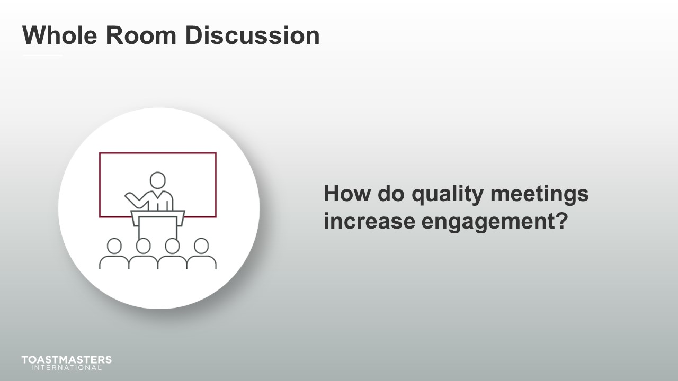
DISCUSS for up to two minutes.
SHOW the Whole Group Discussion slide.
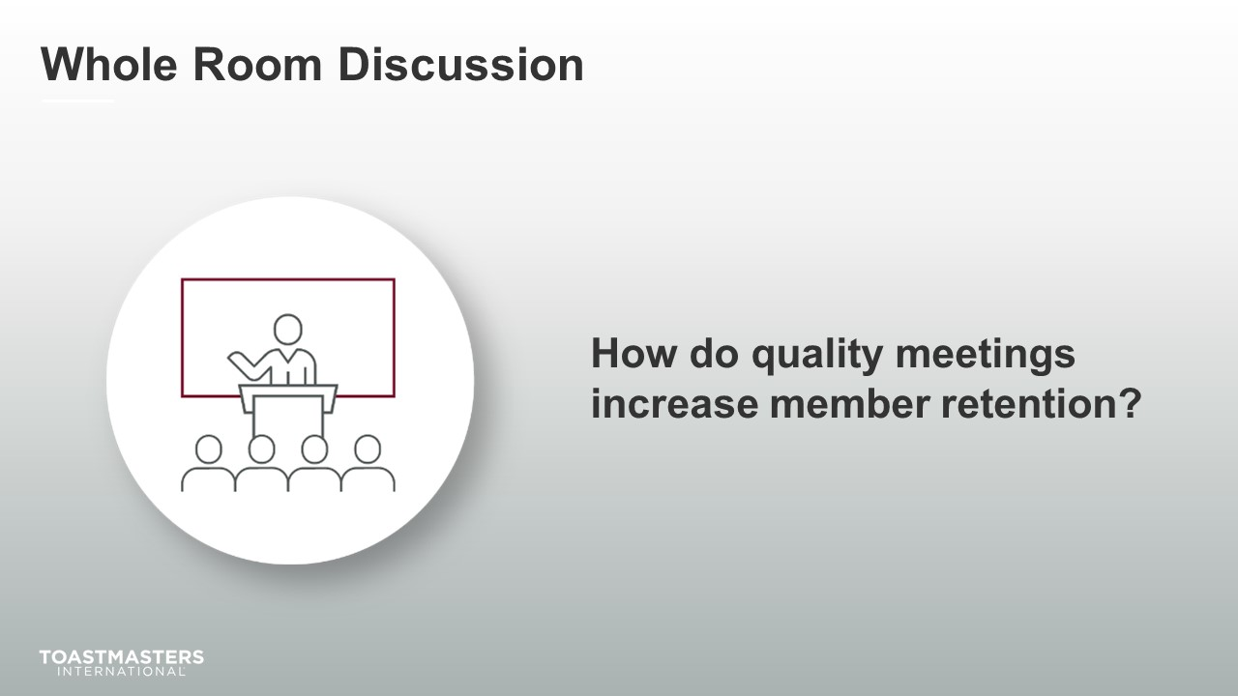
DISCUSS for up to two minutes.

Note To Facilitator
The following slide connects quality meetings with filling roles both for meetings and in leadership. Quality meetings bring confidence to members. They know what to expect at each meeting and how they can contribute to their growth and other members' growth. This confidence supports members to explore meeting roles, and as they grow to understand how the club operates, it gives them the motivation to volunteer for leadership opportunities.
SHOW the Whole Group Discussion slide.
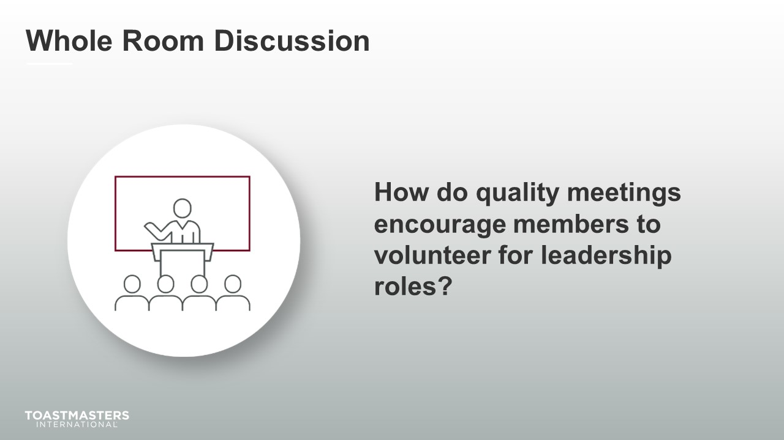
DISCUSS for up to two minutes.

Note To Facilitator
The following slide connects quality meetings with membership growth. A club meeting is the ultimate expression of its officers' teamwork and dedication to development by its membership. If a club delivers consistently organized, impactful, and engaging meetings, prospective members will experience that when they visit, or they will hear about it from members.
SHOW the Whole Group Discussion slide.
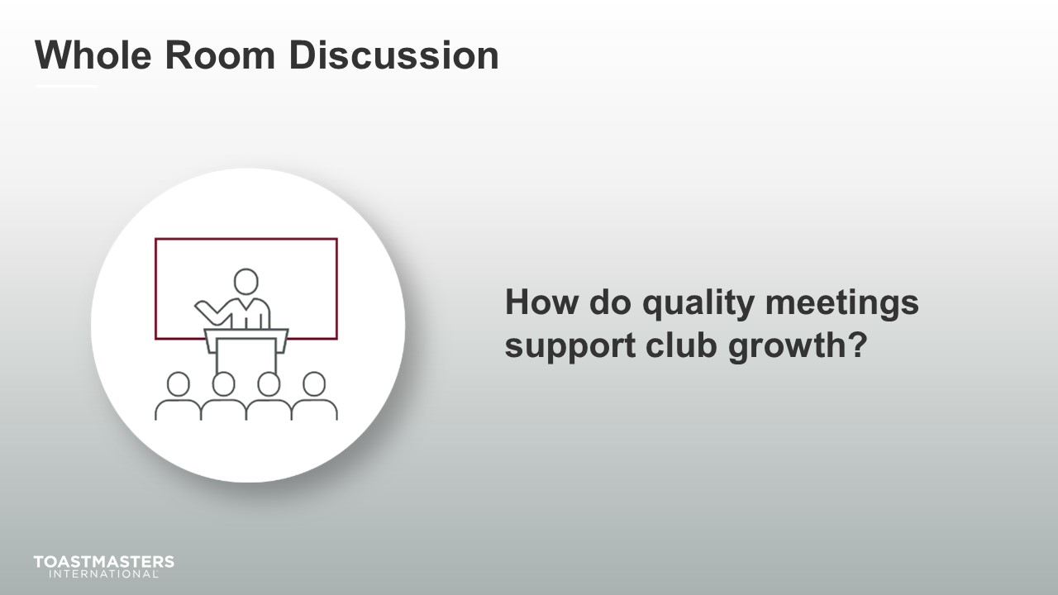
DISCUSS for up to two minutes.
SHOW the Review slide.
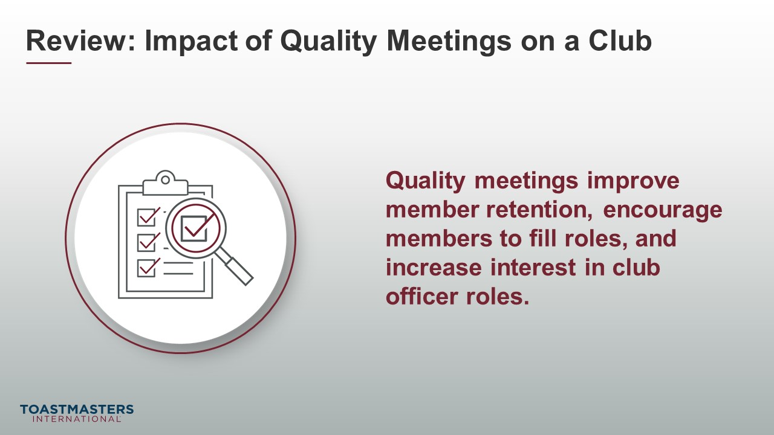

What is a Quality Meeting?
(20 minutes)
Note To Facilitator
In this section, participants define the characteristics of a quality club. This section is critical to the next section's activity in that what participants define as quality will be what they plan to deliver.
PREPARE Breakout Rooms by randomly assigning a minimum of three and a maximum of four club officers to each room.
SHOW the Section Title slide.
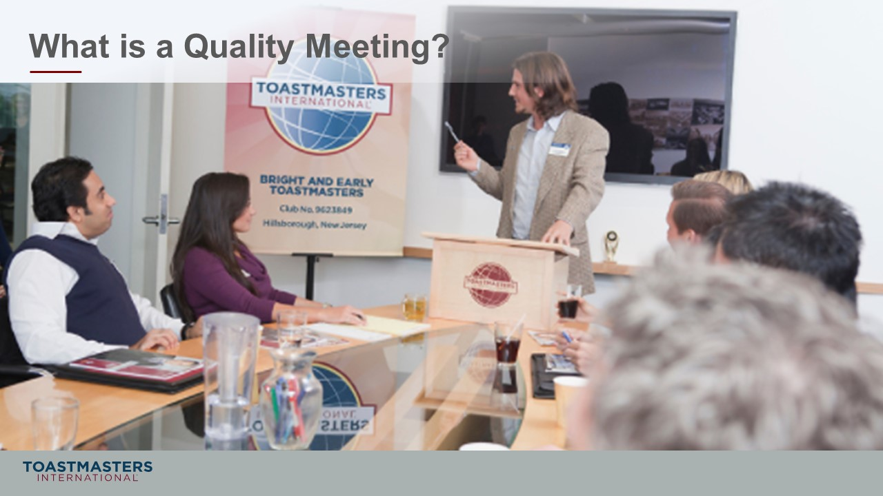
PRESENT
- Now that we agree on the value that quality meetings provide members, it is time to define what quality means in a meeting.
- Once we know the characteristics of a quality meeting, we need to have some way to identify if those characteristics are consistently present at every meeting.
note to facilitator
The following Breakout Room Activity provides participants with the collaborative experience of first brainstorming features of a quality club meeting and then identifying what impact that feature has on a club if it is missing.
SHOW the Breakout Room Activity slide.
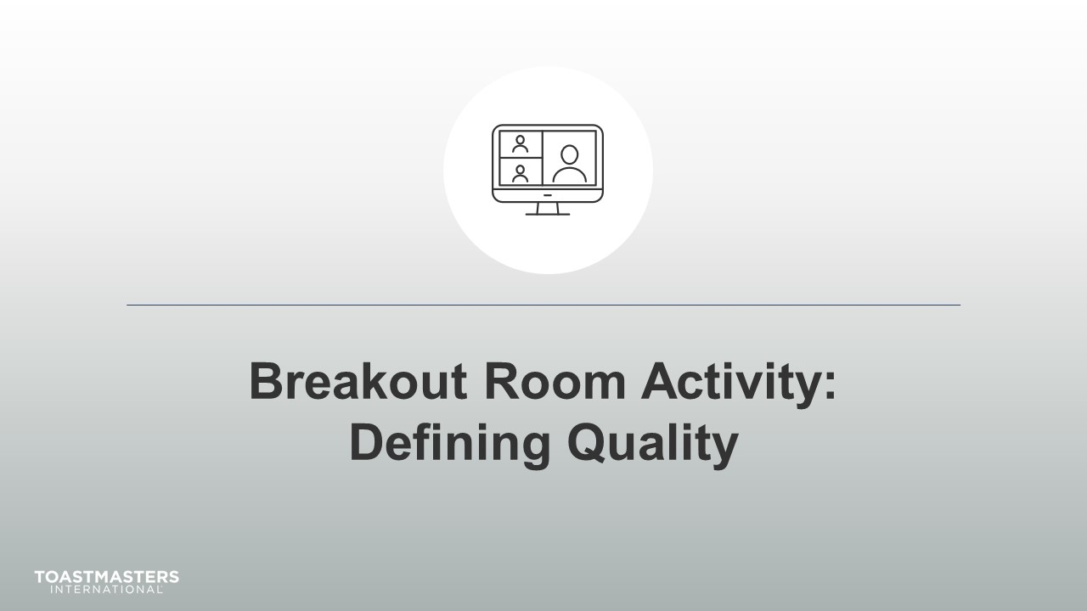
PRESENT
- Our activity, Defining Quality, will assist us in both defining and detecting quality in meetings.
Note To Facilitator
The following slide's purpose is to remind club officers about a few of the tools available to them in virtual Breakout Rooms. You may need to adjust these according to the platform that you are using to deliver this material. Plan to spend less than one minute on the next slide.
Ideally, you would like to see a minimum of three and a maximum of four club officers per group for this activity.

SHOW the Breakout Room Tips slide.
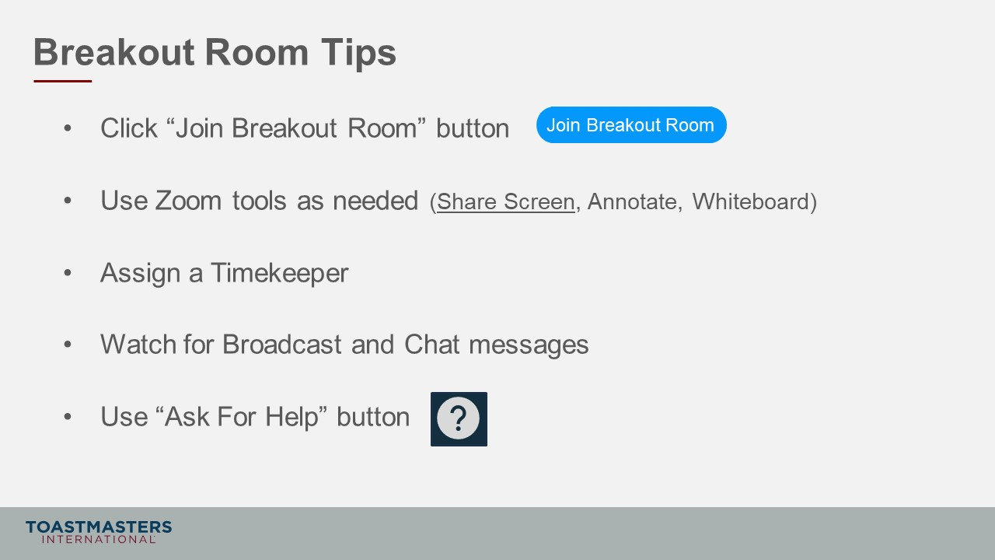
SHOW the Instructions slide.
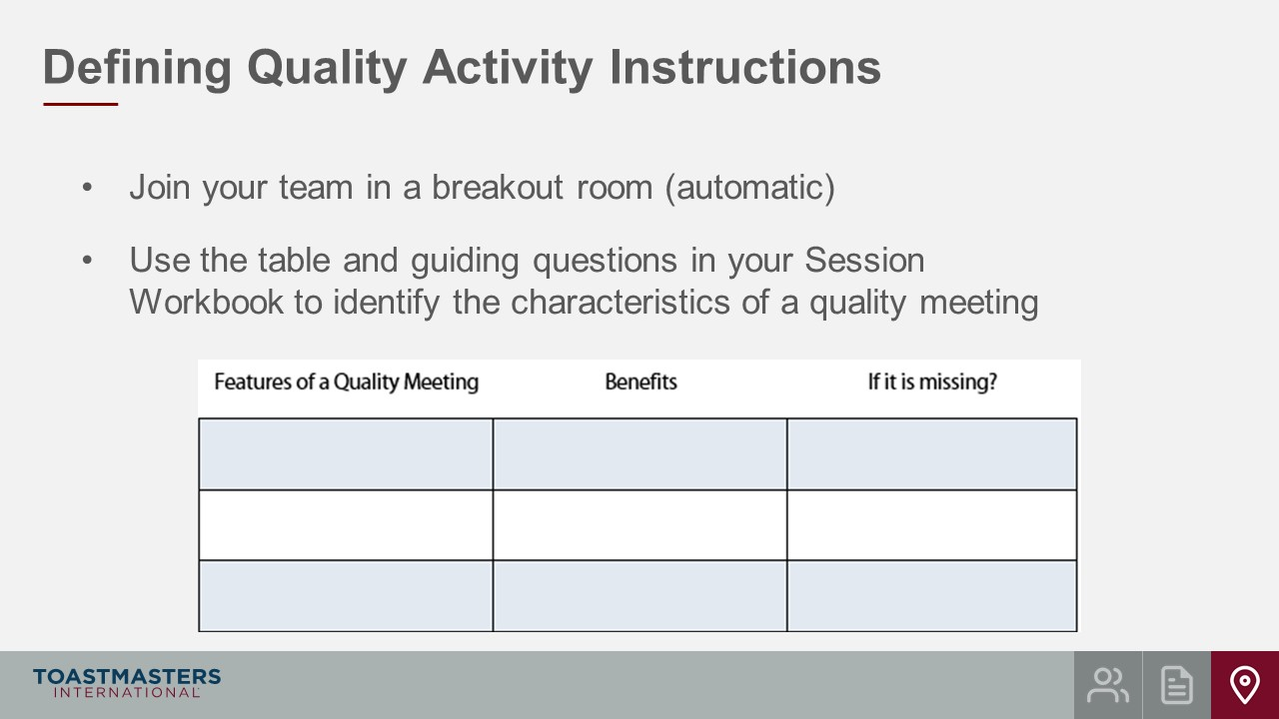
SHOW the Instructions slide.
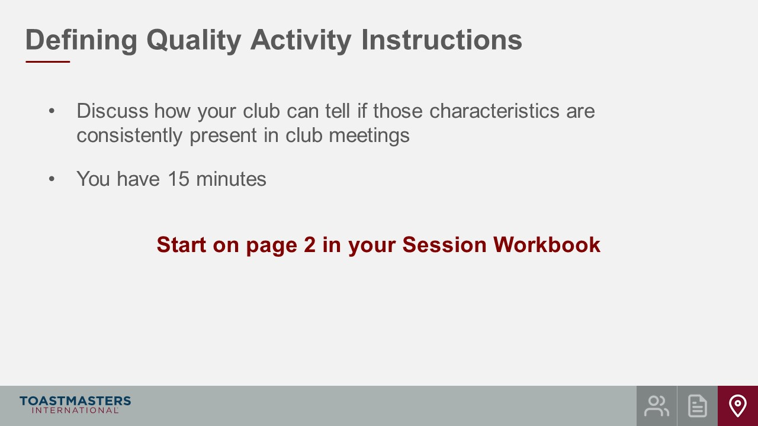
PRESENT
- We will give a two-minute warning before the end of the activity.
- I will be available to answer questions or provide assistance.
note to facilitator
The instructions below are prompts for virtual Breakout Rooms but can be adjusted to deliver in an in-person session.
OPEN Breakout Rooms for activity (3-4 club officers per room).
MONITOR requests for assistance from Breakout Rooms.
VISIT Breakout Rooms to offer assistance and guidance, as needed.
SEND broadcast after 5 minutes has elapsed: you have 10 more minutes.
SEND broadcast after 10 minutes has elapsed: you have 5 more minutes.
SEND BROADCAST after 13 minutes has elapsed: in approximately 2 minutes, you will be asked to return to the main session room.
CLOSE Breakout Rooms After 15 Minutes.
SHOW the Review slide.
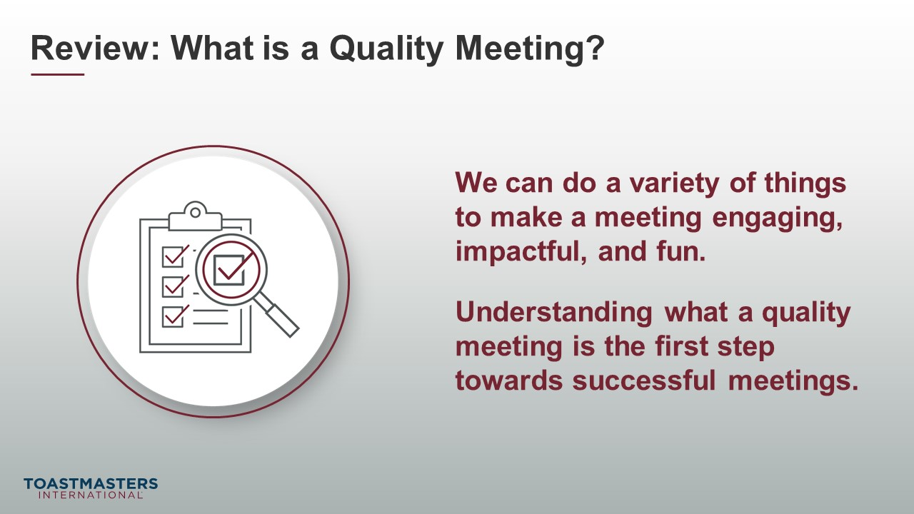

Delivering Quality Meetings
(36 minutes)
Note To Facilitator
This section connects the characteristics of a quality meeting to how that quality is created and then delivered.
PREPARE Breakout Rooms by randomly assigning a minimum of three and a maximum of four club officers to each room.
SHOW the Section Title slide.
PRESENT
- So far, we have identified the impact that quality meetings have on your club and defined what constitutes a quality meeting.
SHOW the Present slide.
PRESENT
- If you remember from your Pre-work, you read and reflected on what these categories of quality mean. We are going to use these categories and the characteristics from the last Breakout Room Activity to identify how we deliver quality in meetings.
SHOW the Breakout Room Activity slide.
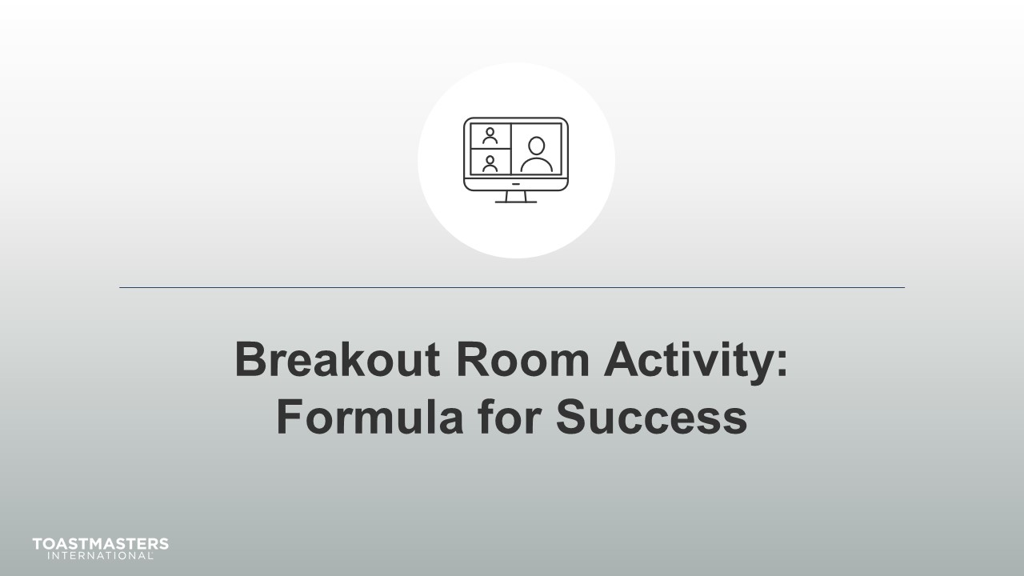
Note To Facilitator
The following slide contains helpful tips for participants to use in Zoom Breakout rooms. You should replace the text on this slide with directions if you are using a different online platform. If you are presenting this session, live you should remove this slide from your deck.
SHOW the Breakout Room Tips slide.
Note To Facilitator
Ideally, you would like to see a minimum of three and a maximum of four club officers per group for this activity. You may have to adjust the number per group based on the number of participants because you will be asking them to share highlights of their results. Adjust group sizes and speaking time for each spokesperson to keep your session within the schedule parameters.
SHOW the Instructions slide.
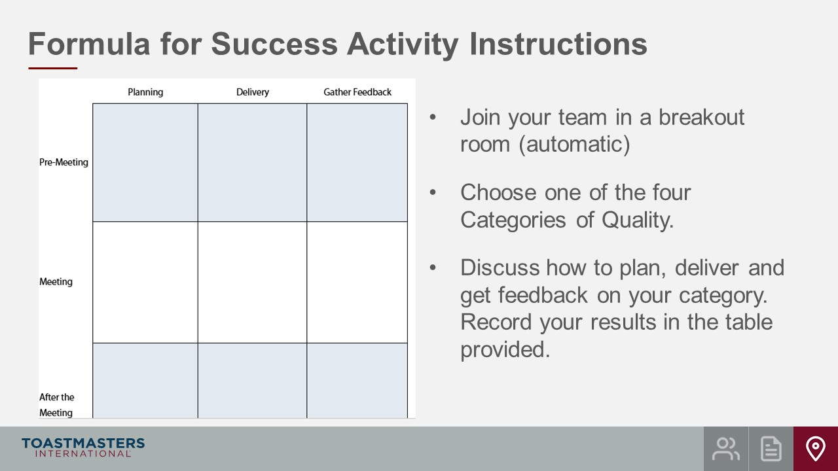
SHOW the Instructions slide.
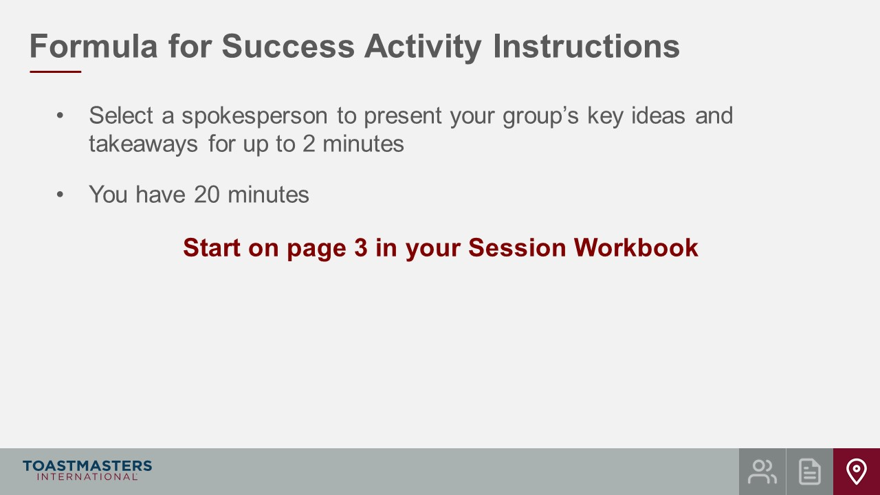
PRESENT
- We will send a two-minute warning before the end of each scenario.
- I will be available to answer questions or provide assistance.

note to facilitator
The instructions below are prompts for virtual Breakout Rooms but can be adjusted to deliver in an in-person session.
OPEN Breakout Rooms for activity (3-4 club officers per room).
MONITOR requests for assistance from breakout rooms.
VISIT breakout rooms to offer assistance and guidance, as needed.
SEND broadcast after 10 minutes has elapsed: you have 10 more minutes.
SEND broadcast after 15 minutes has elapsed: you have 5 more minutes.
SEND broadcast after 18 minutes has elapsed: in approximately 2 minutes, you will be asked to return to the main session room.
CLOSE Breakout Rooms after 20 minutes.
SHOW the Whole Room Discussion slide.
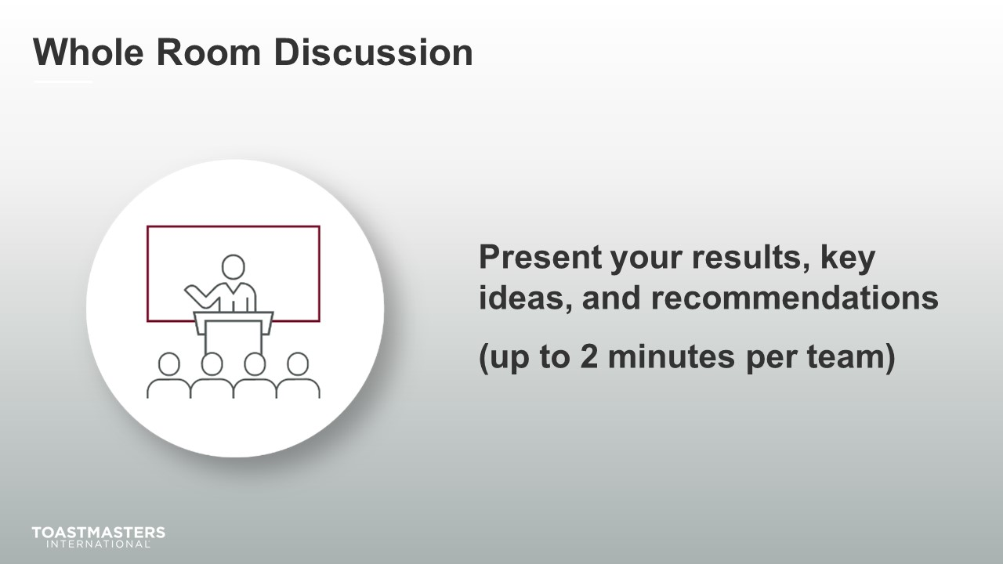
SHOW the Review slide.
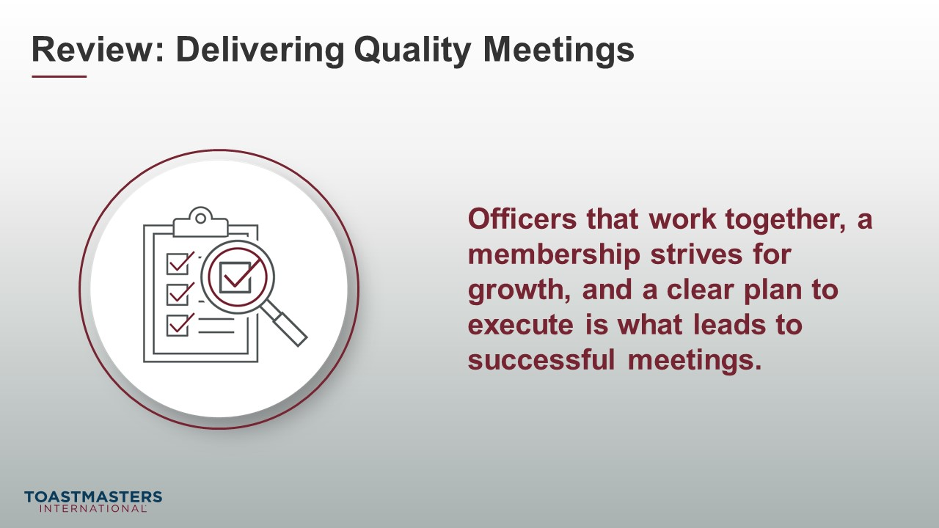
PRESENT
- [insert your talking points here]

Conclusion
(10 minutes)
SHOW the Conclusion slide.
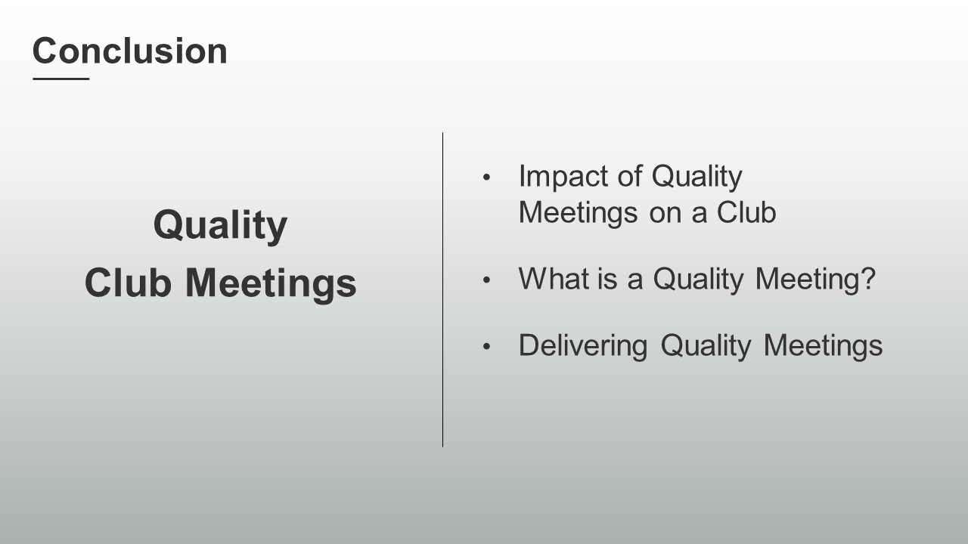
PRESENT
- There are resources in your Session Workbook on page 5 and a reflection activity on page 6 for you to complete on your own.
SHOW the Chat slide.
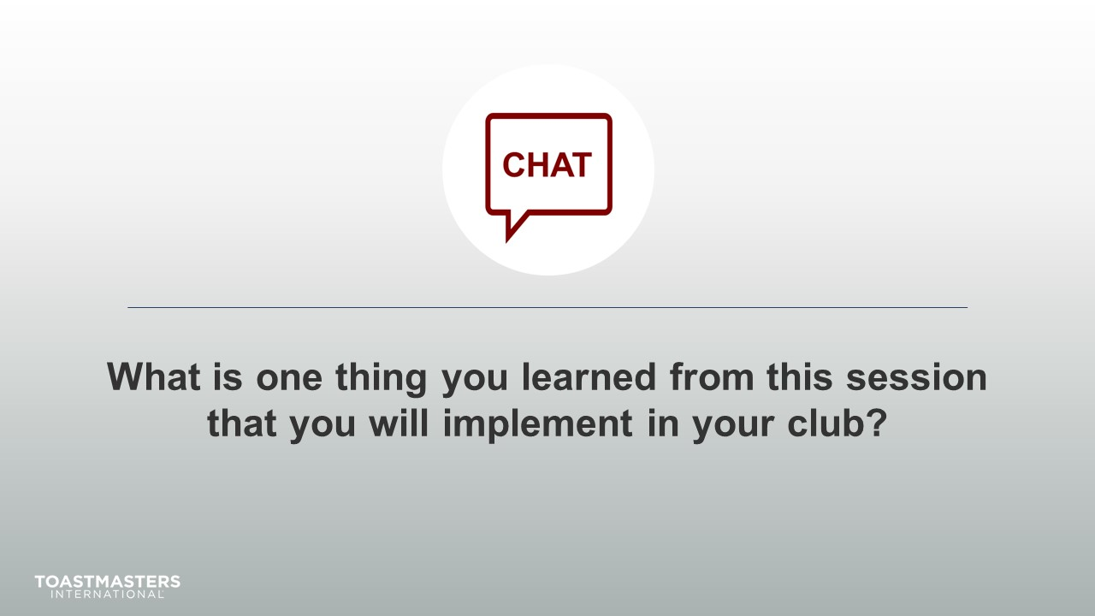
MONITOR chat responses.
DISCUSS responses from club officers for up to two minutes.
note to facilitator
The following two slides should be edited to fit your requirements.
SHOW the Session Assessment slide.
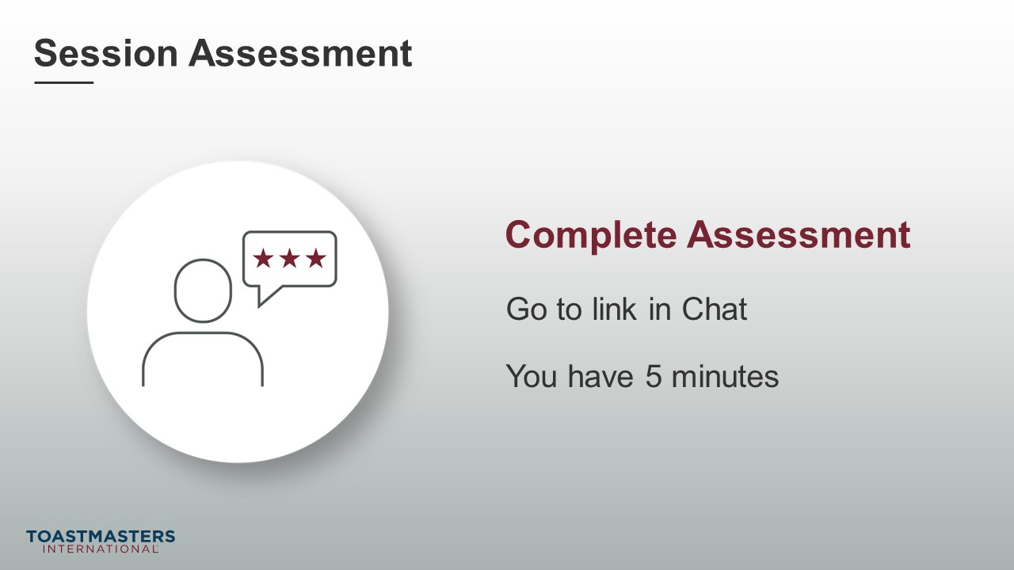
SEND chat message to everyone: [insert link to assessment]
SHOW the What is Next slide.
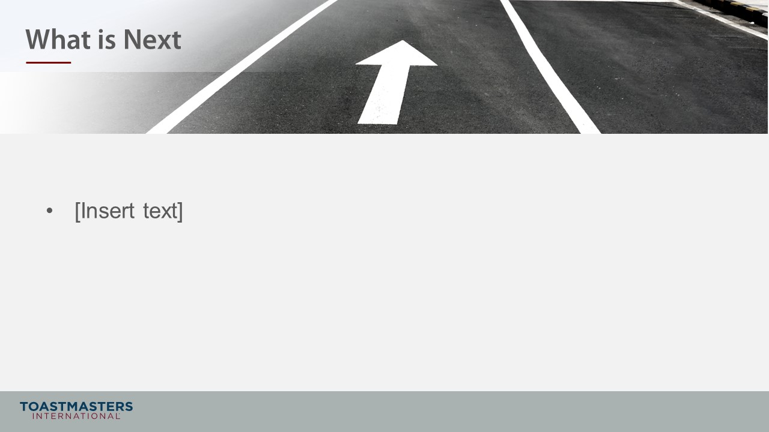
PRESENT
- [insert your talking points here]

